**统一业务平台安装手册**



**2014年3月10日**

|  |  |
| --- | --- |
| **文档编号:** | 陕煤化统一业务平台_安装手册_0.1.0 |
| **当前版本号:** | 0.1.0 |
| **最初发布日期:** | 2014-3-10 |
| **最新修订日期:** | 2014-3-10 |

* **文档位置**

文档存放在文档服务器：

* **文档修改历史**

| **版本号** | **版本日期** | **修改总结** | **修订人** |
| --- | --- | --- | --- |
| 0.1.0 | 2014/3/10 | 初始版本 | 董桥梁 |
|  |  |  |  |
|  |  |  |  |
|  |  |  |  |
|  |  |  |  |

* **参考文档**

| **序号** | **参考文档** | **版本** | **日期** |
| --- | --- | --- | --- |
|  |  |  |  |
|  |  |  |  |
|  |  |  |  |
|  |  |  |  |
|  |  |  |  |
|  |  |  |  |

* **审批**

|  |  |  |  |  |
| --- | --- | --- | --- | --- |
|  |  | 签字 |  | 日期 |
|  |  |  |  |  |
|  |  | 签字 |  | 日期 |

目录

1. 前言 5

1.1. 定义 5

**1.2.** **参考文档** 5

2. 系统说明 6

2.1. 系统用途 6

2.2. 系统构成 6

2.2.1. 硬件构成 6

2.2.2. 软件构成 6

2.3. 系统运行环境 6

2.4. linux操作系统检查及修改 6

3. 系统安装整体架构 7

3.1. 物理架构 7

3.2. 软件架构 8

4. 基础软件的安装 8

4.1. DB2数据库的安装 8

4.2. WAS的安装 15

4.2.1. 安装基础版 15

4.2.2. 安装补丁 21

5. TDS的安装 29

5.1. 安装TDS 29

5.2. 安装TDS语言包 35

5.3. 安装TDS补丁 37

5.4. 安装TDS管理程序 39

5.5. 创建TDS实例 44

5.6. TDI的安装 65

6. TIM的安装 74

6.1. 安装TIM的ldap服务器 74

6.2. 安装SIM软件 81

6.3. 安装SIM的语言包 95

6.4. 安装SIM的补丁 97

6.5. 安装语言包的程序 102

7. TAM的安装 105

7.1. WebSphere的安装 105

7.2. IHS的安装 105

7.3. 安装IHS的补丁 110

7.4. 安装Policy Server 116

7.5. 安装授权服务器 129

7.6. 安装应用程序开发包 137

7.7. Java运行时包的安装 140

7.8. 代理Policy服务器的安装 144

7.9. 安装Webseal运行时包 150

7.10. Webseal Portal Manager的安装 153

7.11. Retrieval Service的安装 161

7.12. Web Security Development kit的安装 164

7.13. Webseal的安装 167

7.14. 补丁的安装 174

7.15. 安装dispatcher 174

7.16. 配置tim的tam插件 177

8. TIM上添加TAM的配置 183

8.1. 在TIM上添加TAM的配置信息 183

8.2. 在TIM上配置TAM Service 183

9. portal安装 195

9.1. Install Manager的安装 195

9.2. 安装Was8.5软件 198

9.3. 安装Portal软件 205

9.4. 将数据库从deby迁移到oralce上 213

9.5. 将用户验证迁移到TDS的服务器上 222

9.6. portal与webseal的单点 223

# 前言

统一业务平台作为陕煤化集团的统一门户平台，其目的是作为公司与员工、员工与员工、员工工作的平台，使员工能够通过一次登录，就能获取公司的信息、处理日常工作、与其他员工进行协同工。本文档将遵循标准化的思路，详细描述统一业务平台相关产品的安装和使用，为维护工作提供依据。

统一业务平台的安装涉及到IBM的门户产品、安全产品，架构上比较复杂，安装的产品分类比较多，本文只涉及到安装部分，不涉及系统的配置信息。

## 定义

IBM WebSphere Portal: (以下简称Portal)是由用于构建和管理安全的企业对企业（B2B）、企业对客户（B2C）和企业对雇员（B2E）门户网站的中间件、应用程序（称为 portlet）和开发工具组成。

IBM InforSphere DB2：（以下简称DB2）是IBM出品的一系列关系型数据库管理系统，分别在不同的操作系统平台上服务，在本项目中是TDS和ITIM的基础。

IBM WebSphere Application:（以下简称WAS）是IBM 的应用集成软件平台。它包含了编写、运行和监视全天候的工业强度的随需应变 Web 应用程序和跨平台、跨产品解决方案所需要的整个中间件基础设施，如服务器、服务和工具。WebSphere 提供了可靠、灵活和健壮的集成软件。

* 1. **参考文档**

《统一业务平台需求设计》

# 系统说明

## 系统用途

统一业务平台作为陕煤化集团的统一门户平台，其目的是作为公司与员工、员工与员工、员工工作的平台，使员工能够通过一次登录，就能获取公司的信息、处理日常工作、与其他员工进行协同工。

## 系统构成

### 硬件构成

5台虚拟机环境，四台安装linux系统，一台安装Windows 2008

### 软件构成

IBM WebSphere Portal Server 8.0.0.1

IBM Tivoli Access Manager 6.1.2

IBM Tivoli Identity Manager 6.1.0.9

IBM Tivoli Directory Server 6.0

IBM ESSO

Oracle extend data (数据库)

## 系统运行环境

操作系统：Linux Redhat5.4

Windows R2 2008

数据库：Oracle 11.2.0.4

## linux操作系统检查及修改

* 安装操作系统相关的包

mount -o loop Redhat.Enterprise.Linux.v5.UPDATE.8.X86_64.DVD.iso /media

cd /media/Server

rpm -ivh compat-libstdc++-*

rpm -ivh compat-db*

rpm -ivh libXp-*

rpm -ivh libXmu-*

rpm -ivh libXtst-*

rpm -ivh pam-*

rpm -ivh libXft-*

rpm -ivh gtk2-*

rpm -ivh gtk2-engines-*

* 修改系统配置文件

/etc/hosts

127.0.0.1 localhost.localdomain localhost

::1 localhost6.localdomain6 localhost6

10.47.0.104 portal1 portal1.shccig.com

10.47.0.105 portal2 portal2.shccig.com

10.47.0.106 webseal webseal.shccig.com

10.47.0.108 tdsldap tdsldap.shccig.com

# 系统安装整体架构

## 物理架构



## 软件架构

| **序号** | **软件** | **版本** | **备注** |
| --- | --- | --- | --- |
| 门户服务器 | | | |
|  | IBM WebSphere Portal | 8.0.0.1 | 物理机器Portal1 |
|  | IBM WebSphere Portal | 8.0.0.1 | 物理机器Portal2 |
| 反向代理服务器 | | | |
| 3 | IBM Tivoli Access Manager | 6.1.0.2 | 物理机器WebSeal |
| LDAP服务器 | | | |
| 4 | IBM Tivoli Directory Server | 6.1 | 物理机器idsldap |
| 身份认证服务器 | | | |
| 5 | IBM Tivoli Identity Manager | 6.1.0.9 | 物理机器idsldap |
| 单点登录服务器 | | | |
| 6 | IBM ESSO | 7.0 | 物理机器ESSO |

# 基础软件的安装

## DB2数据库的安装

cd /software/db2/server

./db2_install

[root@tdsldap server]# ./db2_install

WARNING:

DBT3534W The db2prereqcheck utility determined that ASLR is set to ON and that this could cause issues with some tools.

Default directory for installation of products - /opt/ibm/db2/V9.7

***********************************************************

Do you want to choose a different directory to install [yes/no] ?

no

Specify one of the following keywords to install DB2 products.

AESE

ESE

CONSV

WSE

EXP

PE

CLIENT

RTCL

Enter "help" to redisplay product names.

Enter "quit" to exit.

***********************************************************

ese

WARNING:

DBT3534W The db2prereqcheck utility determined that ASLR is set to ON and that this could cause issues with some tools.

DB2 installation is being initialized.

Total number of tasks to be performed: 48

Total estimated time for all tasks to be performed: 1996

Task #1 start

Description: Checking license agreement acceptance

Estimated time 1 second(s)

Task #1 end

Task #2 start

Description: Base Client Support for installation with root privileges

Estimated time 3 second(s)

Task #2 end

Task #3 start

Description: The DB2 required component.

Estimated time 11 second(s)

Task #3 end

Task #4 start

Description: Product Messages - English

Estimated time 13 second(s)

Task #4 end

Task #5 start

Description: Base client support

Estimated time 202 second(s)

Task #5 end

Task #6 start

Description: Java Runtime Support

Estimated time 121 second(s)

Task #6 end

Task #7 start

Description: Java Help (HTML) - English

Estimated time 7 second(s)

Task #7 end

Task #8 start

Description: Base server support for installation with root privileges

Estimated time 7 second(s)

Task #8 end

Task #9 start

Description: Global Secure ToolKit

Estimated time 51 second(s)

Task #9 end

Task #10 start

Description: Java support

Estimated time 12 second(s)

Task #10 end

Task #11 start

Description: SQL procedures

Estimated time 3 second(s)

Task #11 end

Task #12 start

Description: ICU Utilities

Estimated time 40 second(s)

Task #12 end

Task #13 start

Description: Java Common files

Estimated time 20 second(s)

Task #13 end

Task #14 start

Description: Base server support

Estimated time 261 second(s)

Task #15 start

Description: IBM Software Development Kit (SDK) for Java(TM)

Estimated time 35 second(s)

Task #15 end

Task #16 start

Description: Control Center Help (HTML) - English

Estimated time 13 second(s)

Task #16 end

Task #17 start

Description: Connect support

Estimated time 3 second(s)

Task #17 end

Task #18 start

Description: Communication support - TCP/IP

Estimated time 3 second(s)

Task #18 end

Task #19 start

Description: Parallel Extension

Estimated time 3 second(s)

Task #19 end

Task #20 start

Description: EnterpriseDB code

Estimated time 3 second(s)

Task #20 end

Task #21 start

Description: Replication tools

Estimated time 21 second(s)

Task #21 end

Task #22 start

Description: Relational wrappers common

Estimated time 3 second(s)

Task #22 end

Task #23 start

Description: Control Center

Estimated time 41 second(s)

Task #23 end

Task #24 start

Description: Command Line Processor Plus

Estimated time 6 second(s)

Task #24 end

Task #25 start

Description: DB2 data source support

Estimated time 6 second(s)

Task #25 end

Task #26 start

Description: DB2 LDAP support

Estimated time 4 second(s)

Task #26 end

Task #27 start

Description: DB2 Instance Setup wizard

Estimated time 8 second(s)

Task #27 end

Task #28 start

Description: Integrated Flash Copy Support

Estimated time 53 second(s)

Task #28 end

Task #29 start

Description: Spatial Extender client

Estimated time 3 second(s)

Task #29 end

Task #30 start

Description: Base application development tools

Estimated time 34 second(s)

Task #30 end

Task #31 start

Description: DB2 Update Service

Estimated time 4 second(s)

Task #31 end

Task #32 start

Description: First Steps

Estimated time 3 second(s)

Task #32 end

Task #33 start

Description: Product Signature for DB2 Enterprise Server Edition

Estimated time 5 second(s)

Task #33 end

Task #34 start

Description: Sample database source

Estimated time 4 second(s)

Task #34 end

Task #35 start

Description: DB2 Text Search

Estimated time 70 second(s)

Task #35 end

Task #36 start

Description: Informix data source support

Estimated time 4 second(s)

Task #36 end

Task #37 start

Description: Setting DB2 library path

Estimated time 180 second(s)

Task #37 end

Task #38 start

Description: Installing or updating SA MP

Estimated time 40 second(s)

Task #38 end

Task #39 start

Description: Installing or updating DB2 HA scripts for SA MP

Estimated time 40 second(s)

Task #39 end

Task #40 start

Description: Executing control tasks

Estimated time 20 second(s)

Task #40 end

Task #41 start

Description: Updating global registry

Estimated time 20 second(s)

Task #41 end

Task #42 start

Description: Installing IBM Tivoli Monitoring for Databases

Estimated time 600 second(s)

Task #42 end

Task #43 start

Description: Starting DB2 Fault Monitor

Estimated time 10 second(s)

Task #43 end

Task #44 start

Description: Updating the db2ls link

Estimated time 1 second(s)

Task #44 end

Task #45 start

Description: Registering DB2 licenses

Estimated time 5 second(s)

Task #45 end

Task #46 start

Description: Setting default global profile registry variables

Estimated time 1 second(s)

Task #46 end

Task #47 start

Description: Initializing instance list

Estimated time 5 second(s)

Task #47 end

Task #48 start

Description: Registering DB2 Update Service

Estimated time 30 second(s)

Task #48 end

Task #49 start

Description: Updating global profile registry

Estimated time 3 second(s)

Task #49 end

The execution completed successfully.

For more information see the DB2 installation log at

"/tmp/db2_install.log.1247".

## WAS的安装

### 安装基础版

/software/was/WAS

./install

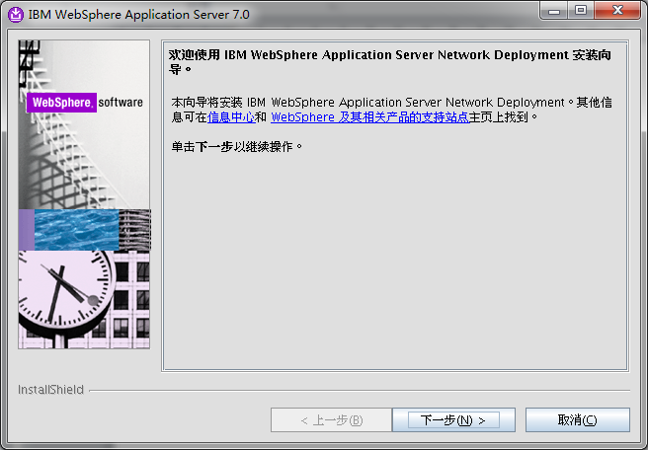

点击下一步 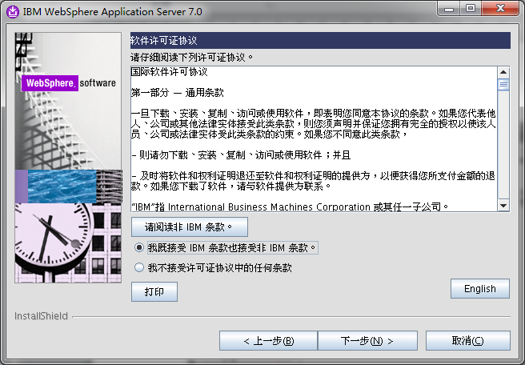

接收条款，并选择下一步 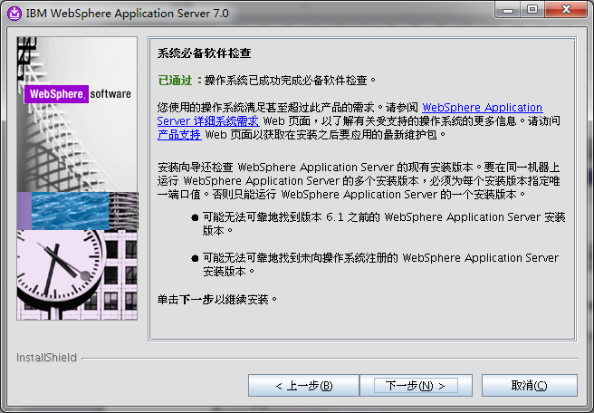

Was自己坚持系统是否满足条件 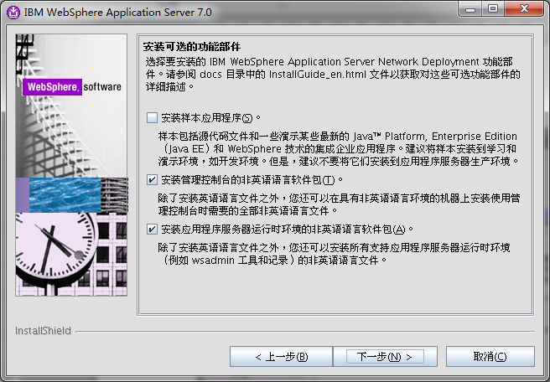

选择安装管理控制台、语言包 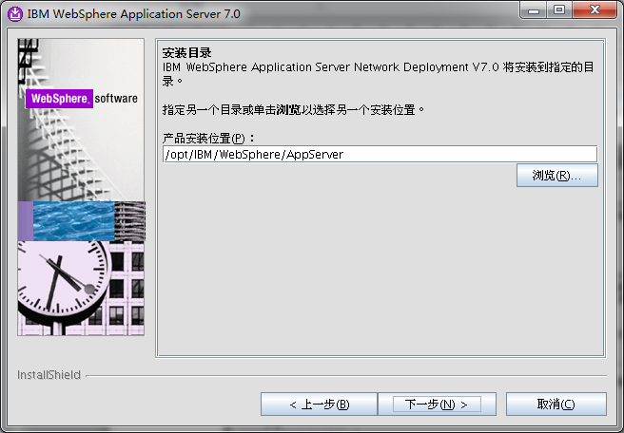

指定服务器的安装路径 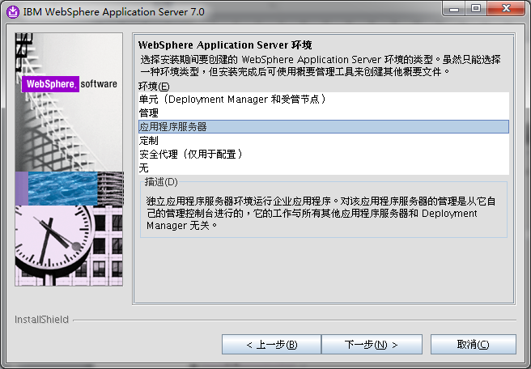

选择单机版本的应用程序服务器 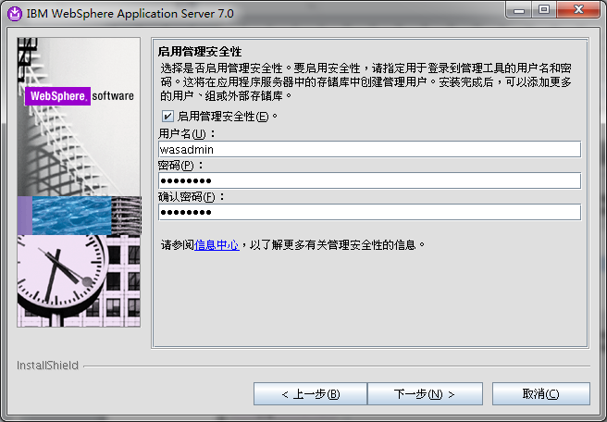

输入管理控制台的用户和密码 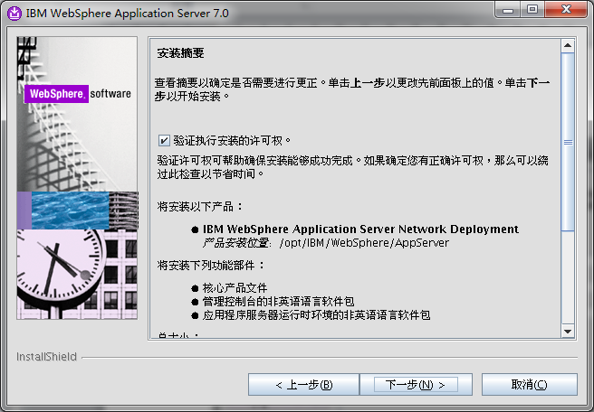

检查安装摘要 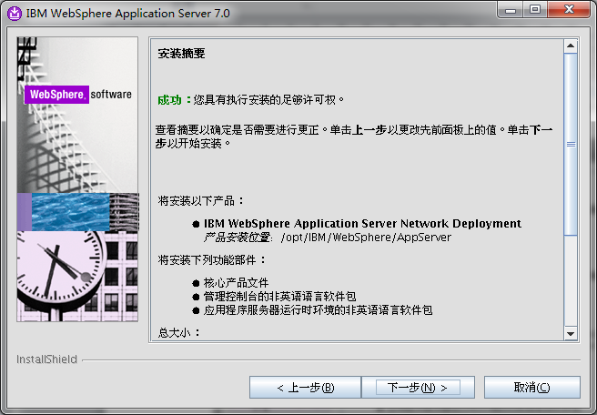 选择下一步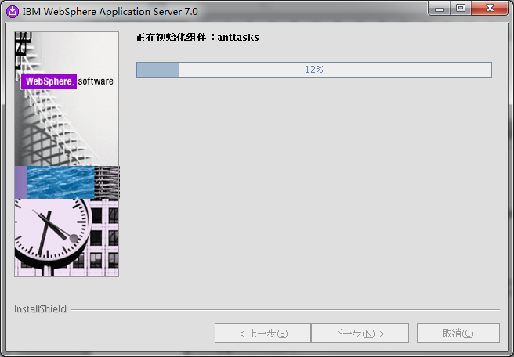

正式安装 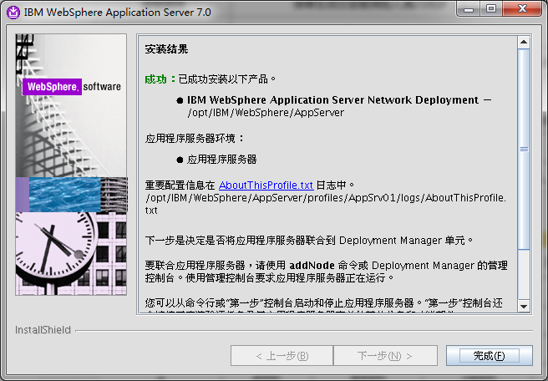

安装完成 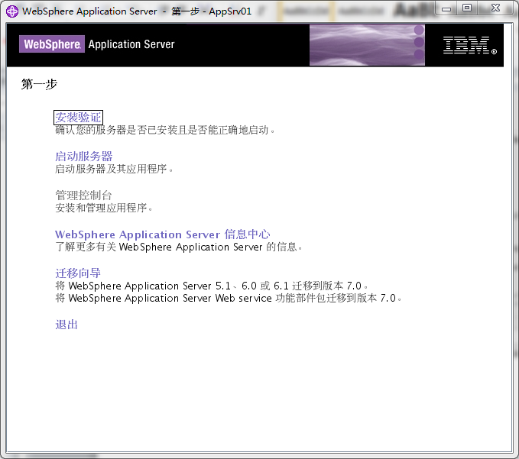

安装验证

### 安装补丁

/software/UpdateInstaller

./install

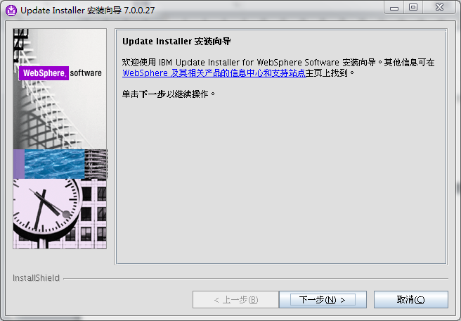

点击下一步 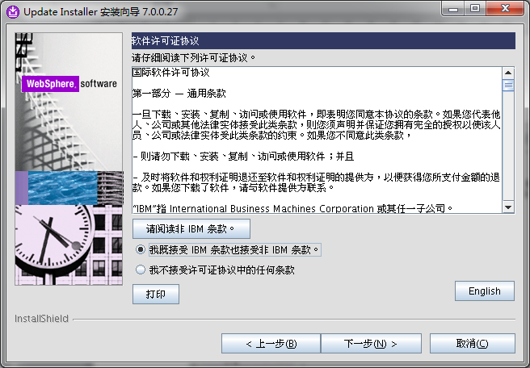

接受协议，点击下一步 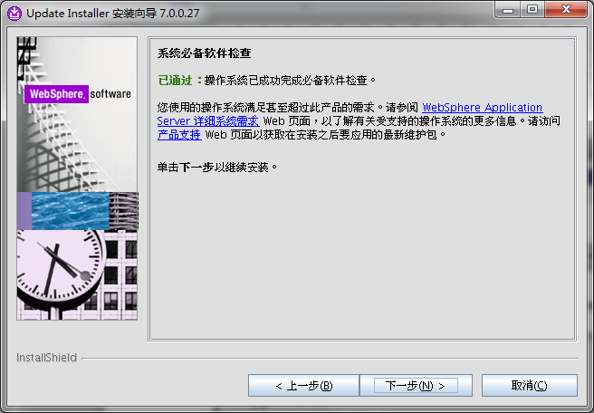

系统自检，点击下一步 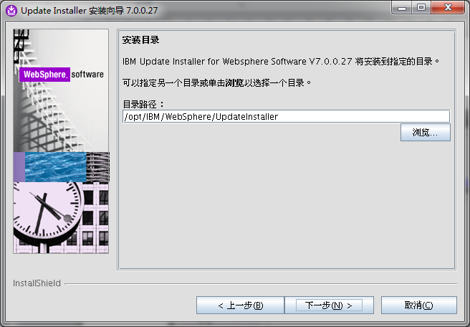

选择补丁安装程序的目录 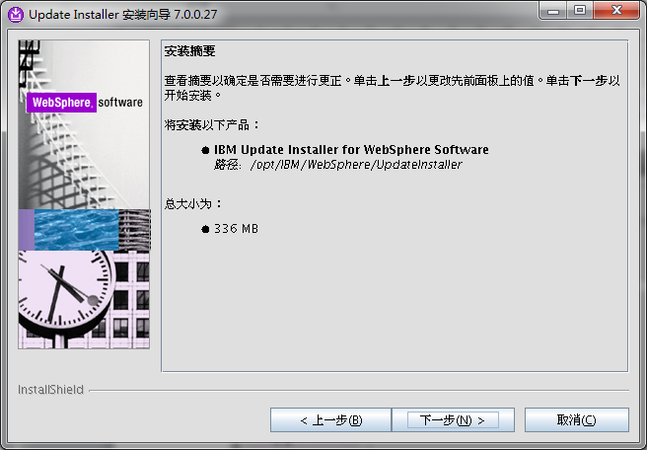

安装补丁安装程序信息 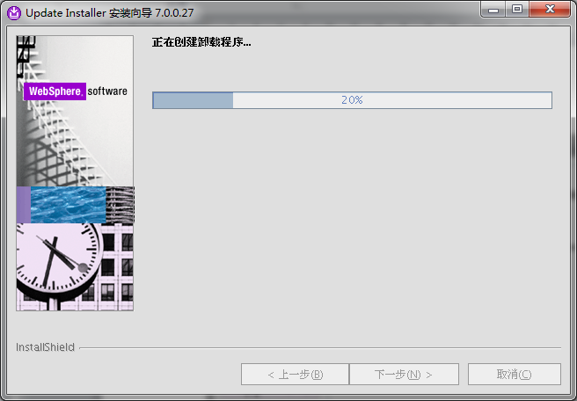

正在安装安装程序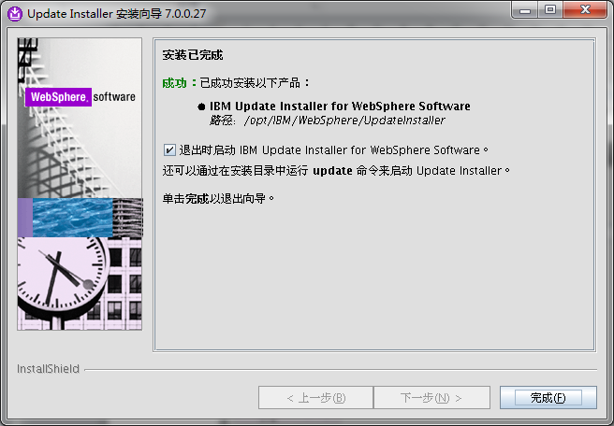

补丁安装程序安装成功 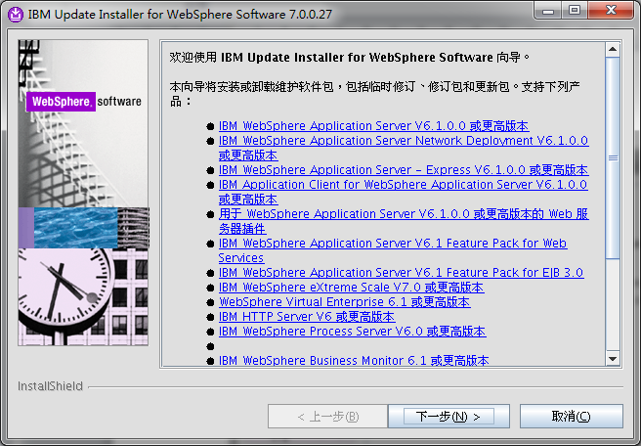

开始安装websphere补丁

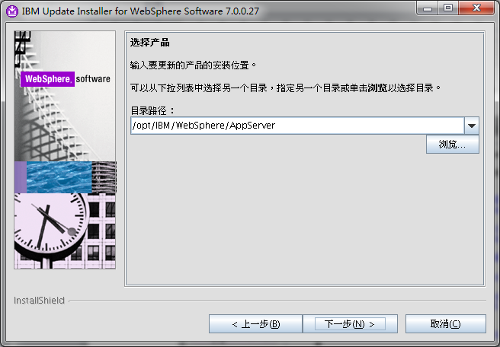

选择原来WebSphere的目录 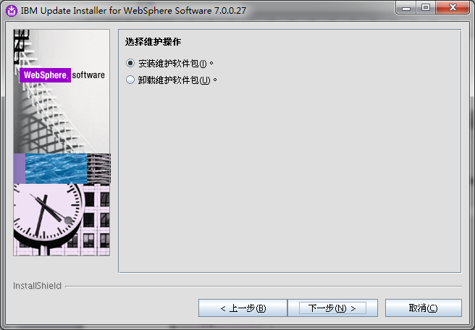

选择需要安装的补丁包 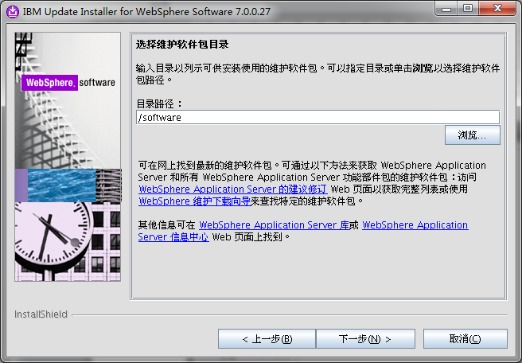

输入放置补丁包的路径 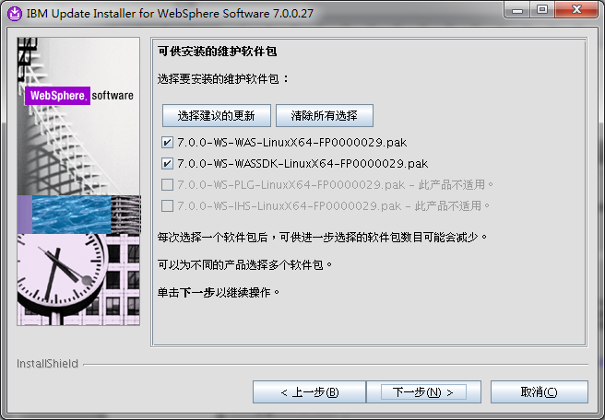

选择合适的补丁包，并进行安装 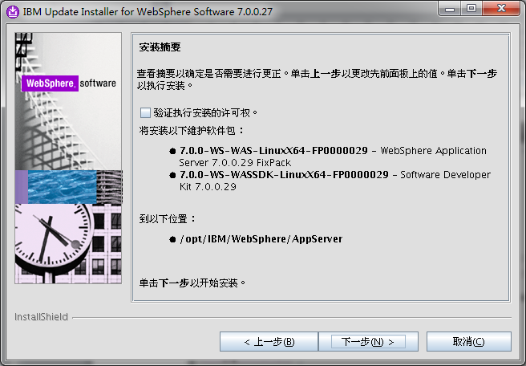

点击下一步 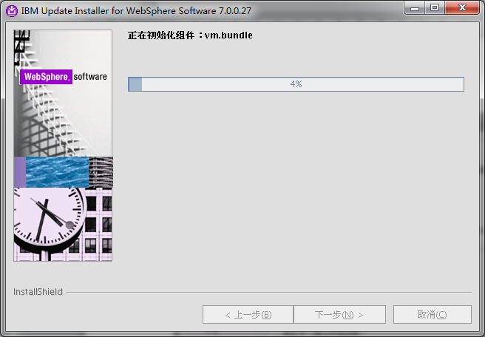

正在安装补丁 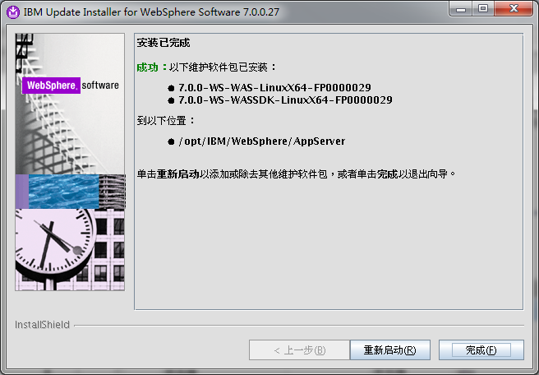

补丁安装成功

# TDS的安装

## 安装TDS

cd /software

mount -o loop tds63-linux-x86-64.iso /media

cd /media/tds

./install_tds.bin

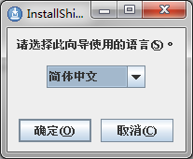

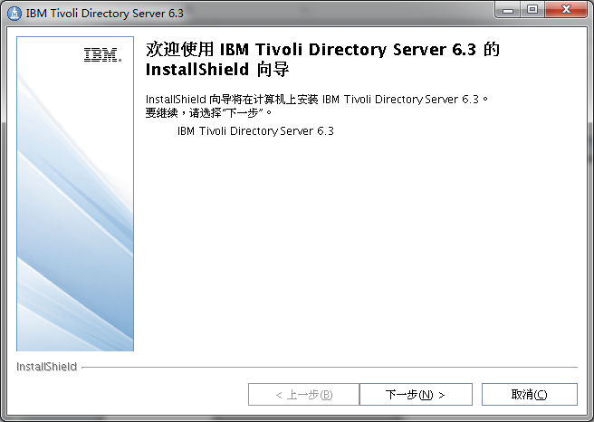

启动TDS的安装程序 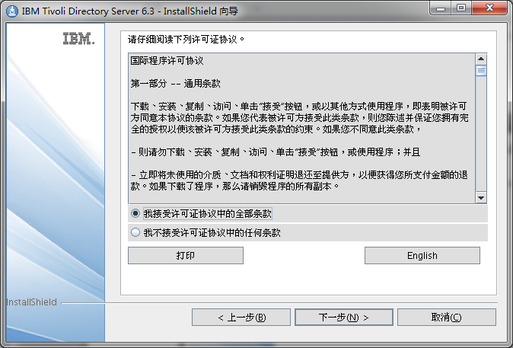

接受安装协议 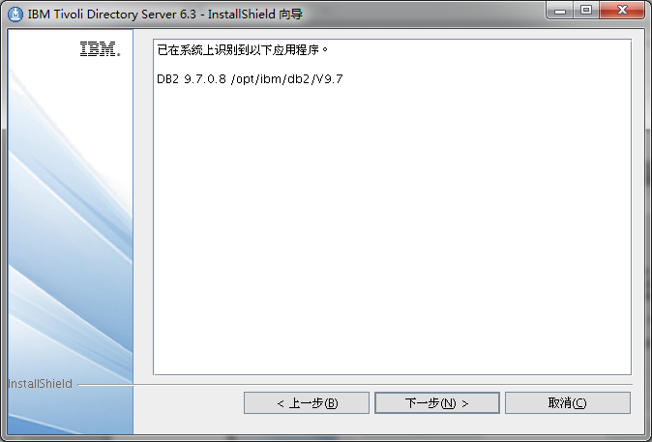

找到已经安装好的DB2 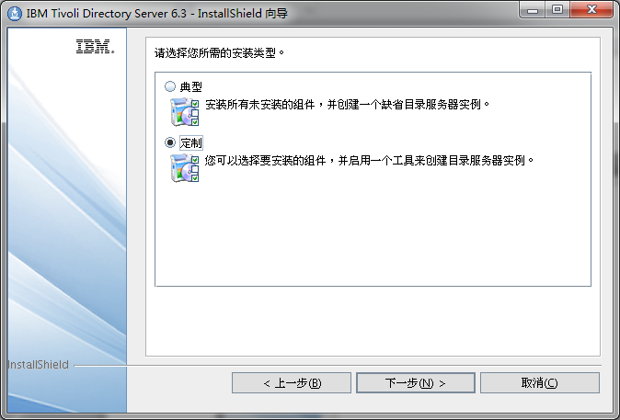

选择定制安装软件 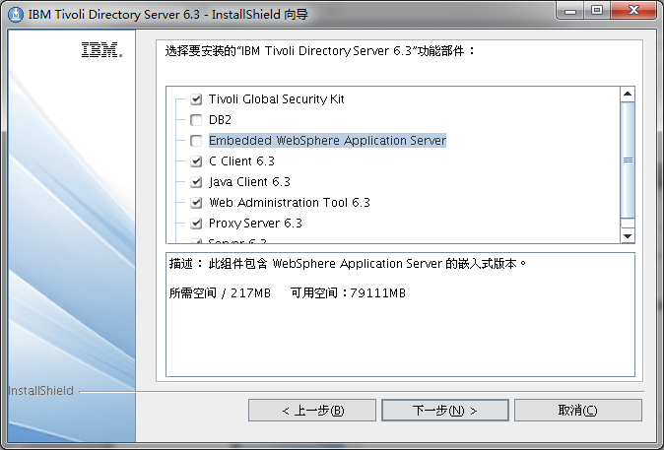

不选内嵌的WebSphere应用服务器 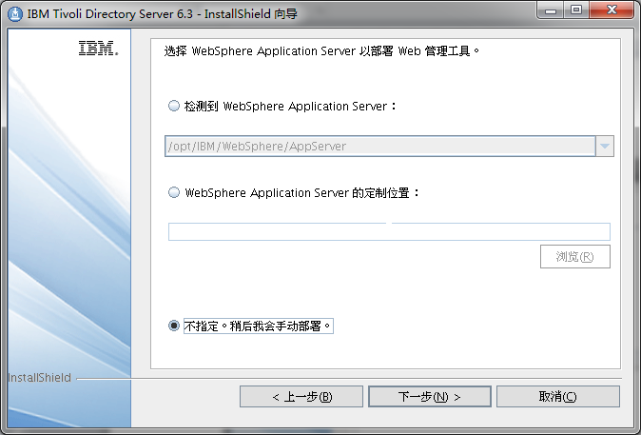

选择已经安装好的WebSphere路径 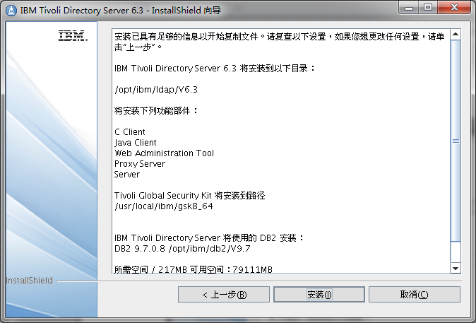

点击开始安装 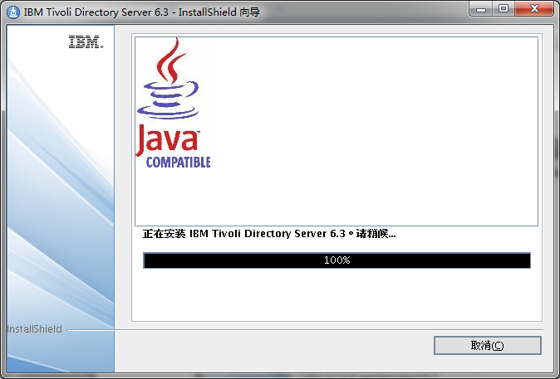

正在安装中

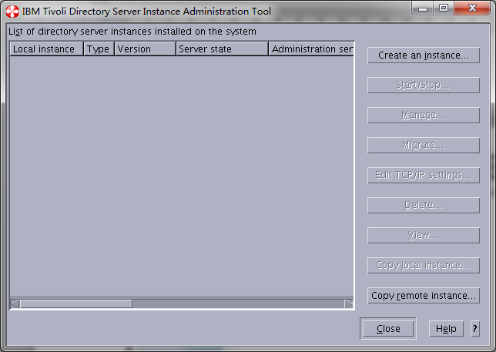

退出TDS配置向导

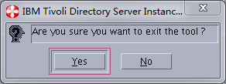

确认退出向导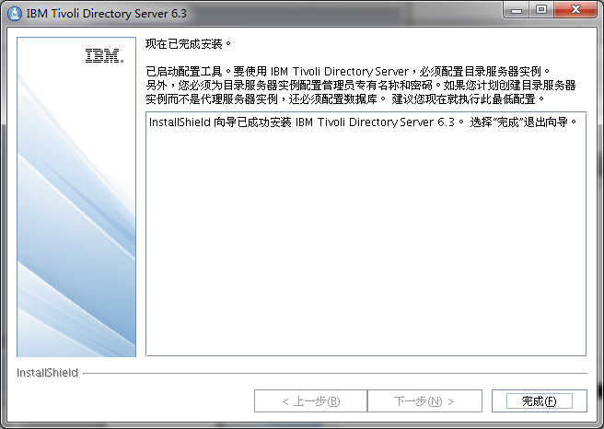

安装TDS完成

## 安装TDS语言包

cd /media/tdsLangpack

./idslp_setup_linux86.bin

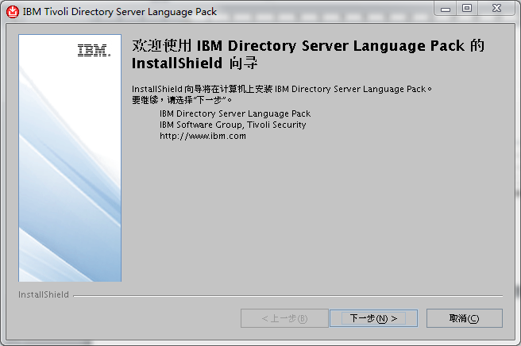

打开语言包安装向导 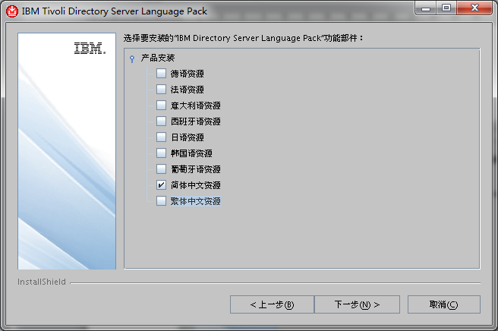

选择简体中文 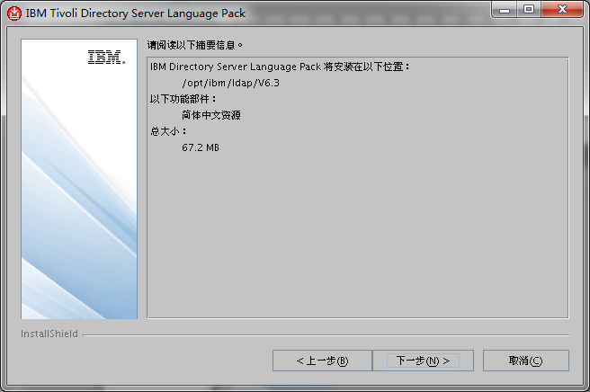

开始安装语言包 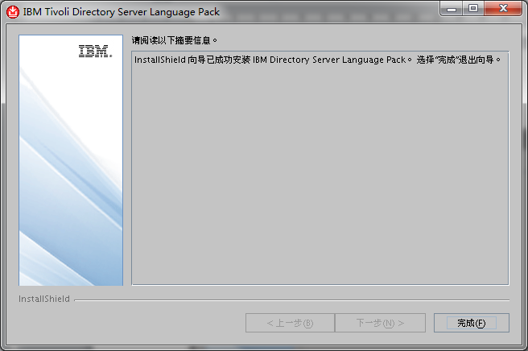

安装完成

## 安装TDS补丁

cd /software/tdsfix/8.0.14.27-ISS-GSKIT-LinuxX64-FP0027/32

rpm -Uvh gsk*.rpm

cd /software/tdsfix/8.0.14.27-ISS-GSKIT-LinuxX64-FP0027/64

rpm -Uvh gsk*.rpm

cd /software/tdsfix/6.3.0.24-ISS-ITDS-LinuxX64-FP0024

./idsinstall –u

International Program License Agreement

Part 1 - General Terms

BY DOWNLOADING, INSTALLING, COPYING, ACCESSING, CLICKING ON AN "ACCEPT" BUTTON, OR OTHERWISE USING THE PROGRAM, LICENSEE AGREES TO THE TERMS OF THIS AGREEMENT. IF YOU

ARE ACCEPTING THESE TERMS ON BEHALF OF LICENSEE, YOU REPRESENT AND WARRANT THAT YOU HAVE FULL AUTHORITY TO BIND LICENSEE TO THESE TERMS. IF YOU DO NOT AGREE TO THESE

TERMS,

* DO NOT DOWNLOAD, INSTALL, COPY, ACCESS, CLICK ON AN "ACCEPT" BUTTON, OR USE THE PROGRAM; AND

* PROMPTLY RETURN THE UNUSED MEDIA, DOCUMENTATION, AND PROOF OF ENTITLEMENT TO THE PARTY FROM WHOM IT WAS OBTAINED FOR A REFUND OF THE AMOUNT PAID. IF THE PROGRAM WAS

DOWNLOADED, DESTROY ALL COPIES OF THE PROGRAM.

1. Definitions

"Authorized Use" - the specified level at which Licensee is authorized to execute or run the Program. That level may be measured by number of users, millions of

service units ("MSUs"), Processor Value Units ("PVUs"), or other level of use specified by IBM.

"IBM" - International Business Machines Corporation or one of its subsidiaries.

"License Information" ("LI") - a document that provides information and any additional terms specific to a Program. The Program's LI is available at www.ibm.com/

software/sla. The LI can also be found in the Program's directory, by the use of a system command, or as a booklet included with the Program.

"Program" - the following, including the original and all whole or partial copies: 1) machine-readable instructions and data, 2) components, files, and modules, 3)

audio-visual content (such as images, text, recordings, or pictures), and 4) related licensed materials (such as keys and documentation).

"Proof of Entitlement" ("PoE") - evidence of Licensee's Authorized Use. The PoE is also evidence of Licensee's eligibility for warranty, future update prices, if any,

and potential special or promotional opportunities. If IBM does not provide Licensee with a PoE, then IBM may accept as the PoE the original paid sales receipt or

other sales record from the party (either IBM or its reseller) from whom Licensee obtained the Program, provided that it specifies the Program name and Authorized Use

obtained.

"Warranty Period" - one year, starting on the date the original Licensee is granted the license.

2. Agreement Structure

This Agreement includes Part 1 - General Terms, Part 2 - Country-unique Terms (if any), the LI, and the PoE and is the complete agreement between Licensee and IBM

regarding the use of the Program. It replaces any prior oral or written communications between Licensee and IBM concerning Licensee's use of the Program. The terms of

Part 2 may replace or modify those of Part 1. To the extent of any conflict, the LI prevails over both Parts.

3. License Grant

Press Enter to continue viewing the license agreement, or, Enter "1" to accept the agreement, "2" to decline it or "99" to go back to the previous screen, "3" Print.

1

Installing the following update packages:

./images/idsldap-clt64bit63-6.3.0-24.x86_64.rpm

./images/idsldap-cltbase63-6.3.0-24.x86_64.rpm

./images/idsldap-msg63-en-6.3.0-24.x86_64.rpm

./images/idsldap-srv64bit63-6.3.0-24.x86_64.rpm

./images/idsldap-srvbase64bit63-6.3.0-24.x86_64.rpm

./images/idsldap-srvproxy64bit63-6.3.0-24.x86_64.rpm

./images/idsldap-webadmin63-6.3.0-24.x86_64.rpm

./images/idsldap-cltjava63-6.3.0-24.x86_64.rpm

All packages were installed successfully!

See the log file: /tmp/idsinstall_03-11-14_15-48-35.log for more details

## 安装TDS管理程序

/opt/IBM/WebSphere/AppServer/profiles/AppSrv01/bin/startServer.sh server1

<http://10.47.0.108:9060/admin>

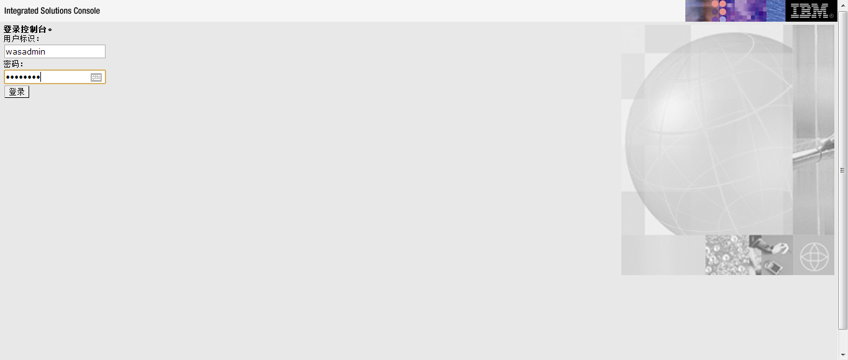

进入WebSphere管理控制台

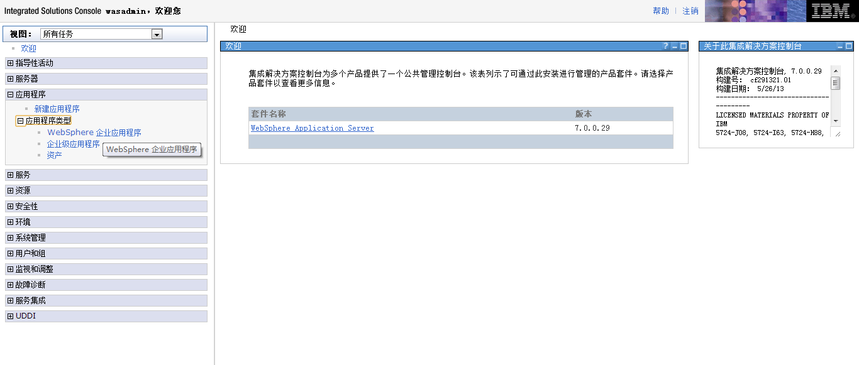

选择应用程序安装 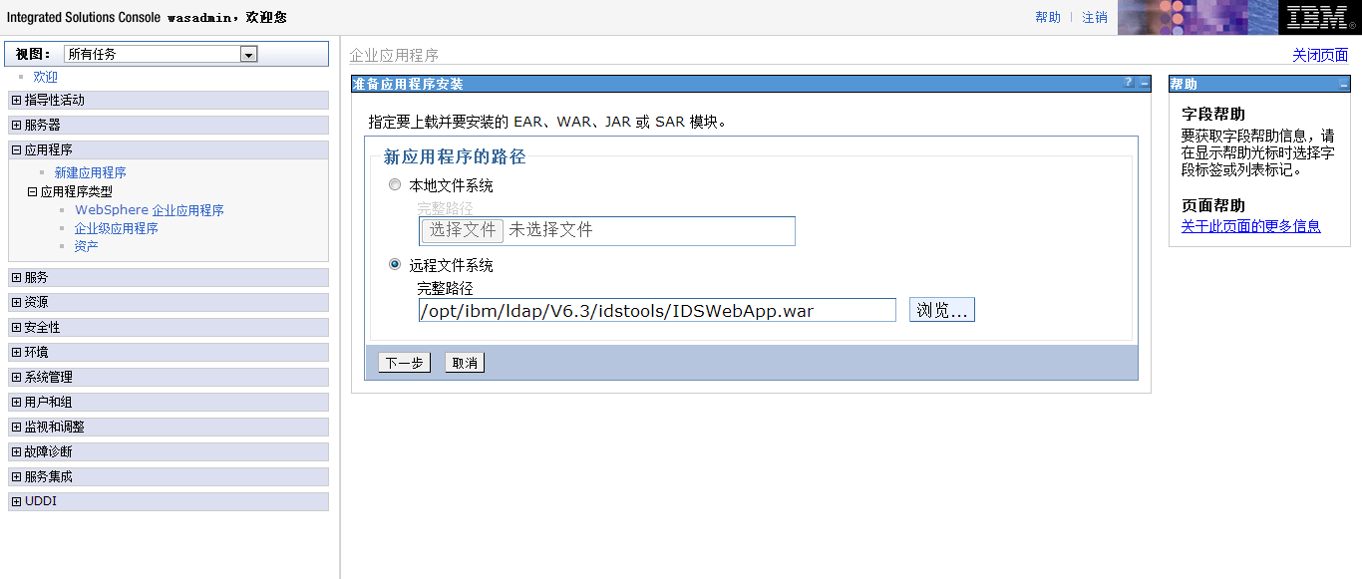

选择被安装程序的路径 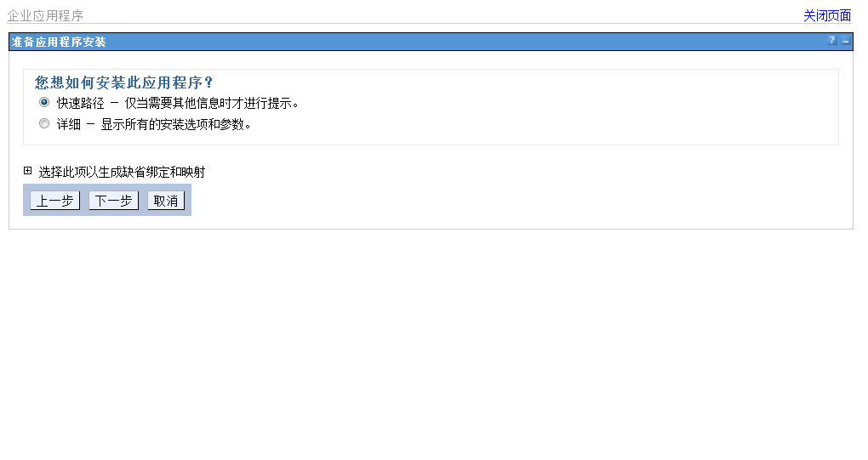

选择下一步 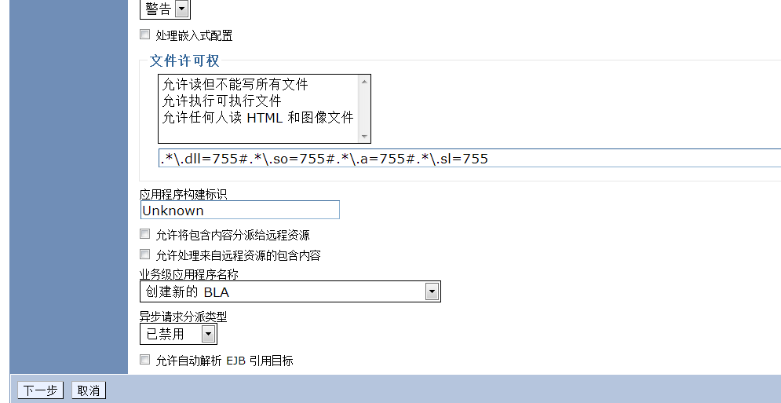

选择下一步安装 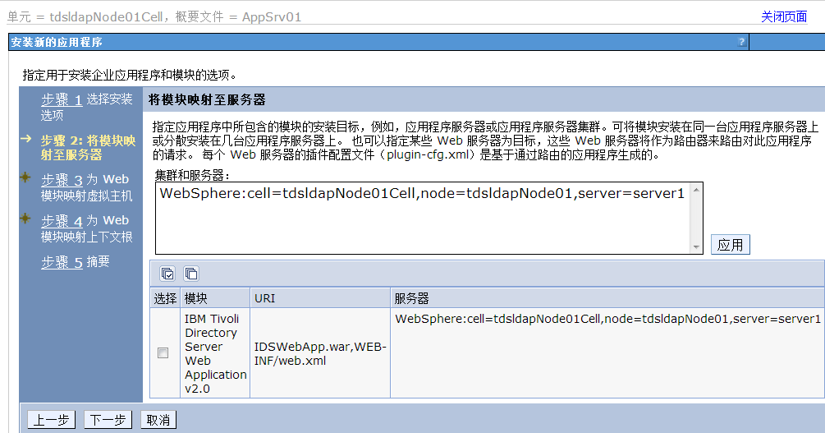

选择被安装的服务器

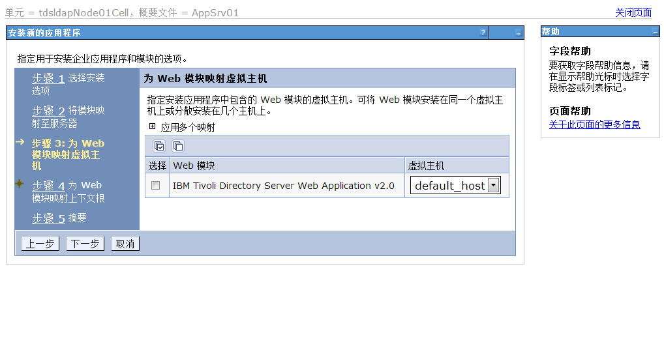

选择安装程序的虚拟主机 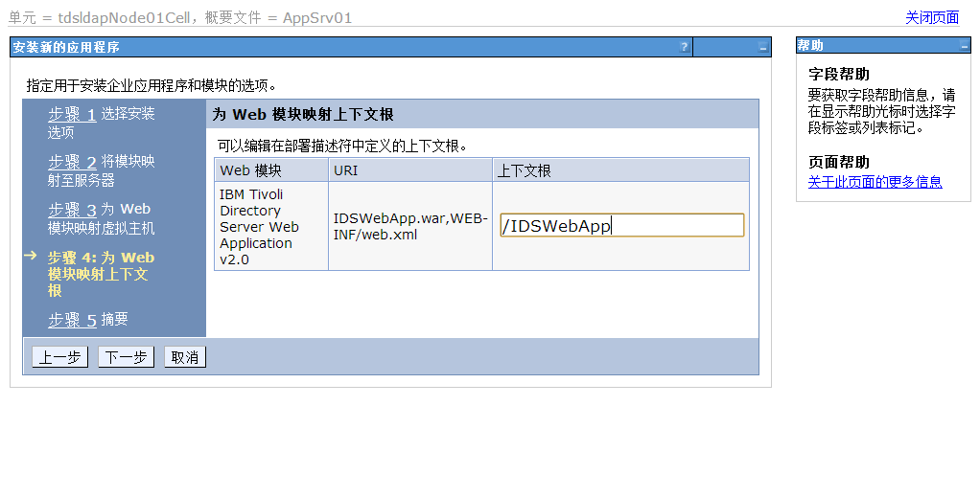 选择被安装主机的上下文根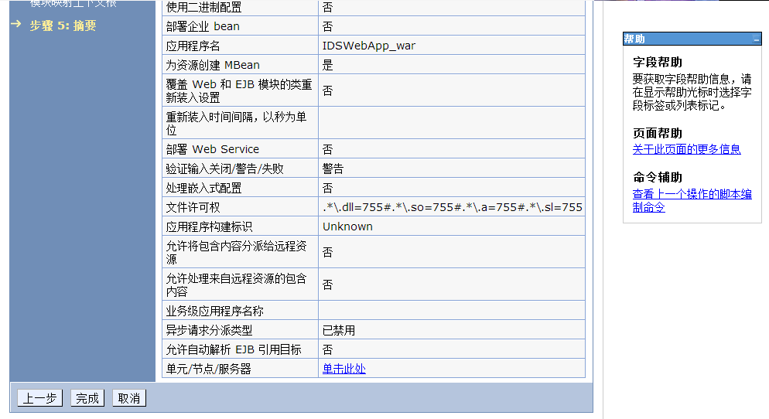

选择安装完成 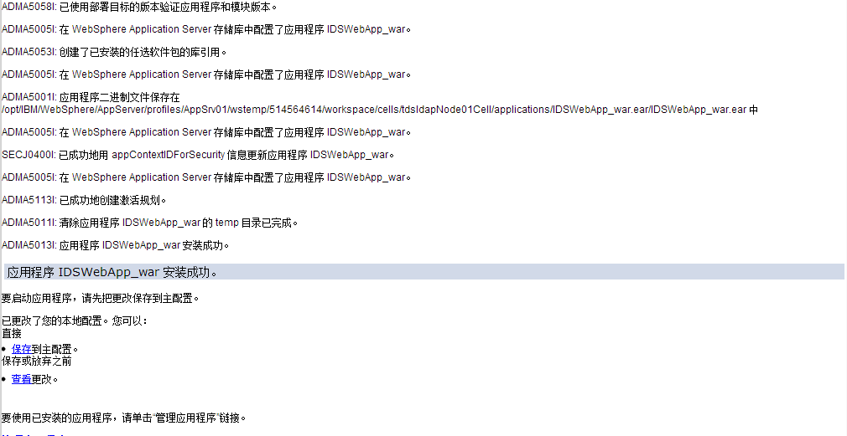

保存安装文档 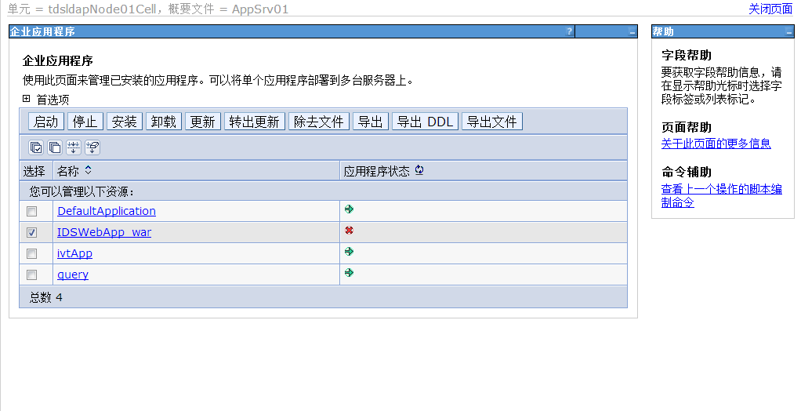

启动安装程序 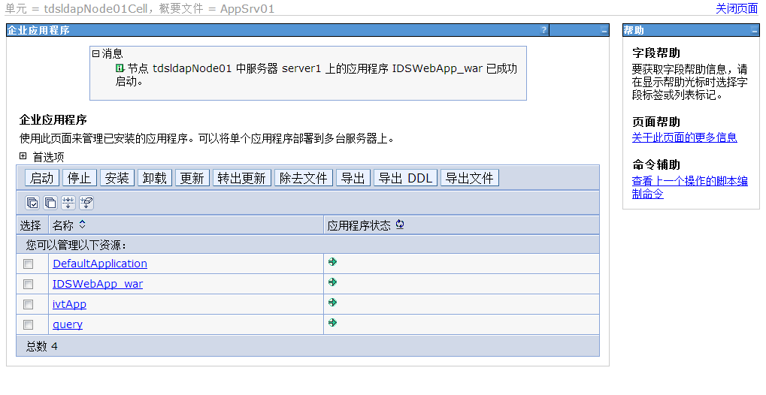

启动完成

## 创建TDS实例

/opt/IBM/ldap/V6.3/sbin

./idsxinst

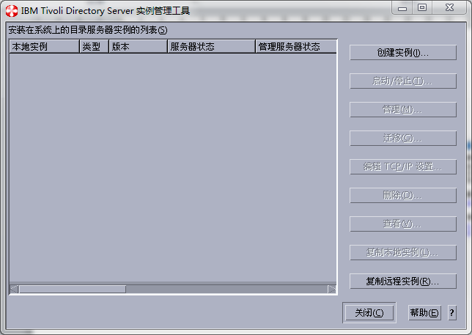

打开实例创建器

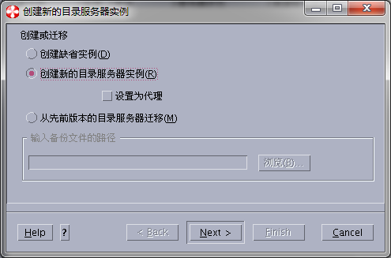

创建新的LDPA

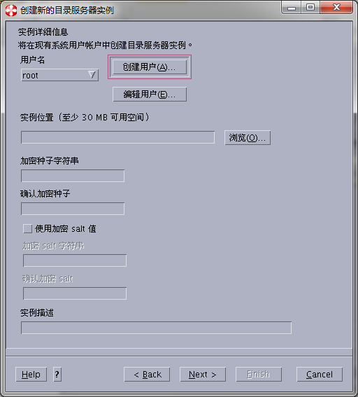

创建实例用户

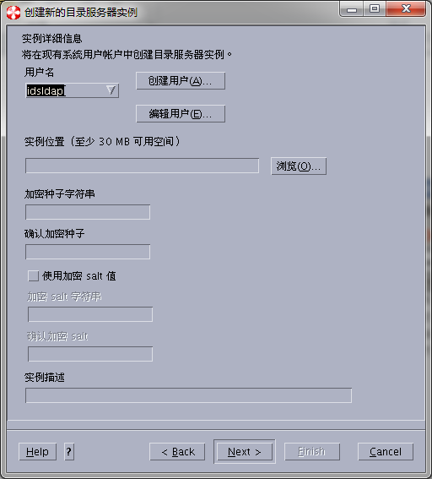

创建用户idsldap

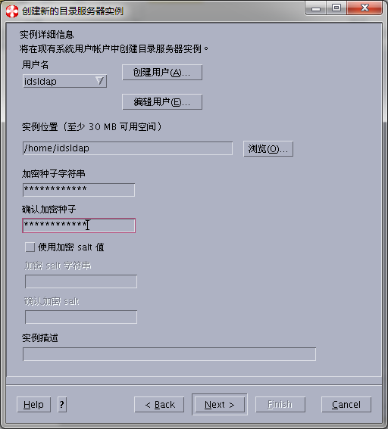

输入种子字符串加密(qwertyuiopasdf)

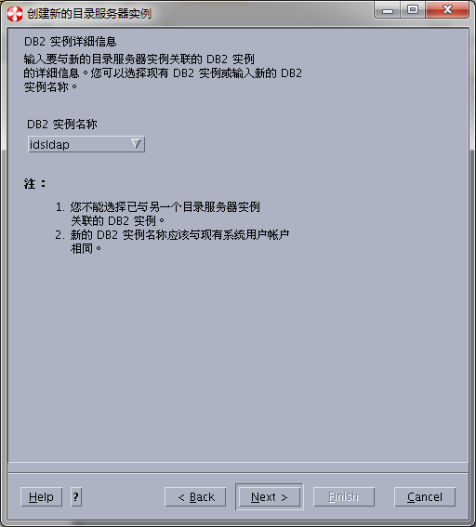

选择需要关联的实例信息

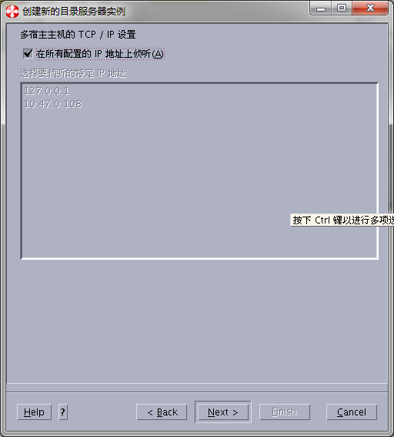

配置监听

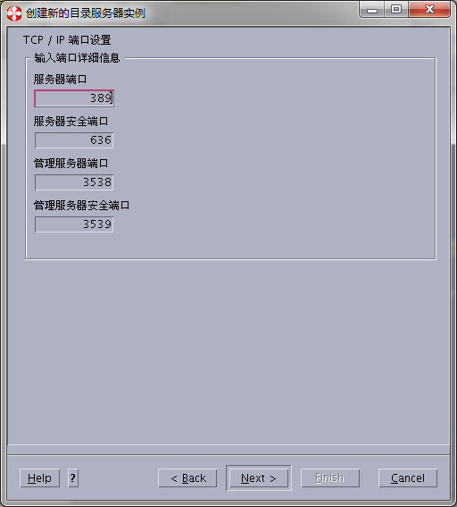

配置被监听的端口信息

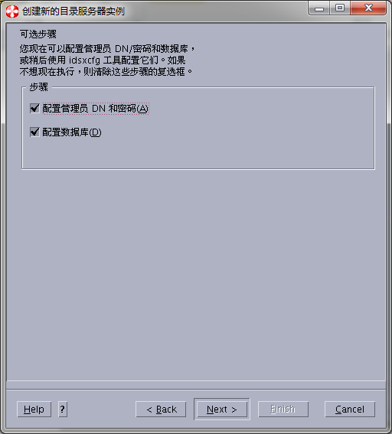

配置数据库和管理员id和密码

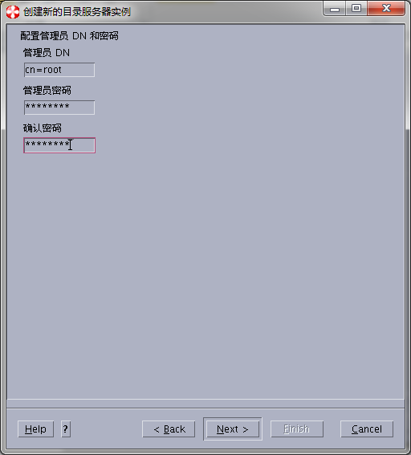

输入密码

[root@tdsldap ~]# passwd idsldap

Changing password for user idsldap.

New UNIX password:

Retype new UNIX password:

passwd: all authentication tokens updated successfully.

[root@tdsldap ~]#

修改该用户的操作系统

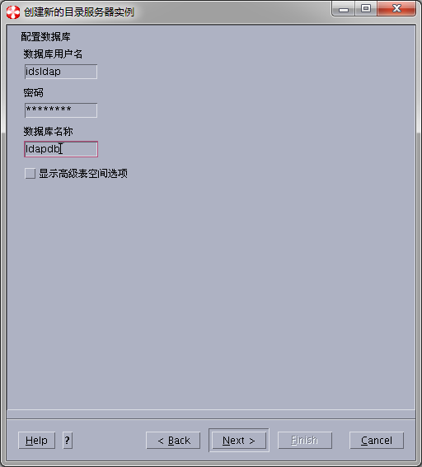

配置实例下面的数据库

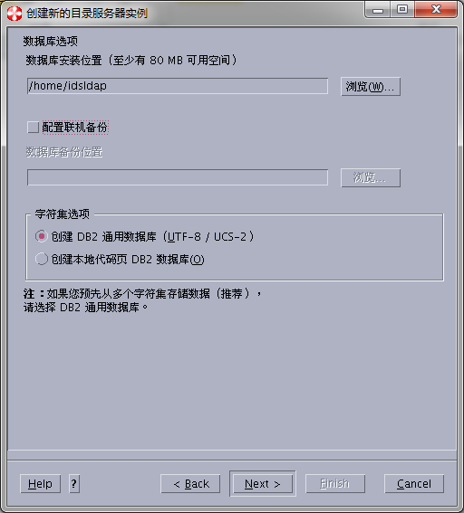

选择数据库的代码页

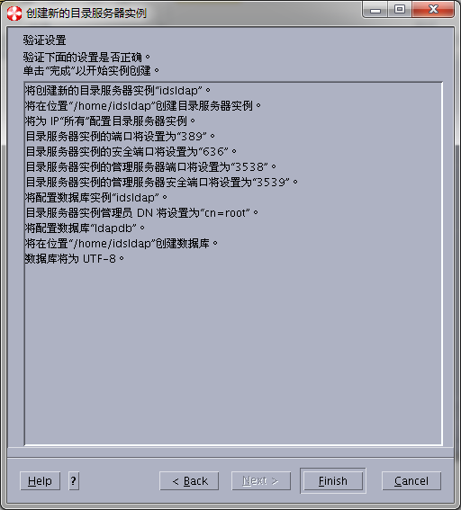

创建数据库

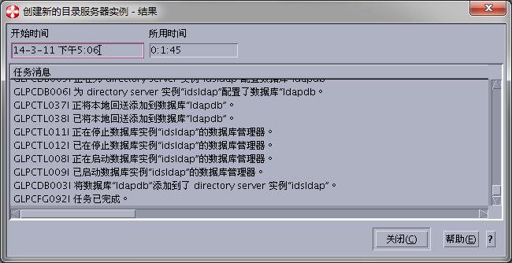

创建完成

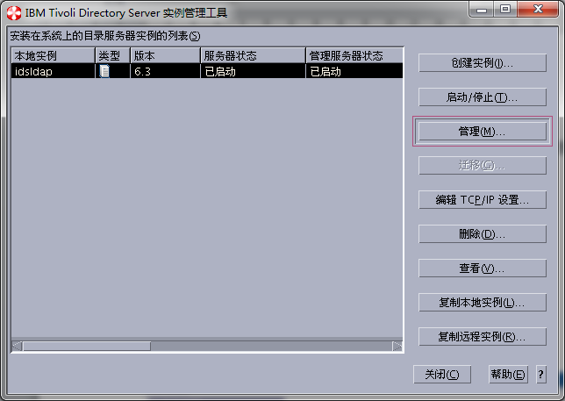

启动实例 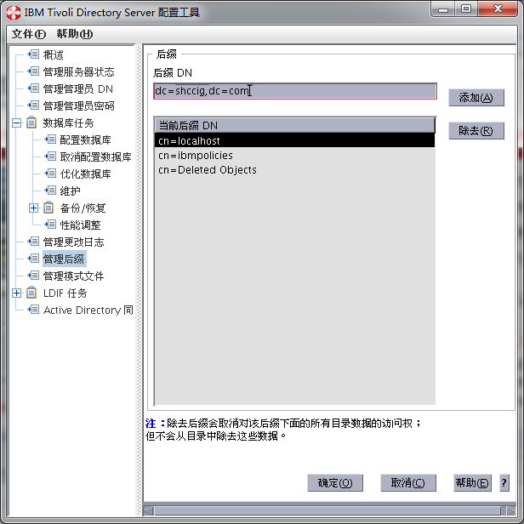

添加陕煤化后缀 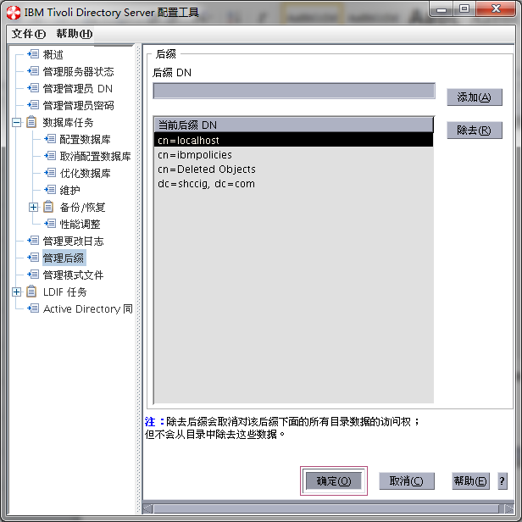 点击确定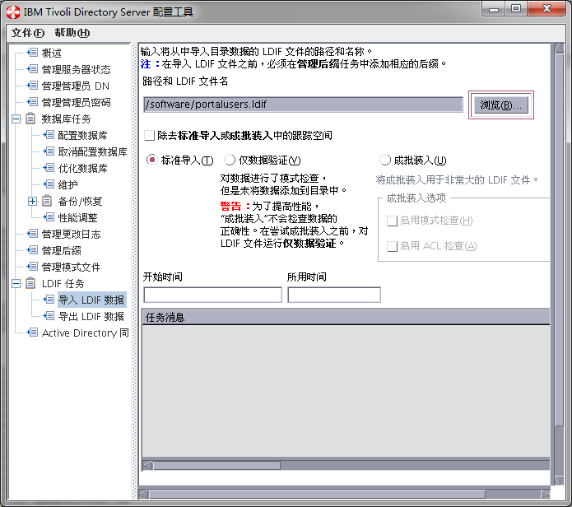

选择导入初始的ldap用户信息的文件

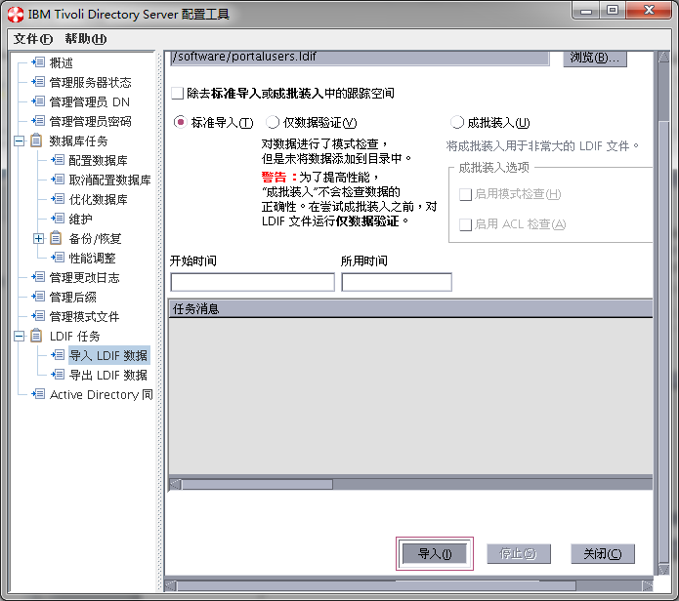

开始导入

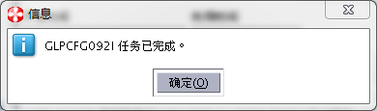

导入完成

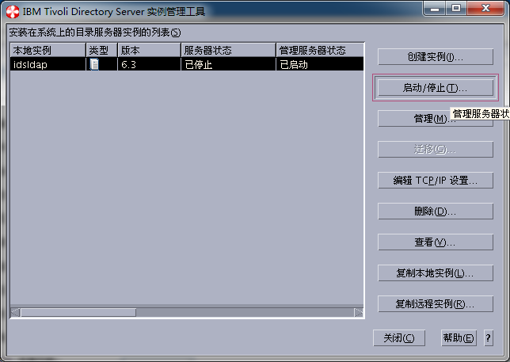

回到管理界面

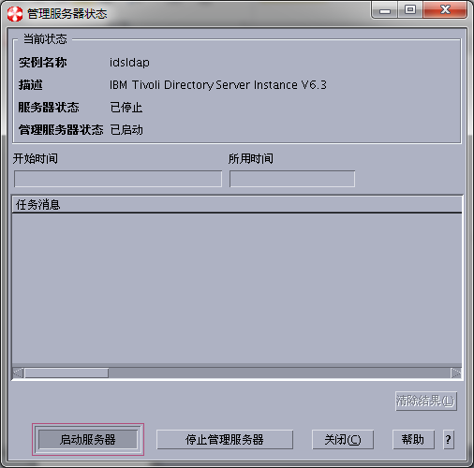

启动服务器

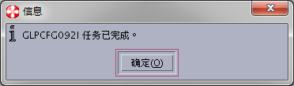

导入任务完成

<http://10.47.0.108:9080/IDSWebApp> (superadmin/secret)

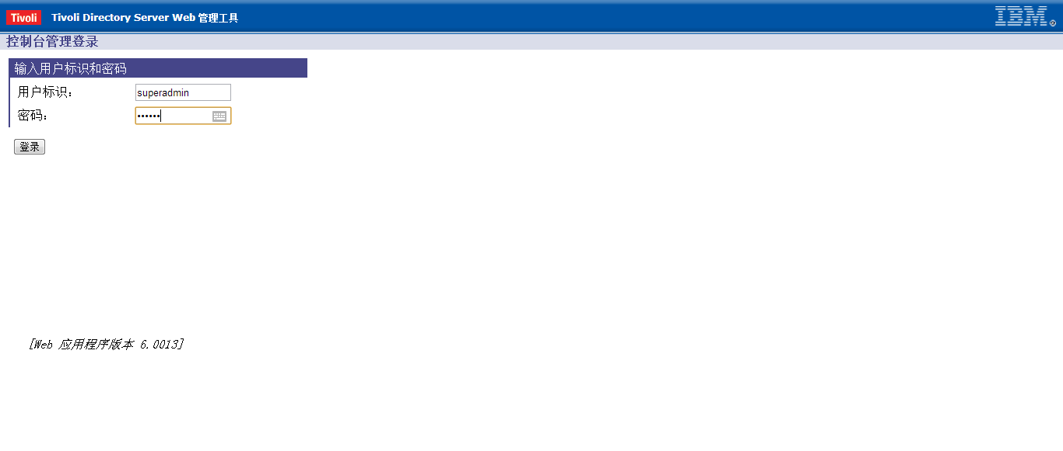

打开Web管理控制台登录页面，输入用户和密码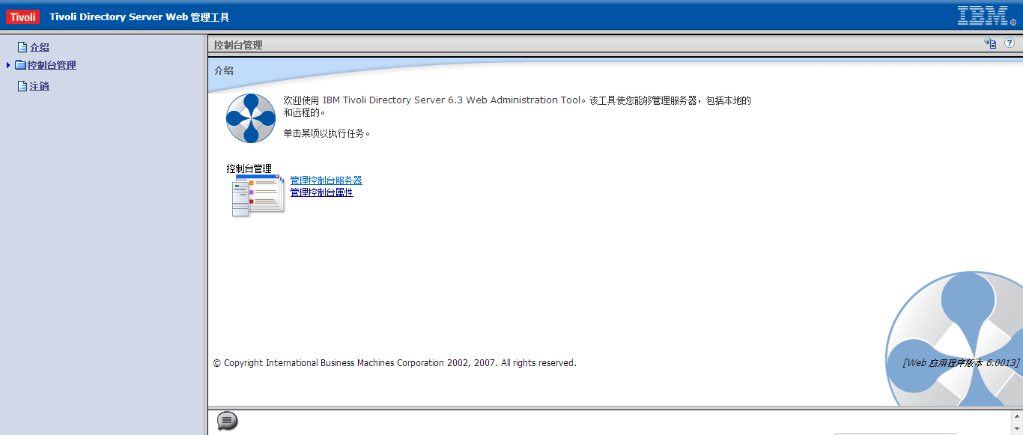进入Web管理控制台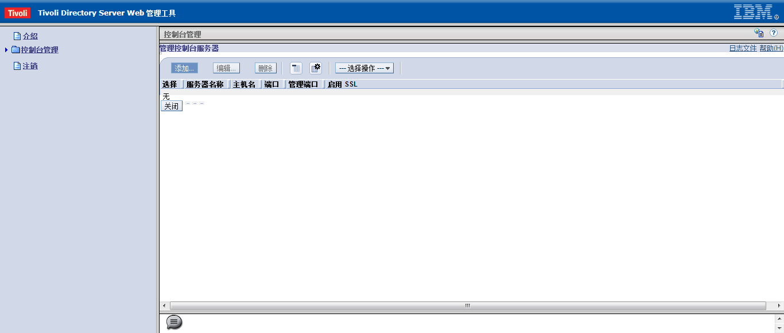

添加ldap的连接信息 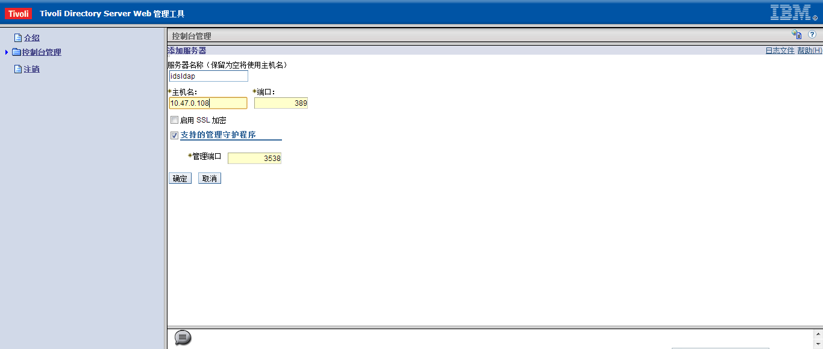

添加ldap的IP和端口号 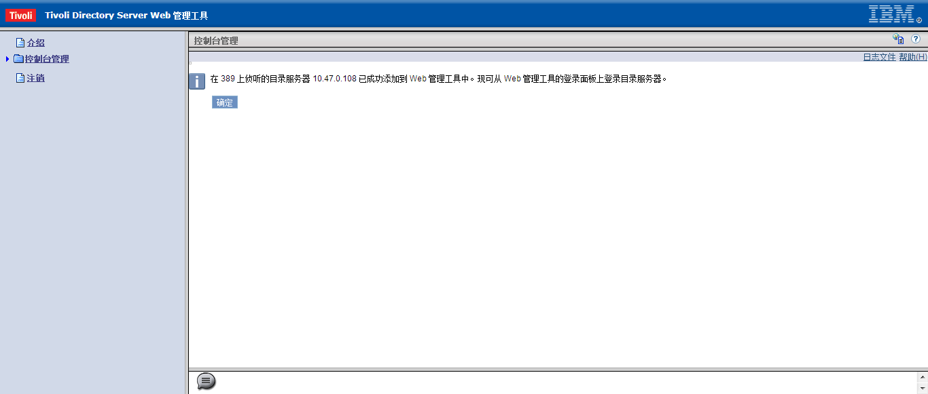

添加成功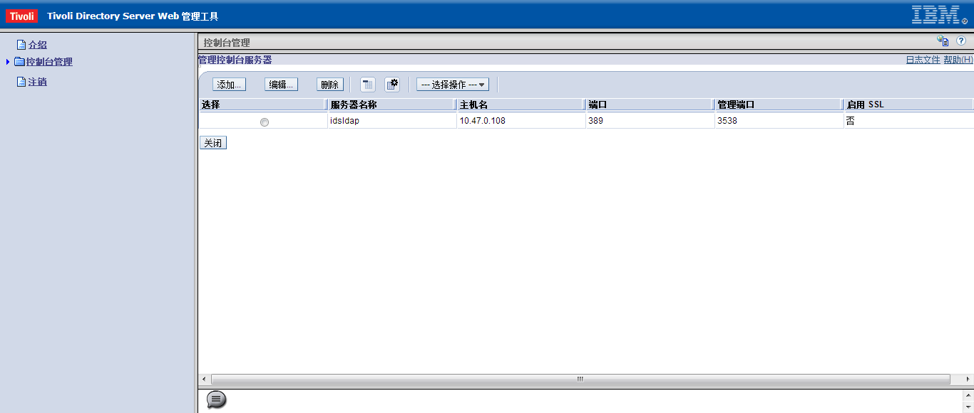

检查添加结果 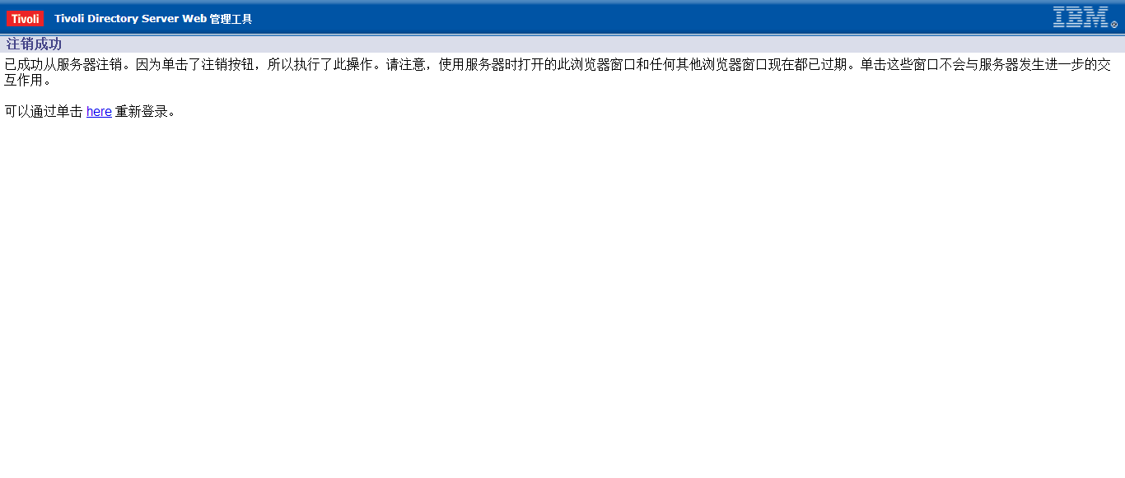

注销管理用户 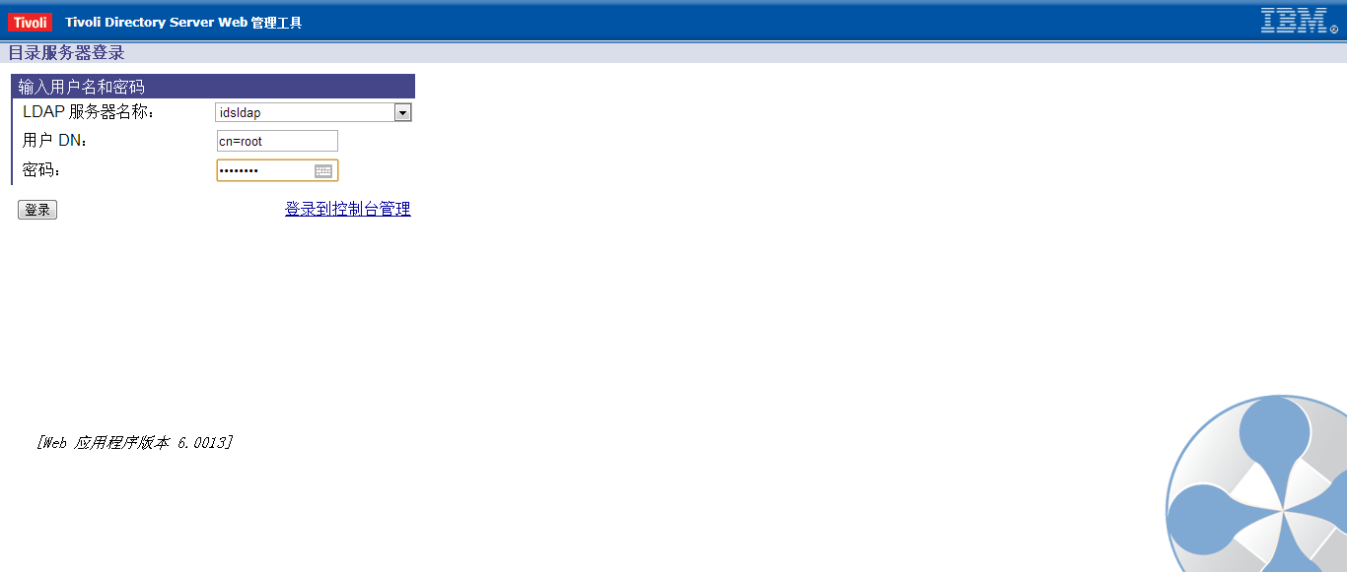

使用ldap的管理登录

## TDI的安装

cd /software/tdi7.1/linux_x86_64

./install_tdiv71_linux_x86_64.bin

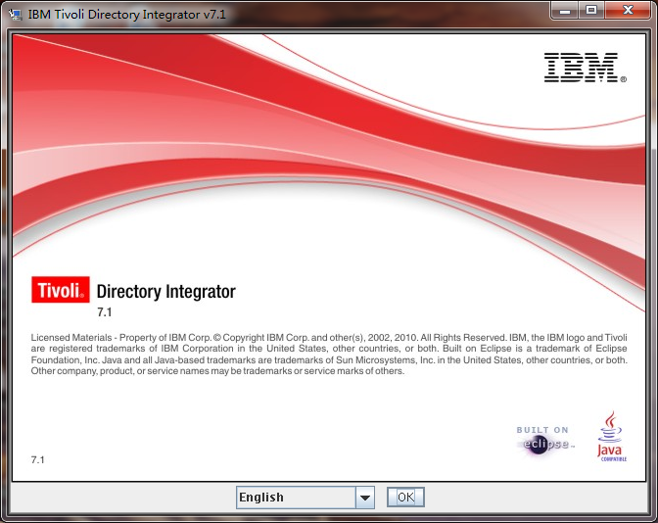

启动TDI的安装

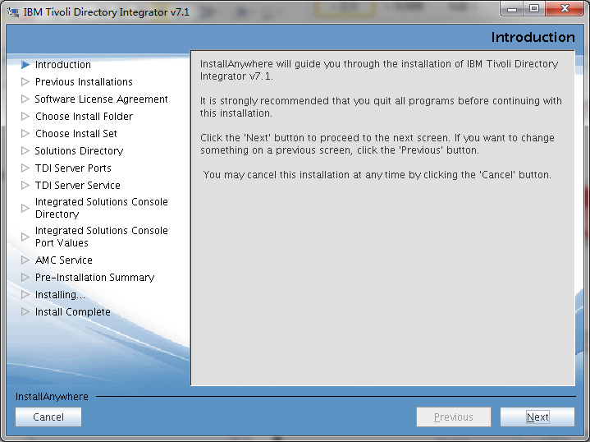

选择下一步

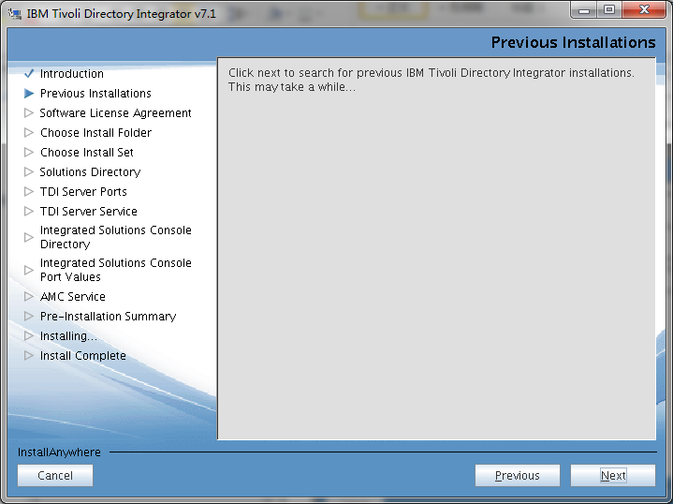

准备安装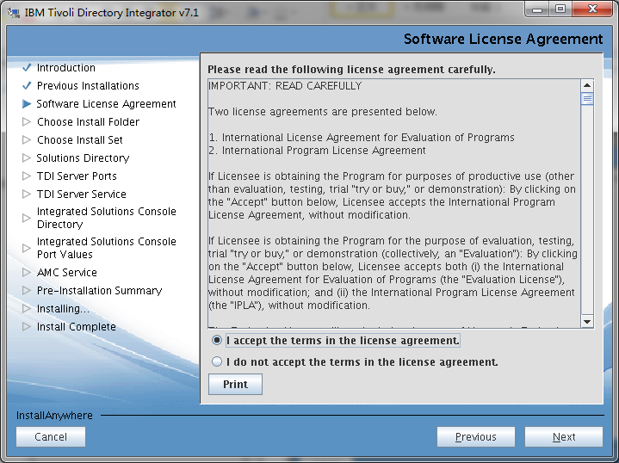

接受安装协议

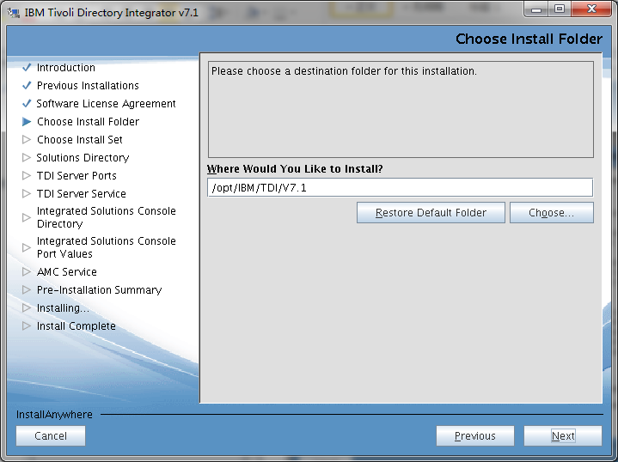

选择安装目录

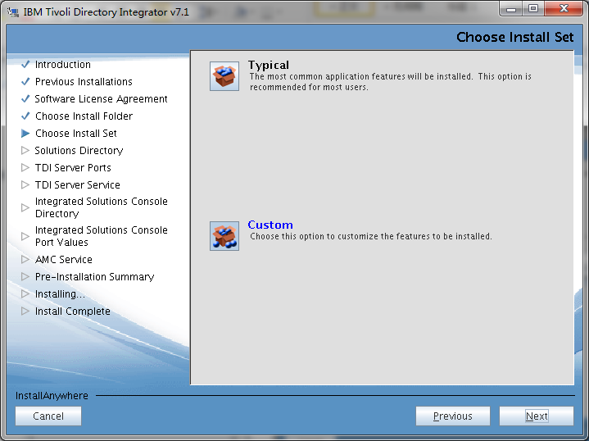

选择定制安装

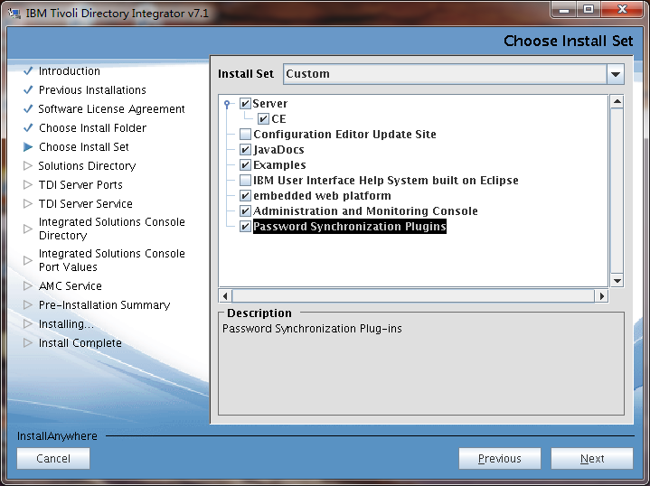

选择密码同步插件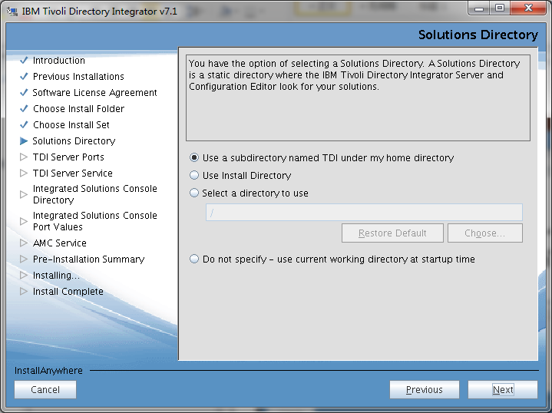

在TDI的子目录下安装解决方案

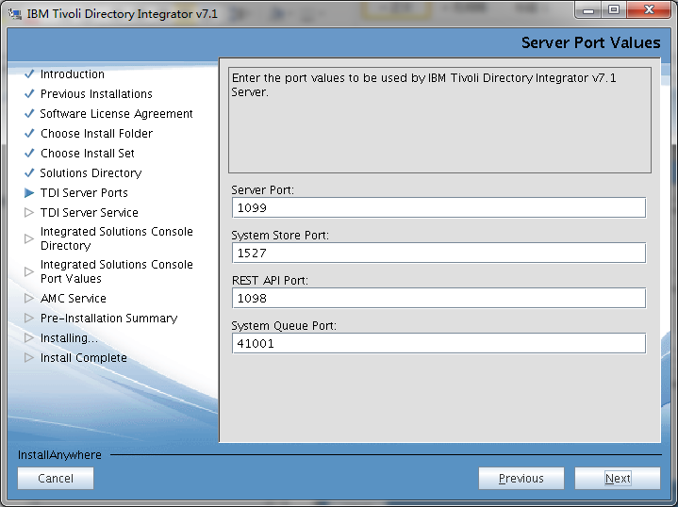

选择ＴＤＩ的端口信息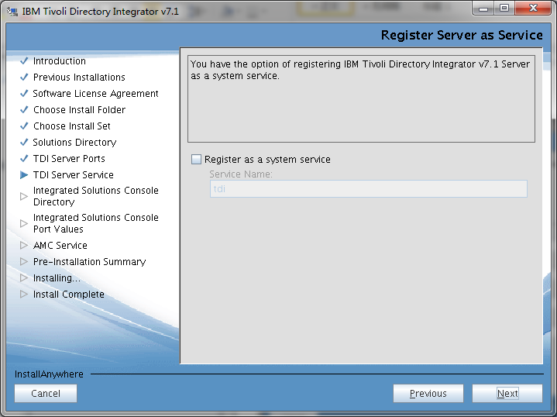

选择不注册成服务

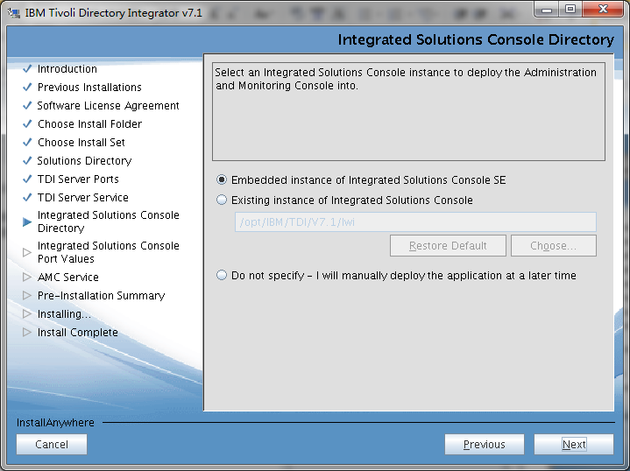

内嵌集成解决方案实例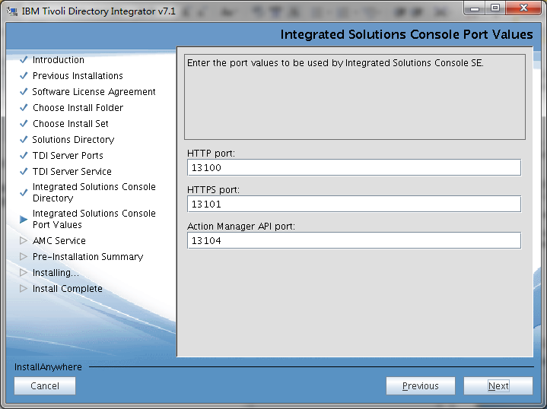

输入集成解决方案的端口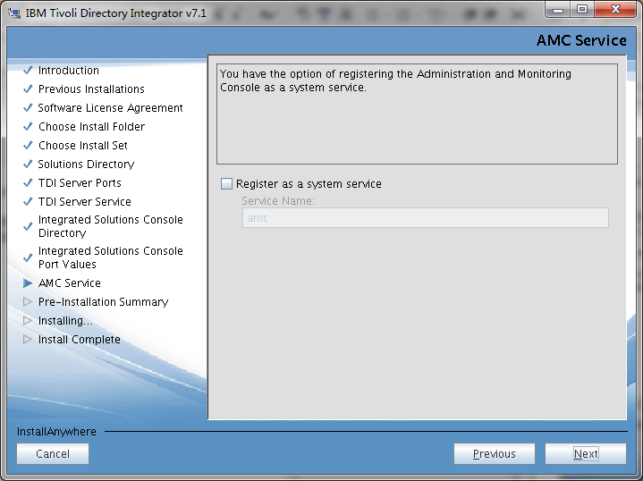

选择下一步

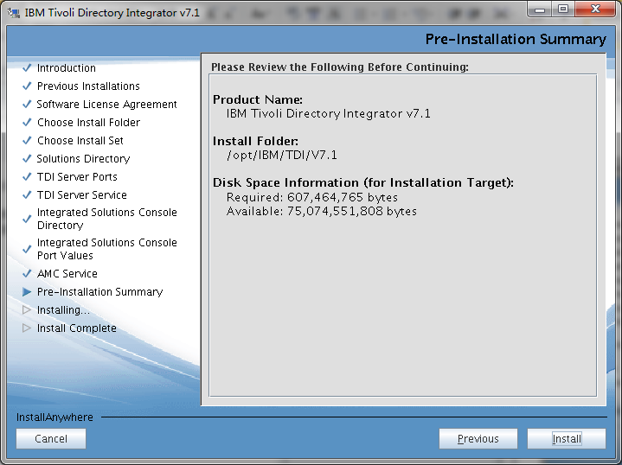

开始安装

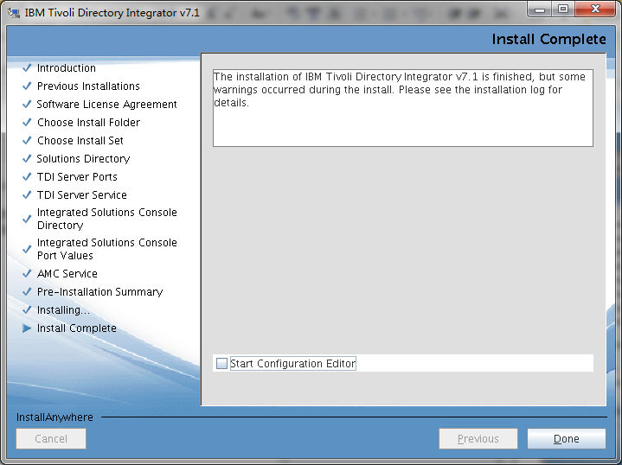

安装完成

cd /software/tdi7.1

cp vm.tar /opt/IBM/TDI/V7.1

tar xvf vm.tar

mv jvm jvm.bak

mv jre jvm

请在xmanager中运行如下命令

cd /software/tdi7.1/7.1.0-TIV-TDI-FP0007

cp applyUpdates.sh /opt/IBM/TDI/V7.1/bin

/opt/IBM/TDI/V7.1/bin/applyUpdates.sh -update TDI-7.1-FP0007.zip

# TIM的安装

## 安装TIM的ldap服务器

cd /software/tim

./cfg_itim_mw_xLinux

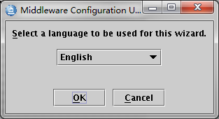 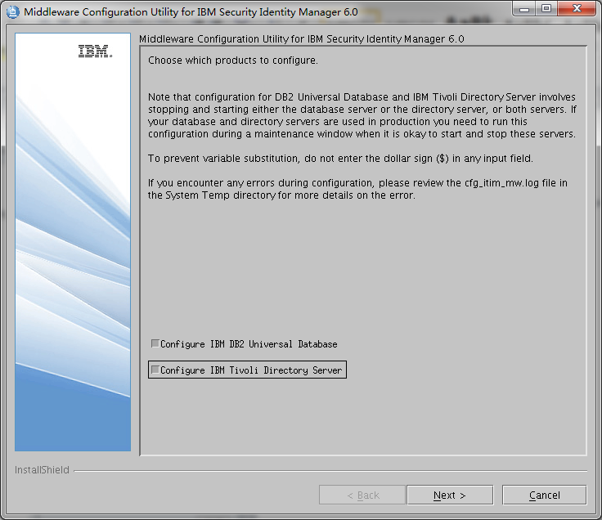 注意两个都要分别选择，否则就出现不了下面两个图。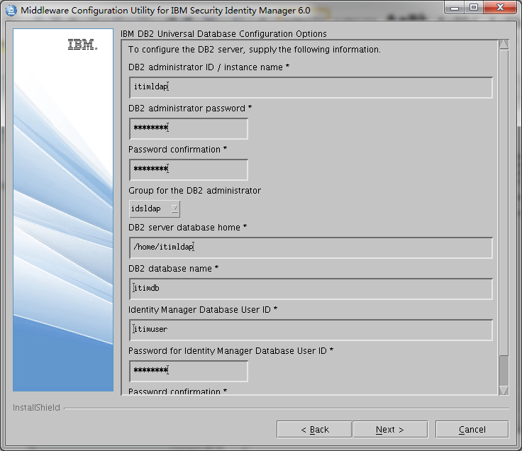

输入ITIM的ldap的配置信息（密码统一为p@55w0rd）

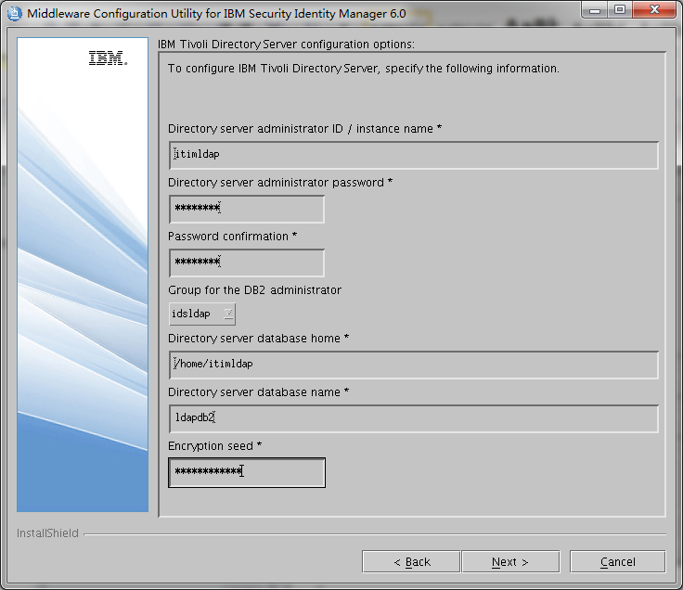

输入加密种子(qwertyuiopas)

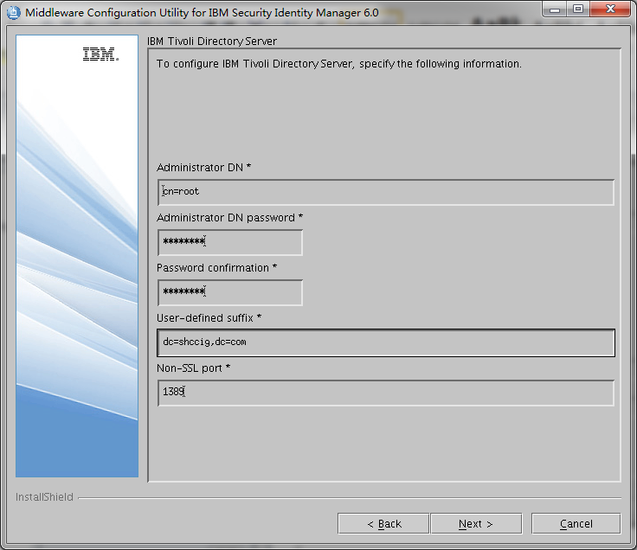

输入管理用户的密码（p@55w0rd） 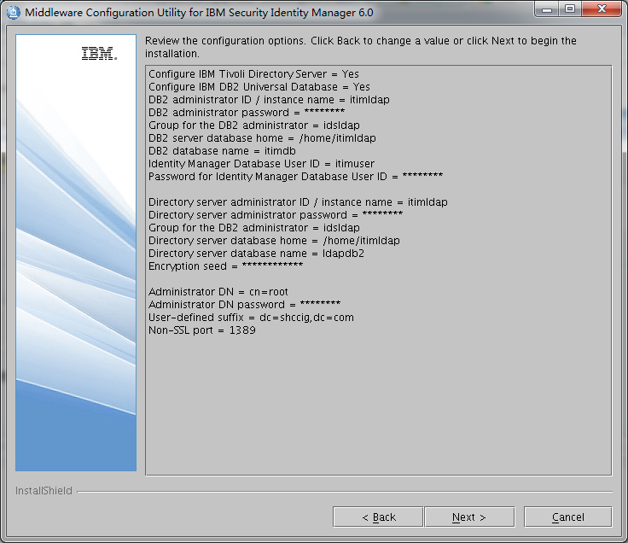

点击下一步 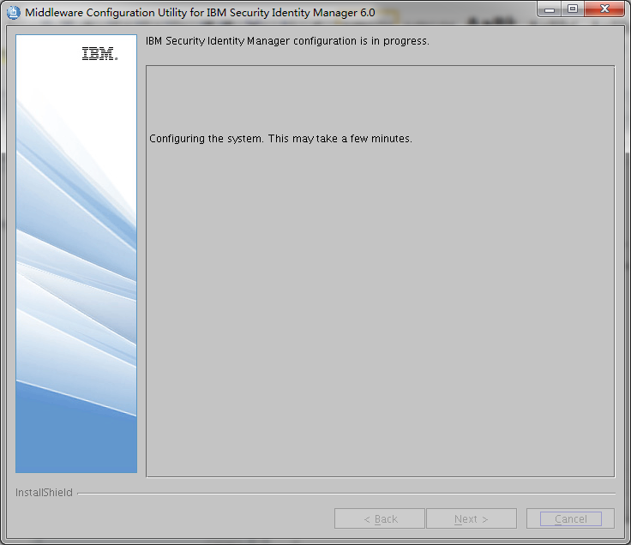

正在配置中 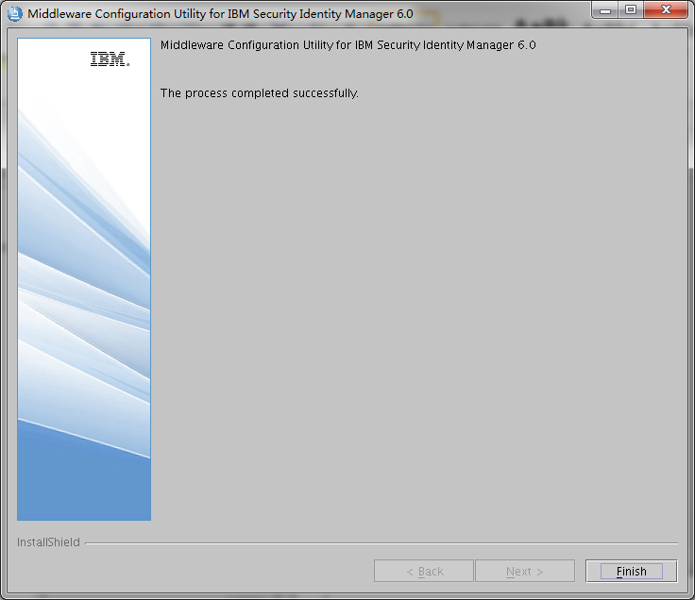

配置完成

## 安装SIM软件

cd /software/tim/itim

./instlinux.bin

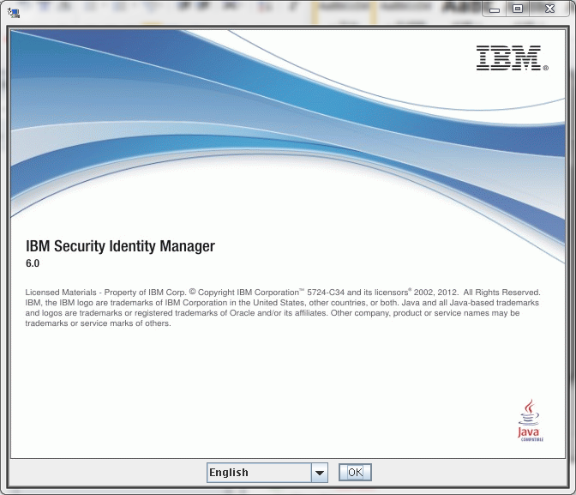

打开安装界面 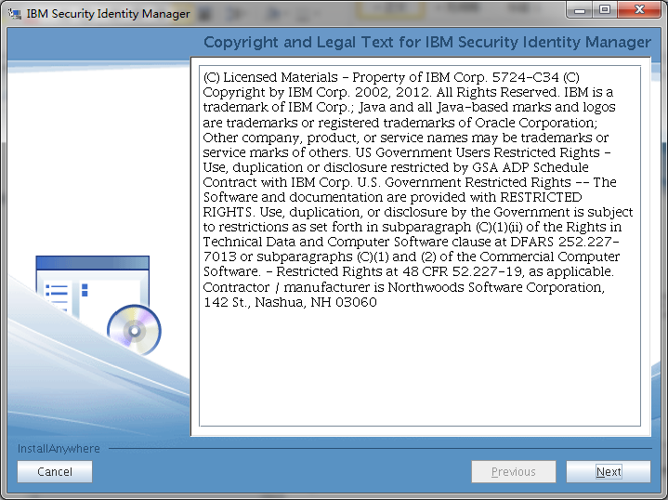

显示法律条文 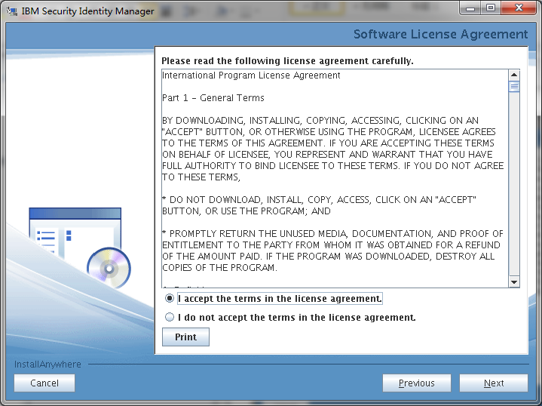

接受协议 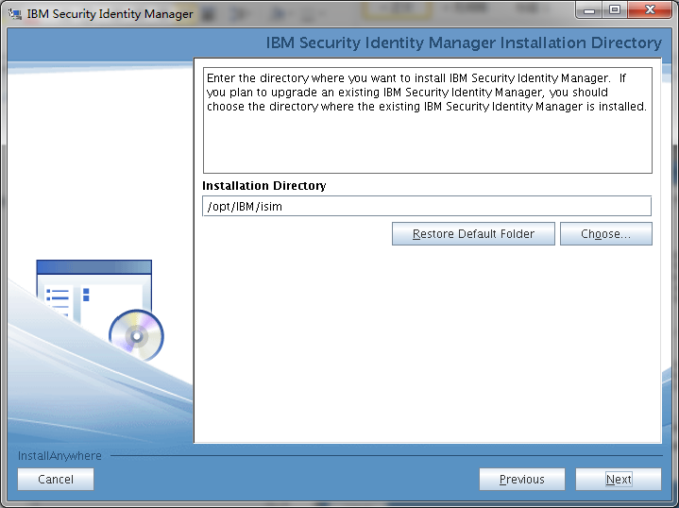 选择安装路径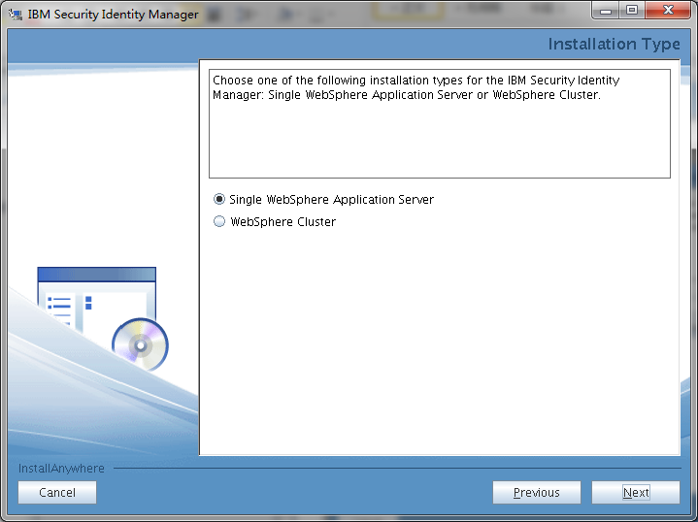

选择安装的应用服务器类型 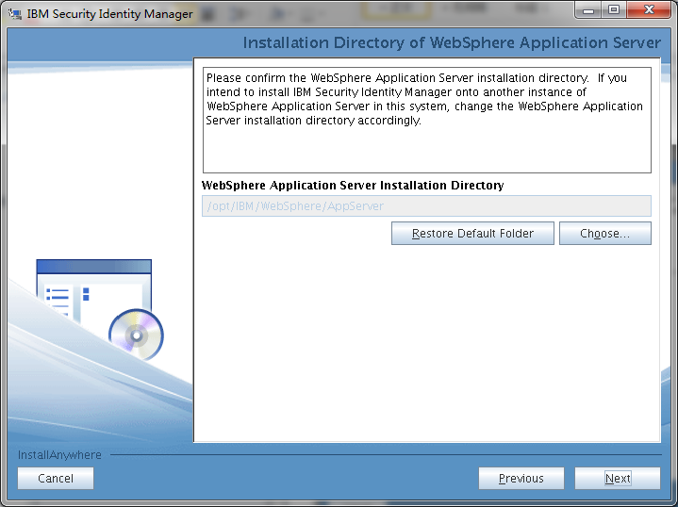 选择web控制台的路径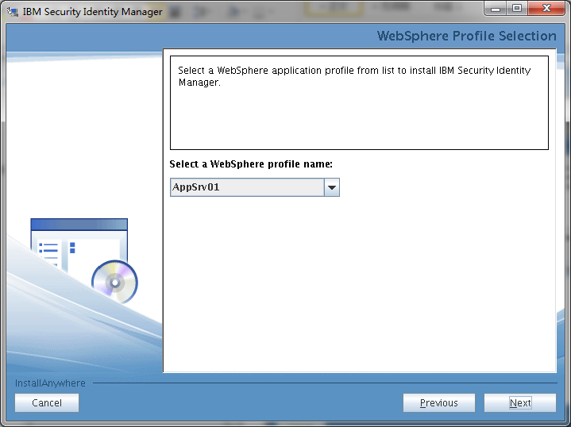

选择应用服务器的porfile

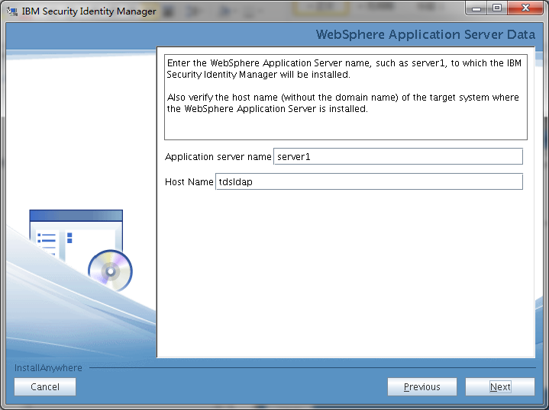

选择应用服务器的server 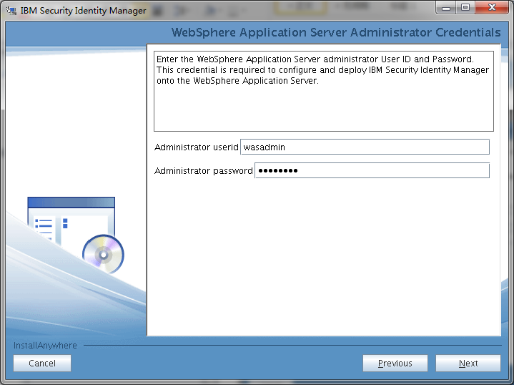

输入该server的管理用户和密码 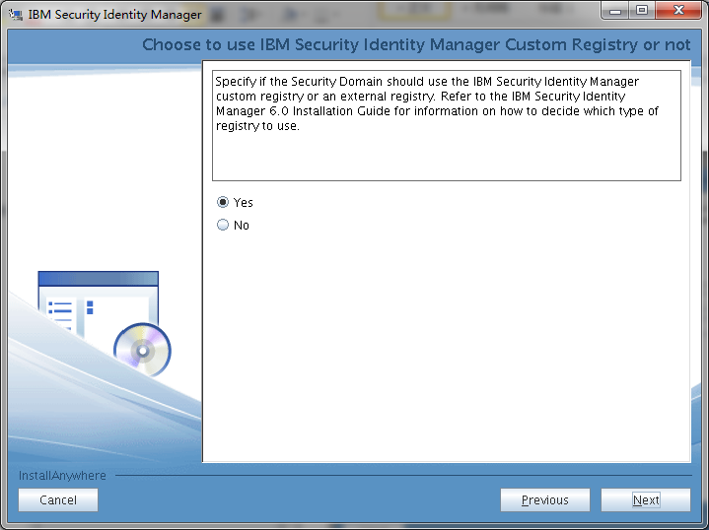

客户化安全性 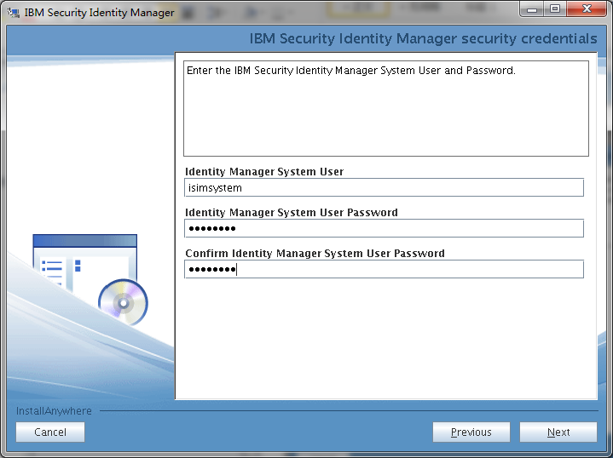 输入ITIM的系统管理用户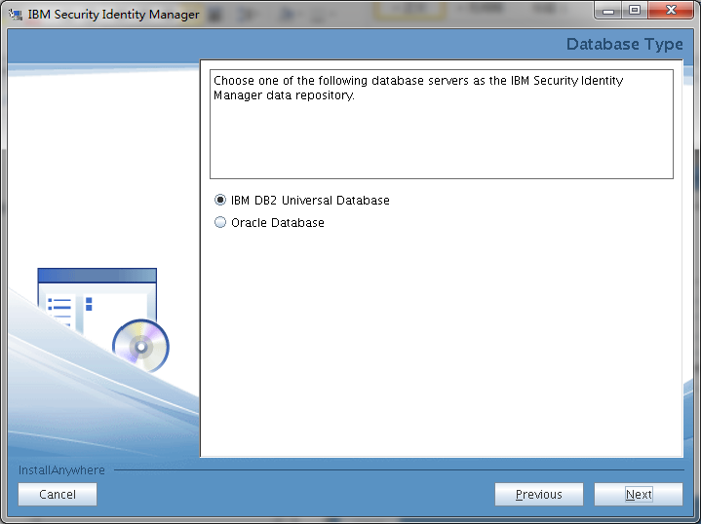

选择所用的数据库

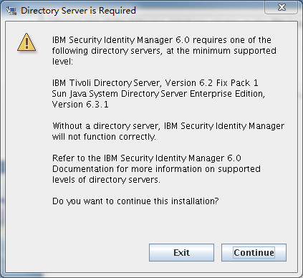

继续安装

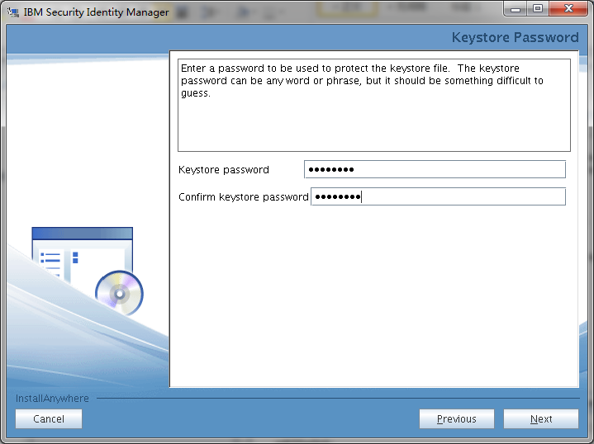

加密种子信息

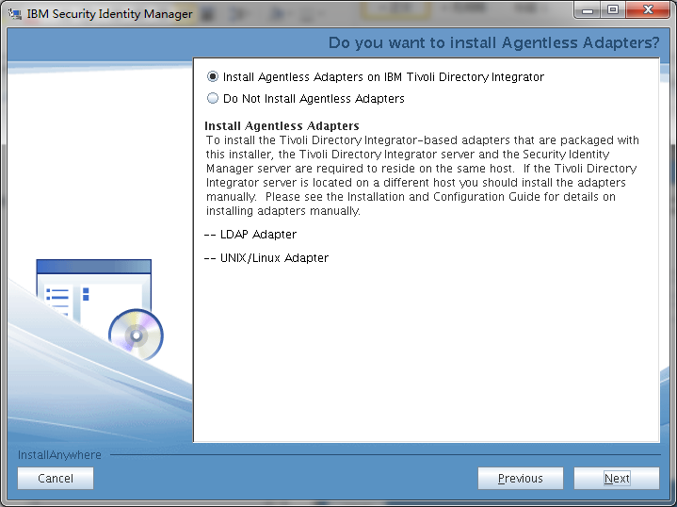

安装TDI的adpater 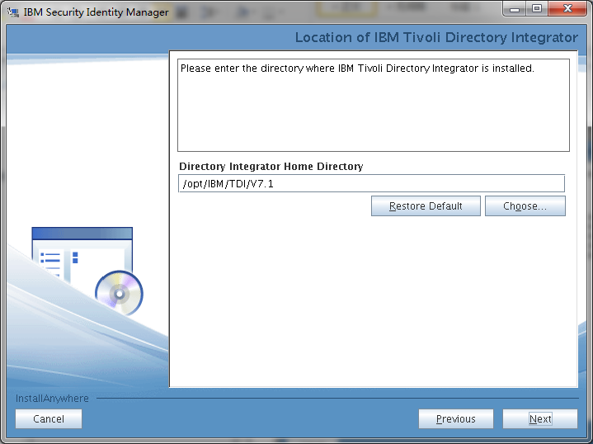 安装ＴＤＩ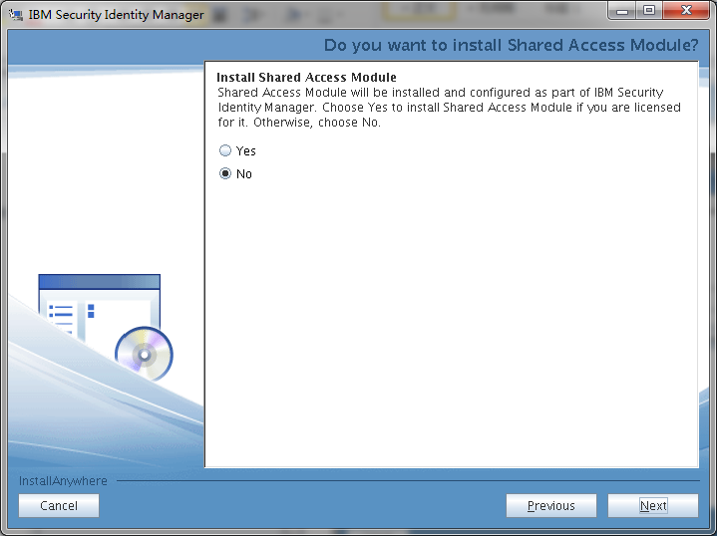

不安装共享的访问模块 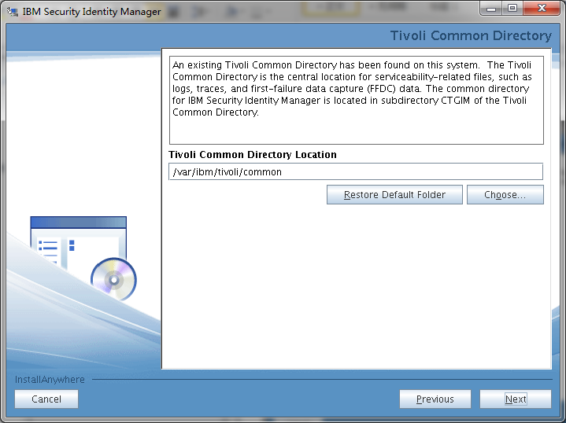

重写tivoli的common模块 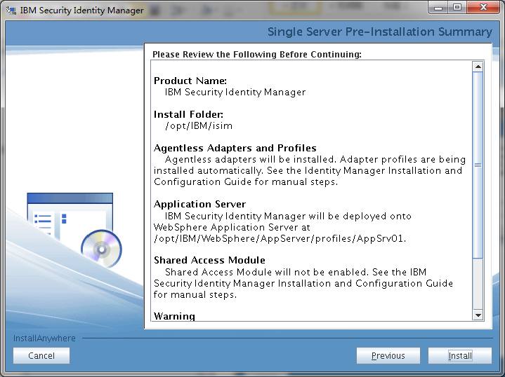

开始安装 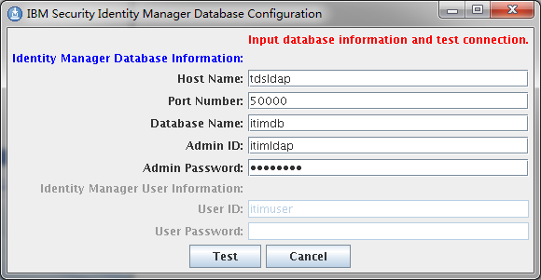

确认连接的ITIM的ldap信息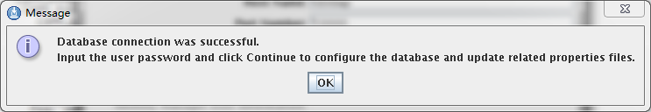 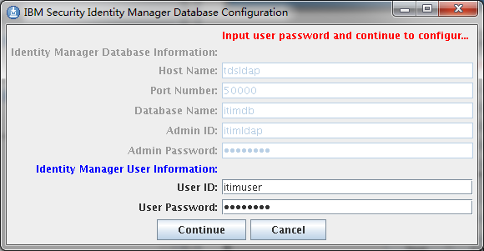

使用itimuser测试连接

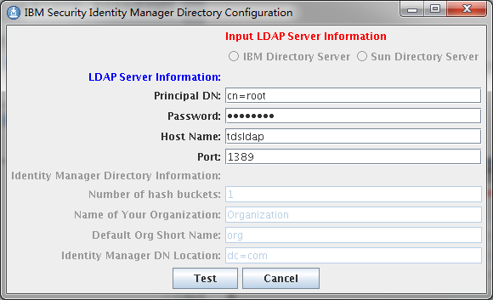

使用管理用户测试连接

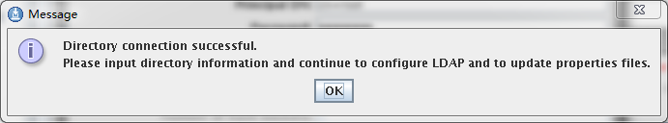 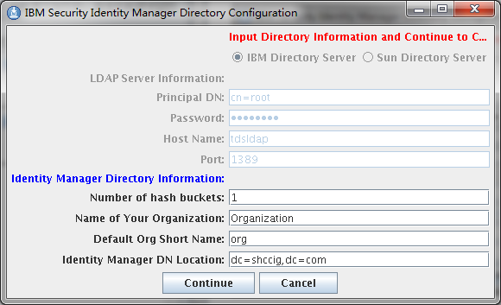

输入组织机构信息 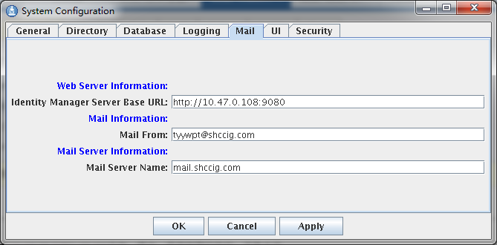

访问邮件信息 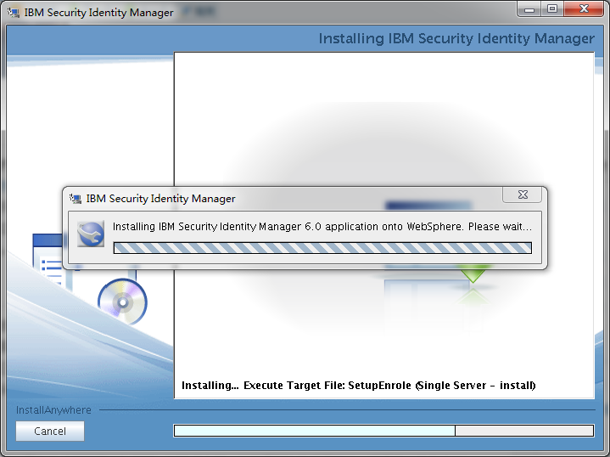

开始安装 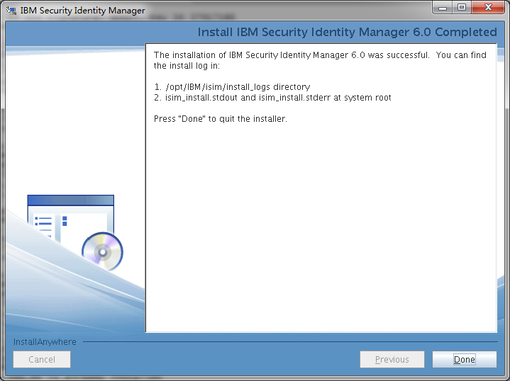

安装完成

## 安装SIM的语言包

cd /software/tim/itim

/opt/IBM/WebSphere/AppServer/java/jre/bin/java -jar itimlp_setup.jar

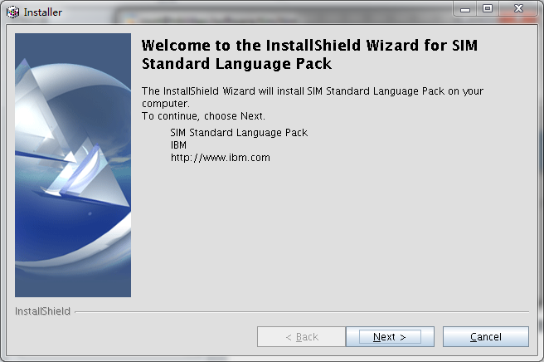

打开安装界面

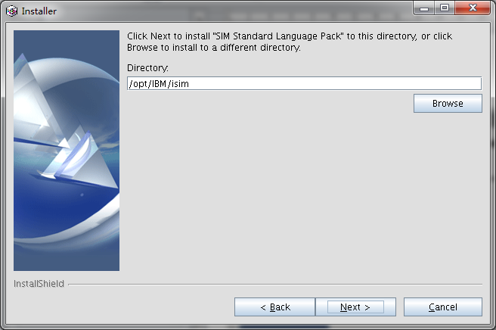

选择itim的安装路径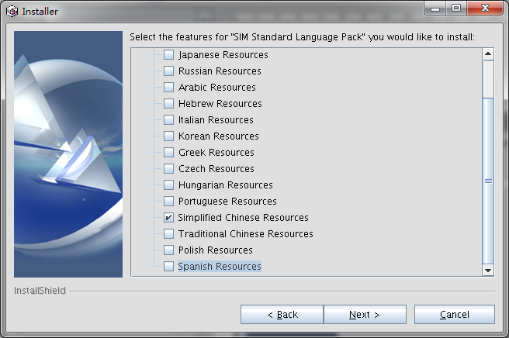

选择中文语言包

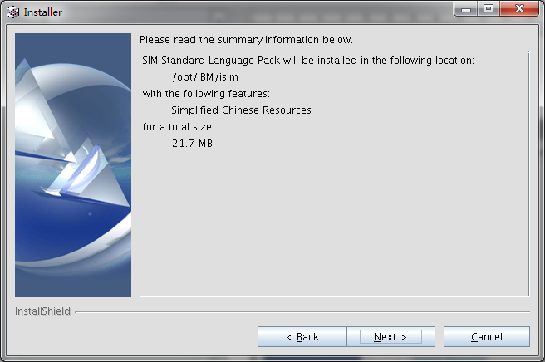

开始安装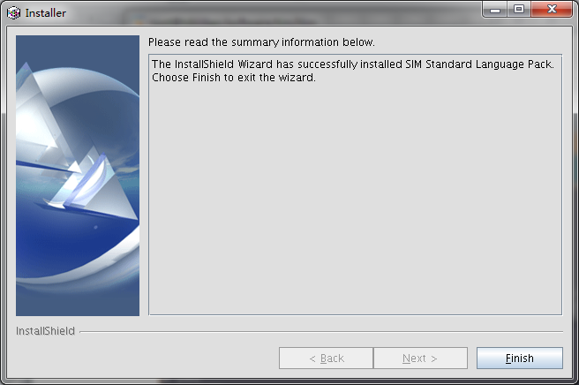

安装完成

## 安装SIM的补丁

cd /opt/IBM/WebSphere/UpdateInstaller

./update.sh

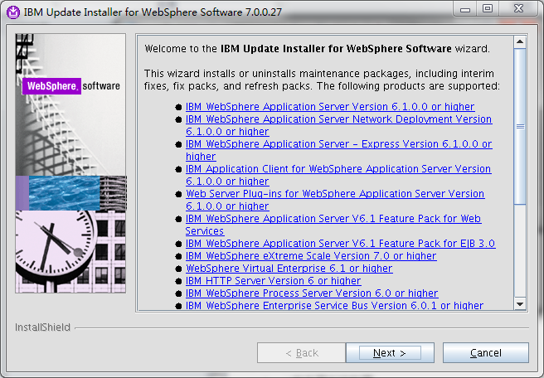

打开软件安装程序安装包 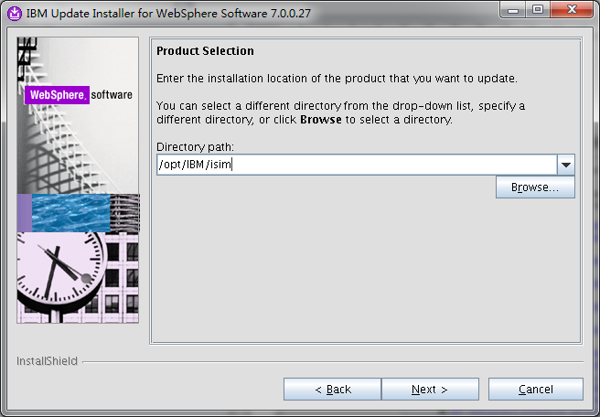

选择安装程序的安装路径 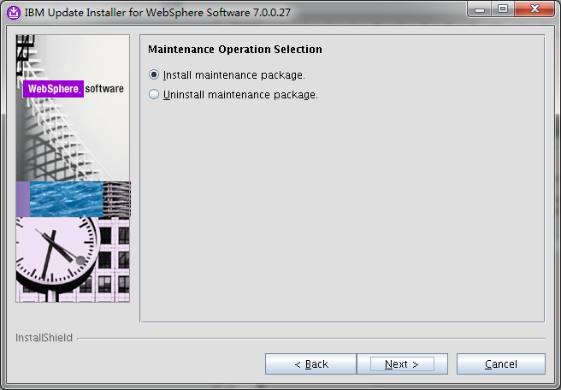 安装维护包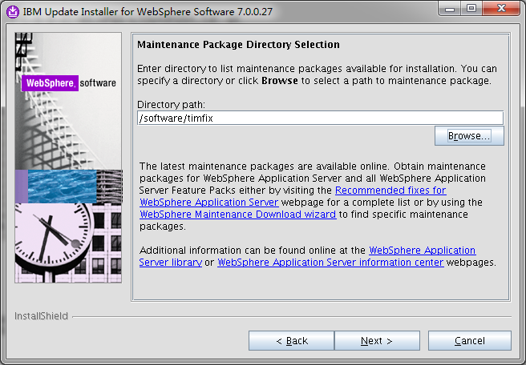

选择itim补丁的路径

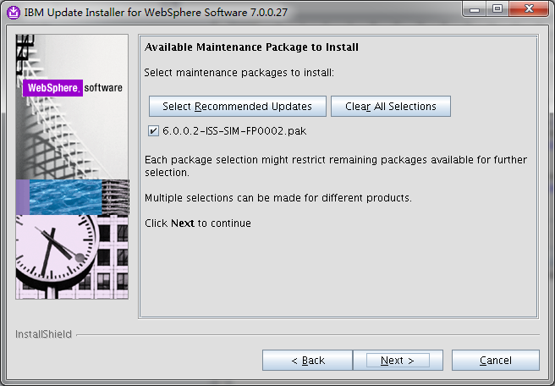 选择需要安装的补丁包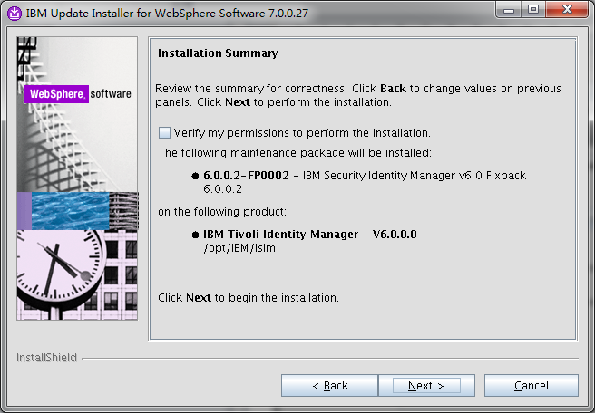

开始安装 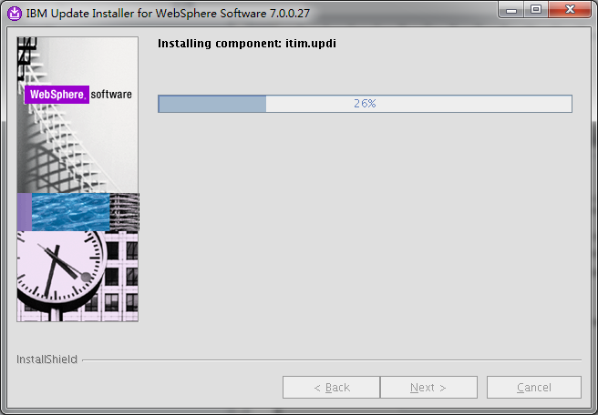

安装中 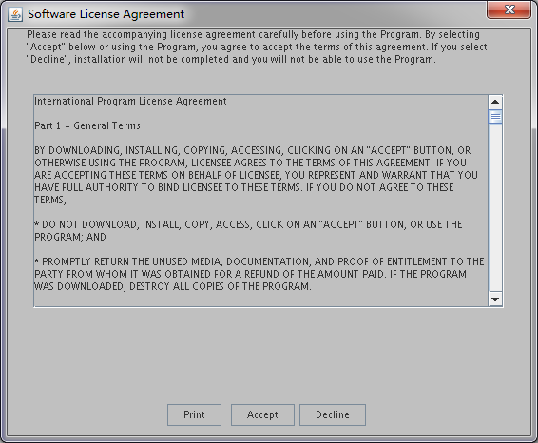

接受安装的协议 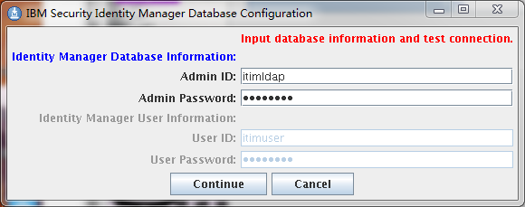

选择itim的ldap信息 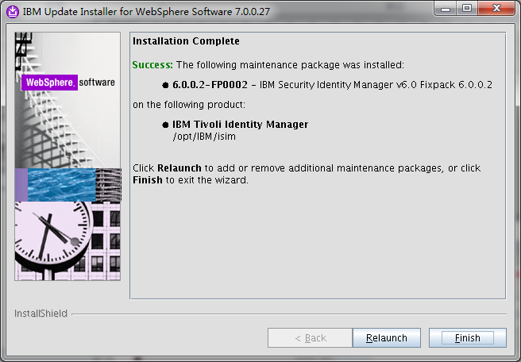

安装完成

## 安装语言包的程序

cd /software/timfix

/opt/IBM/WebSphere/AppServer/java/jre/bin/java -jar itimlp_setup.jar

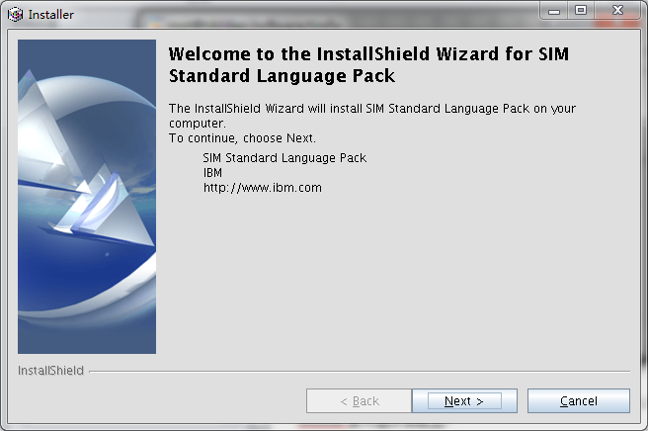

开始安装语言包的补丁

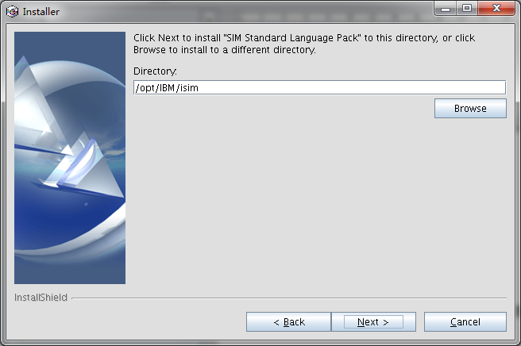

选择安装的路径

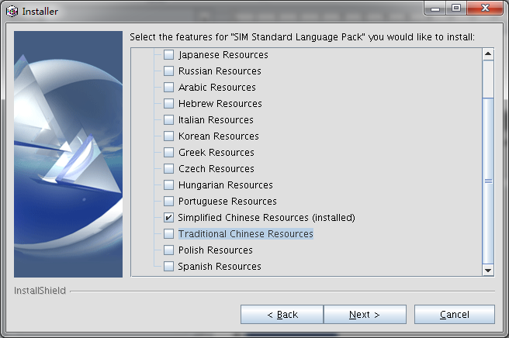

选择简体中文的安装包

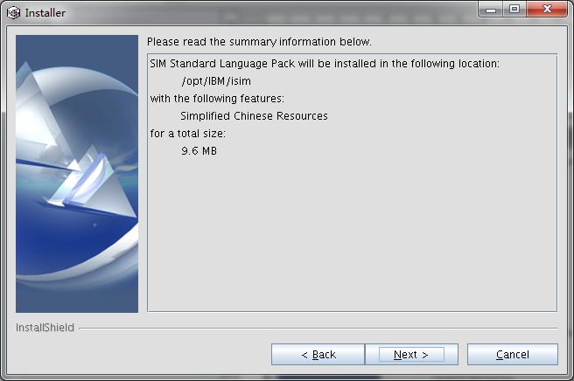

开始安装



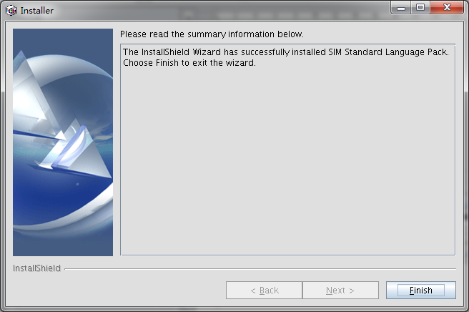

安装结束

# TAM的安装

## WebSphere的安装

参加2.2部分的was安装介绍

## IHS的安装

cd /software/ihs/IHS

./install

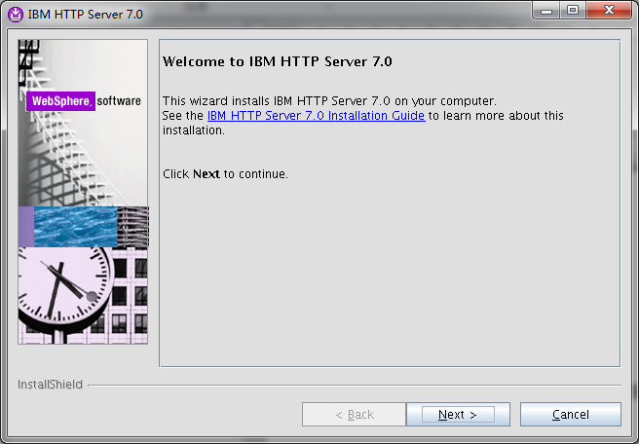

启动IHS的安装

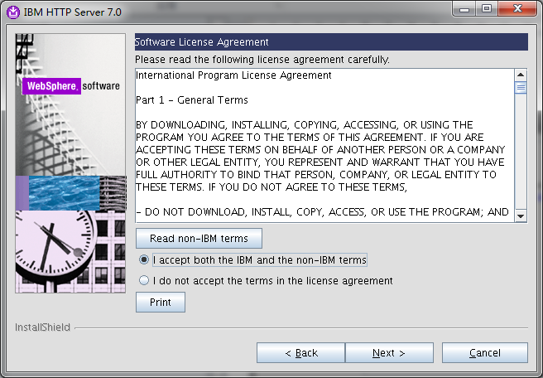

接受安装协议

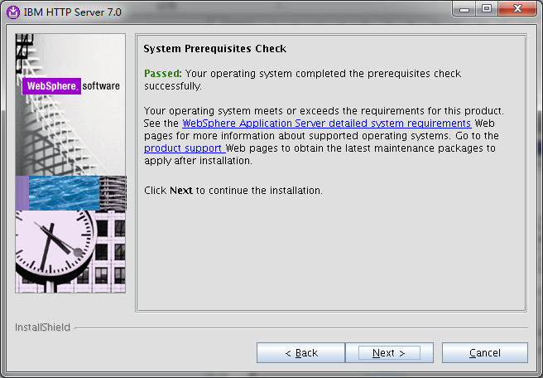

系统自检

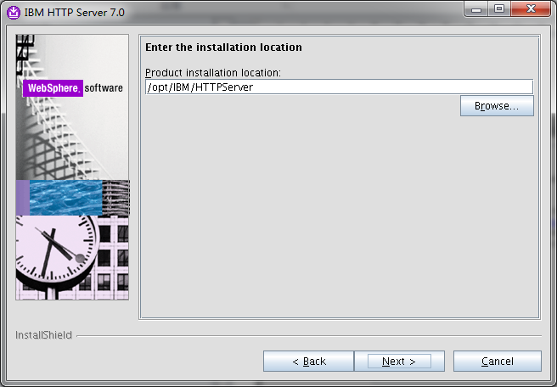

输入IHS的安装路径

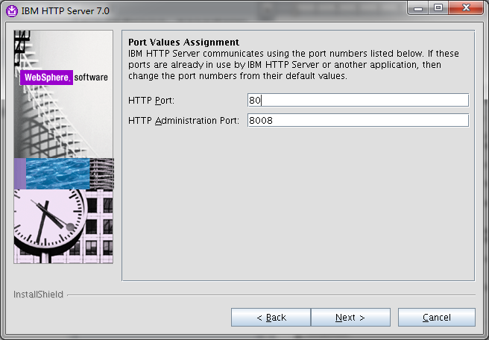

输入管理和应用的端口号

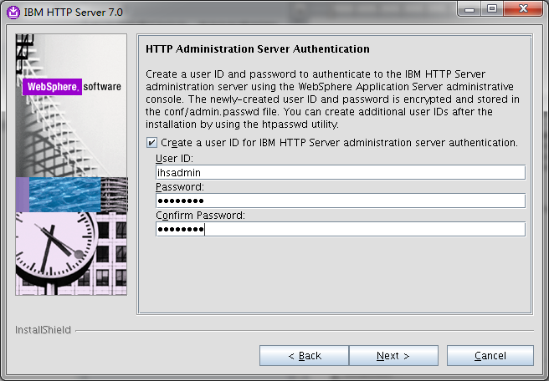

输入管理的用户名和密码

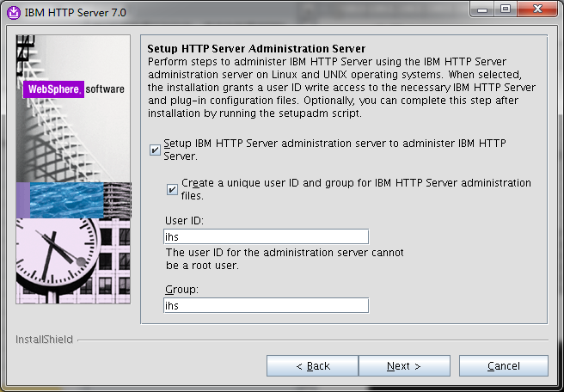

创建应用程序用户

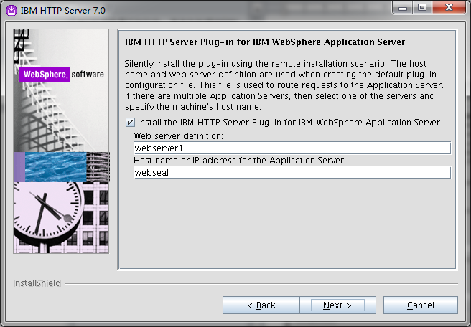

创建plug_in

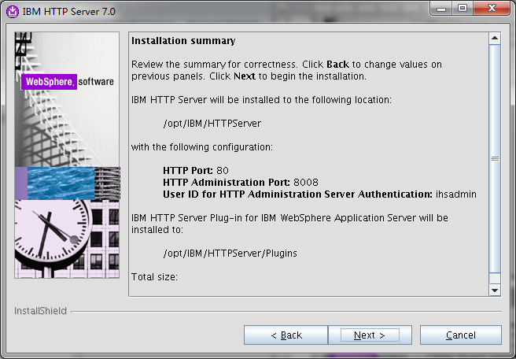

安装内容一览

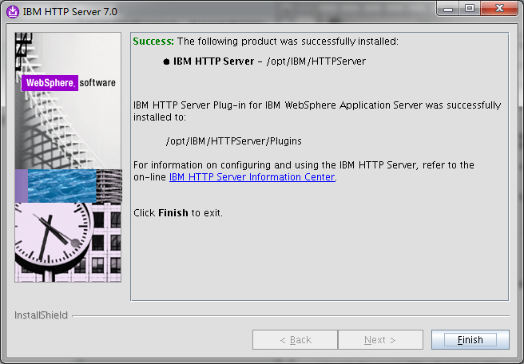

开始安装

## 安装IHS的补丁

cd /opt/IBM/WebSphere/UpdateInstaller

./update.sh

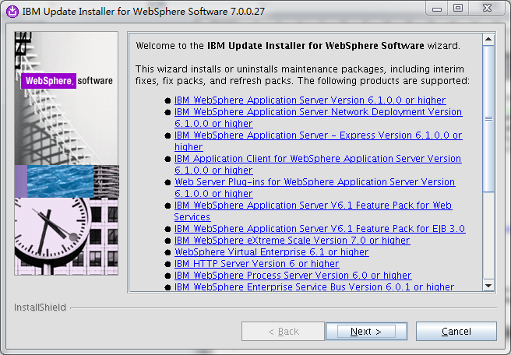

进入补丁安装路径

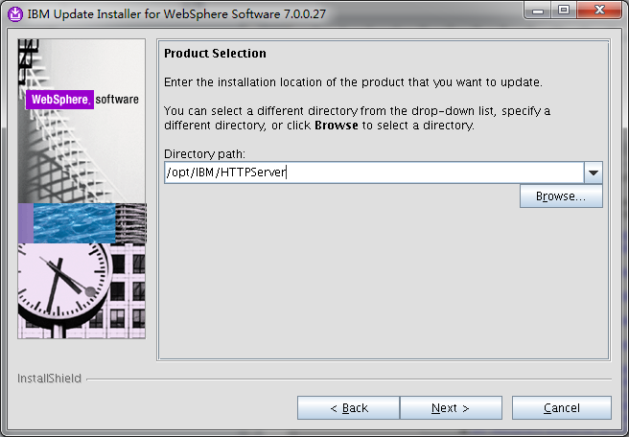

输入IHS的安装路径

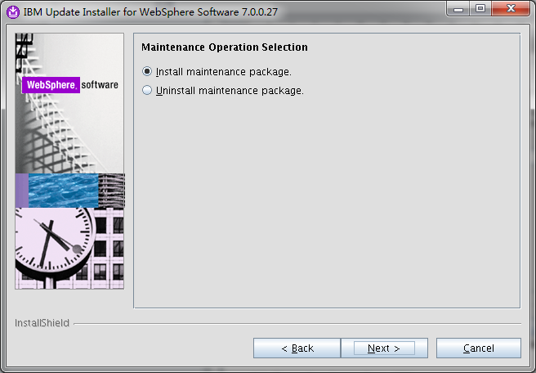

确认安装补丁包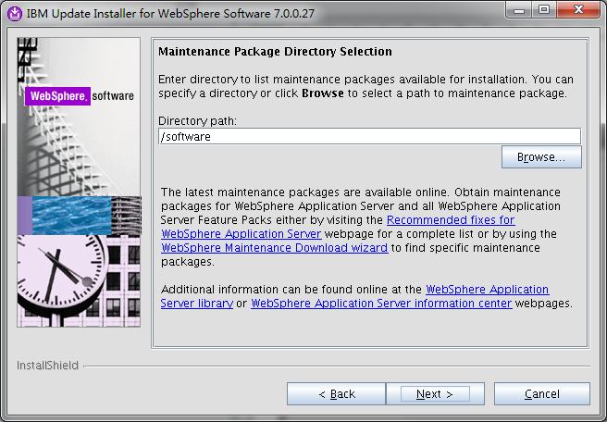

输入补丁安装包的路径

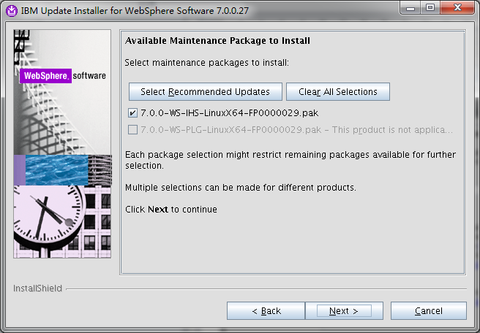

选择需要安装的补丁

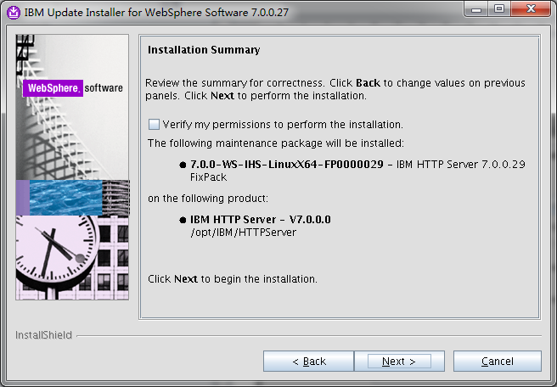

安装一览

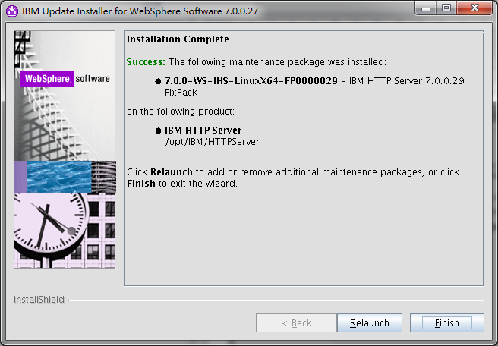

安装完成

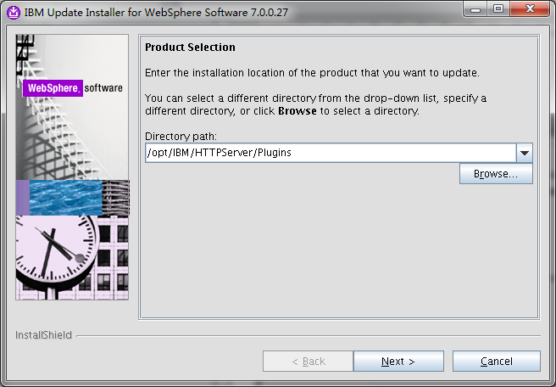

启动安装plugin的补丁

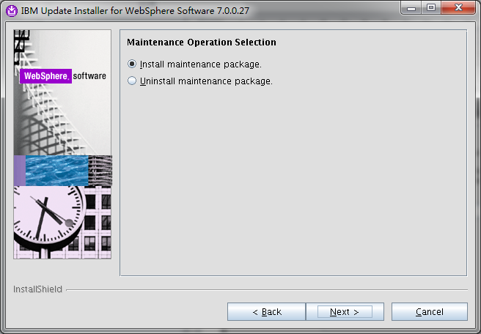

确认安装plugin的补丁



选择plugin的补丁包的路径

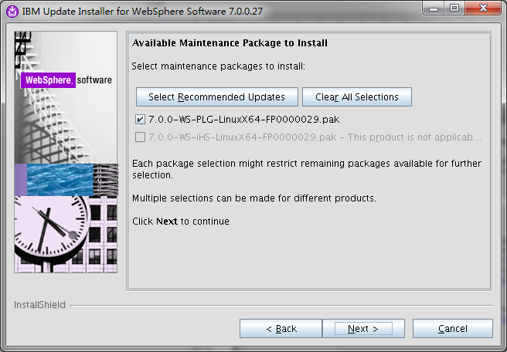

选择合适的补丁包

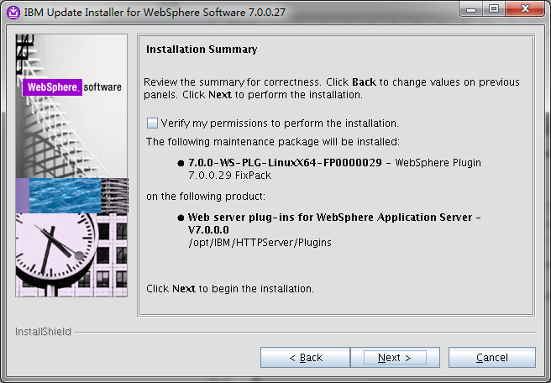

安装一览

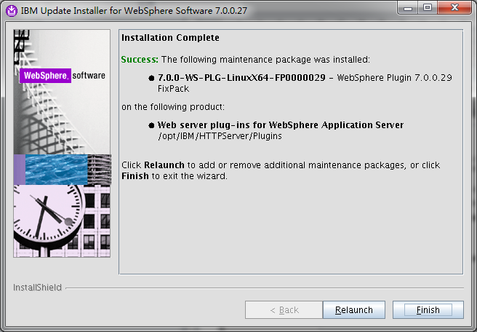

补丁安装完成

## 安装Policy Server

cd /software/tam/server/linux_i386

rpm -ivh ibm-java2-i386-sdk-5.0-5.0.i386.rpm

cd /software/tam/server

./install_ammgr -is:javahome /opt/ibm/java2-i386-50/jre

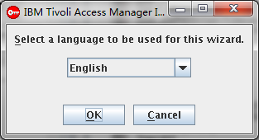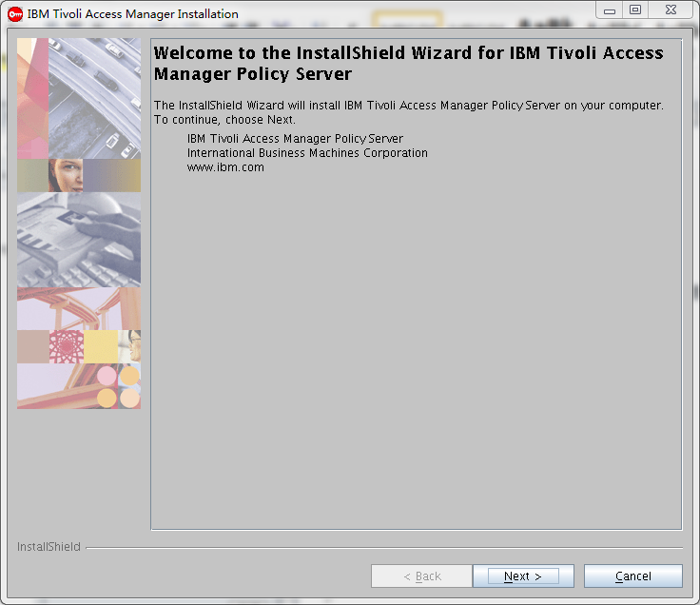

开始安装策略服务器

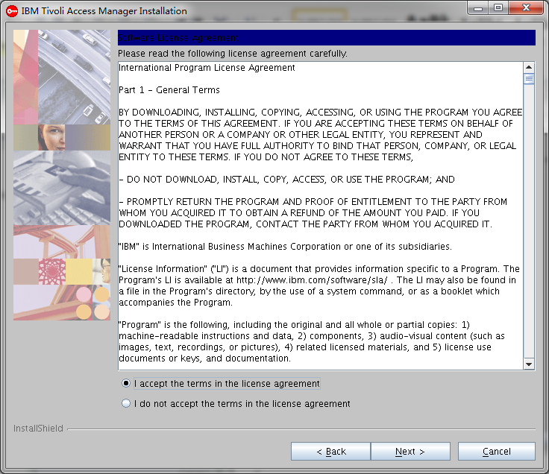

接受安装协议

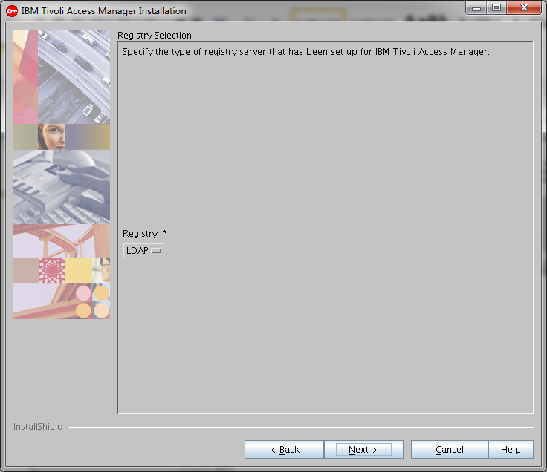

选择LDAP的认证方式

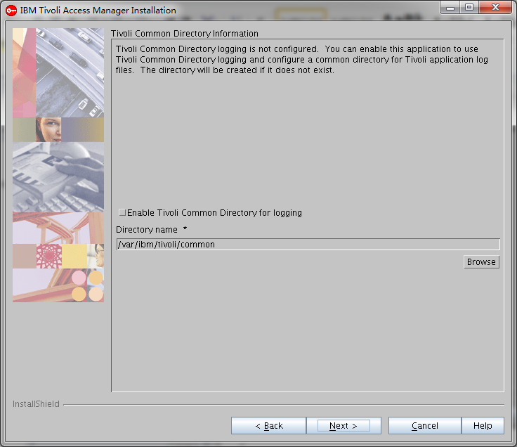

选择默认的日志存放路径

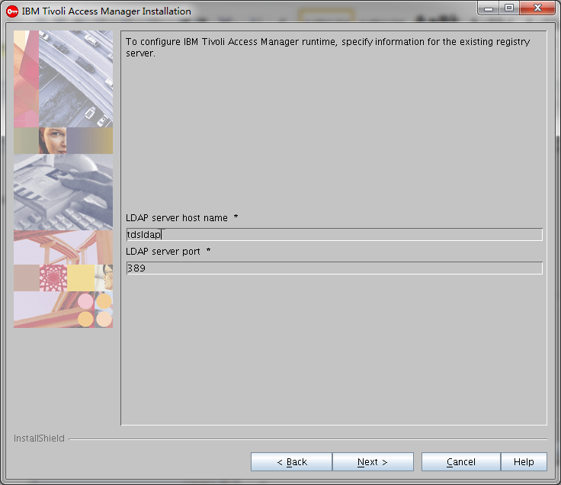

选择配置的ldap服务器

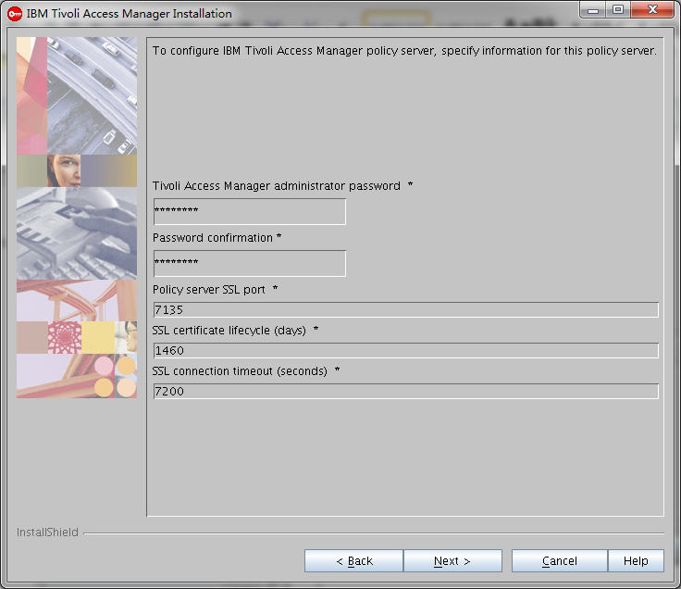

配置管理控制台的密码以及策略服务器的端口号

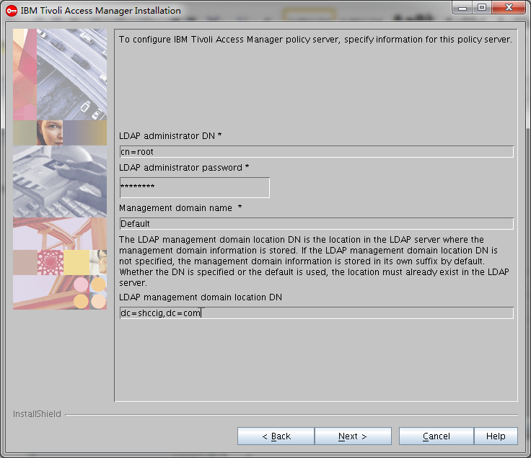

输入管理用户的密码和根域名

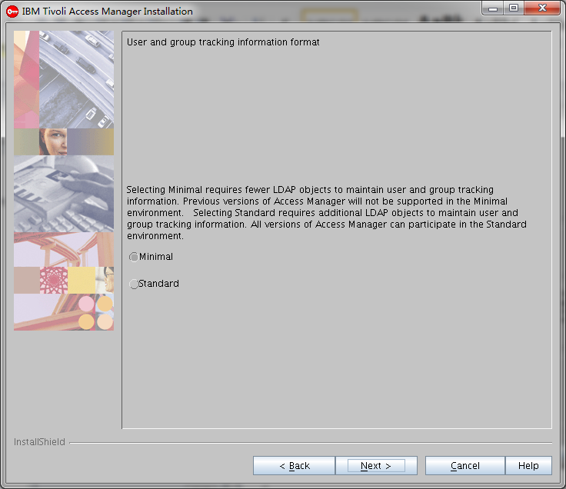

选择最小化安装

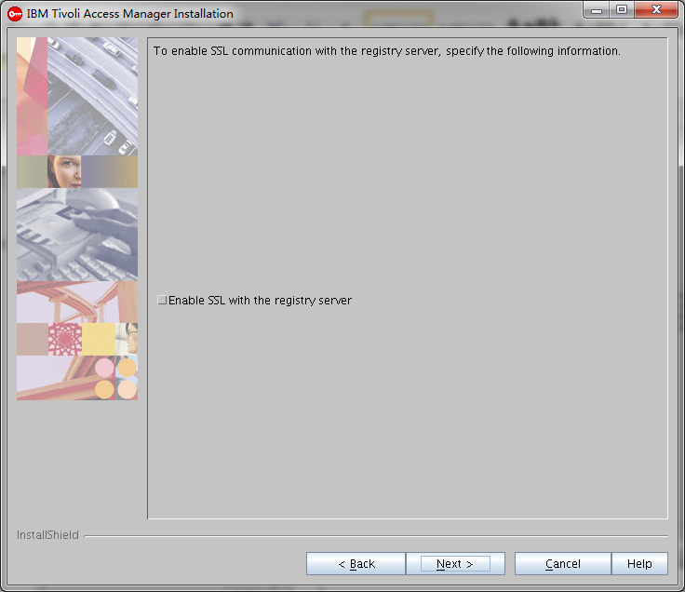

不允许SSL访问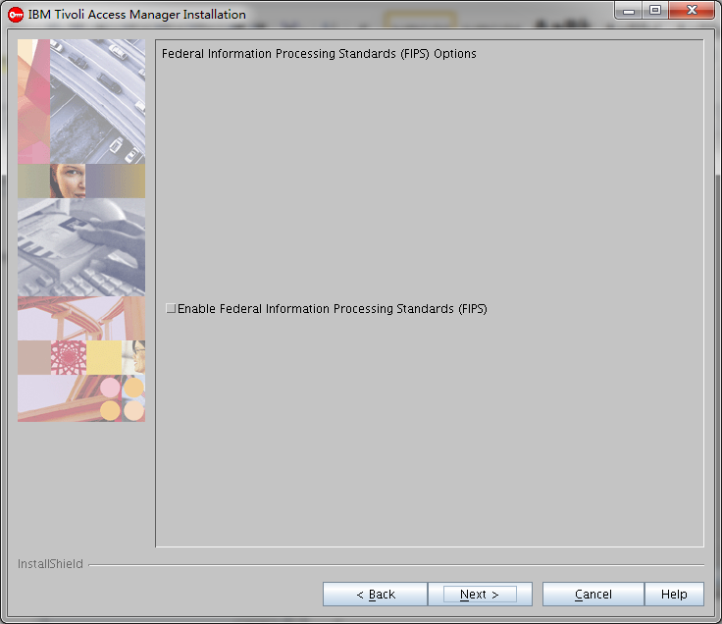

不允许标准联邦信息处理

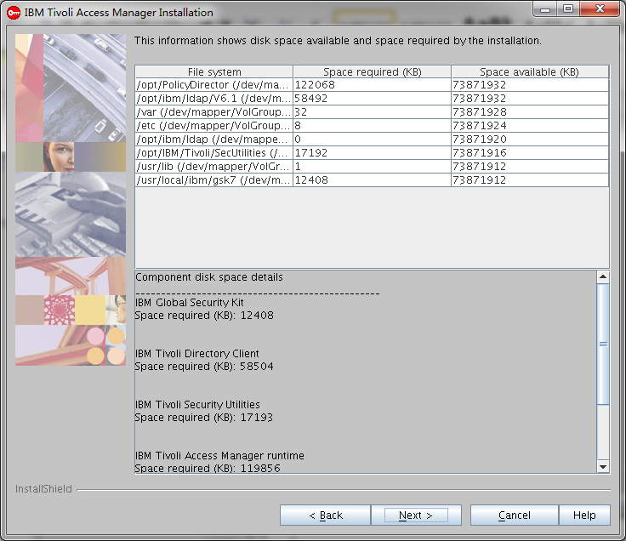

安装空间一览

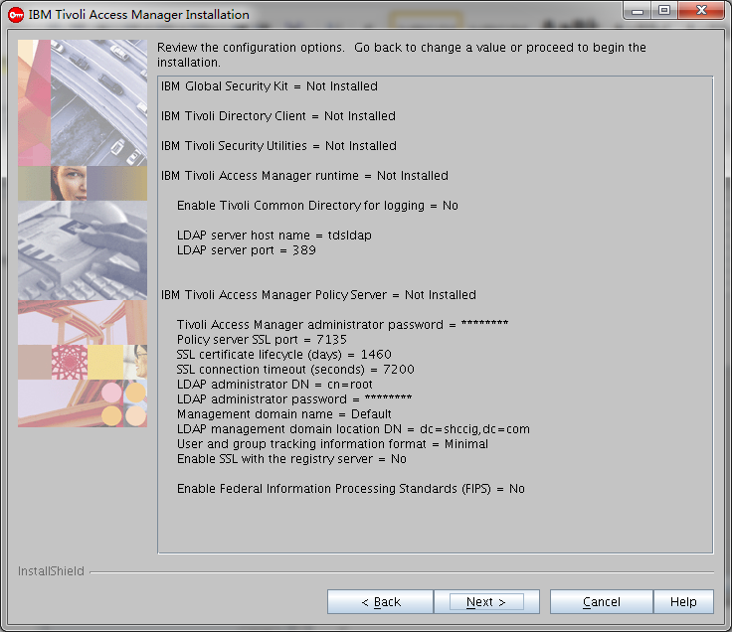

安装组件一览

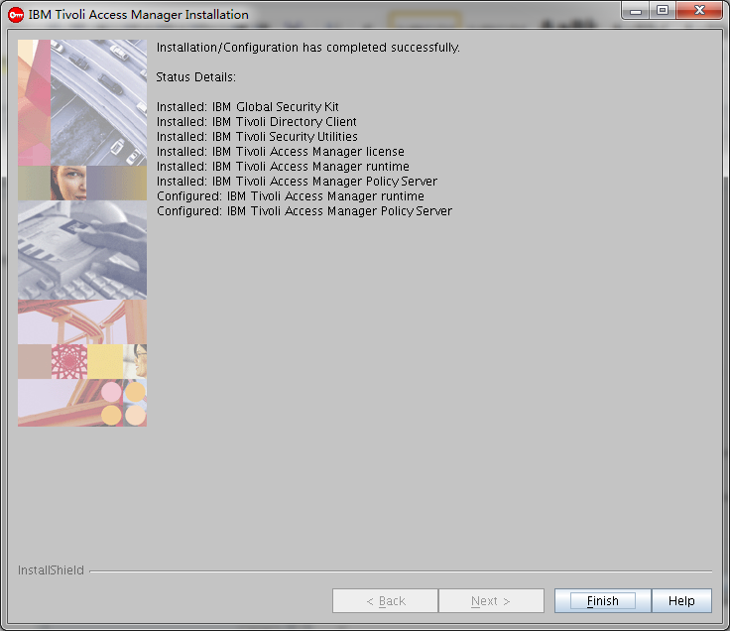

安装完成

## 安装授权服务器

./install_amacld -is:javahome /opt/ibm/java2-i386-50/jre

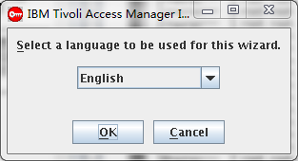 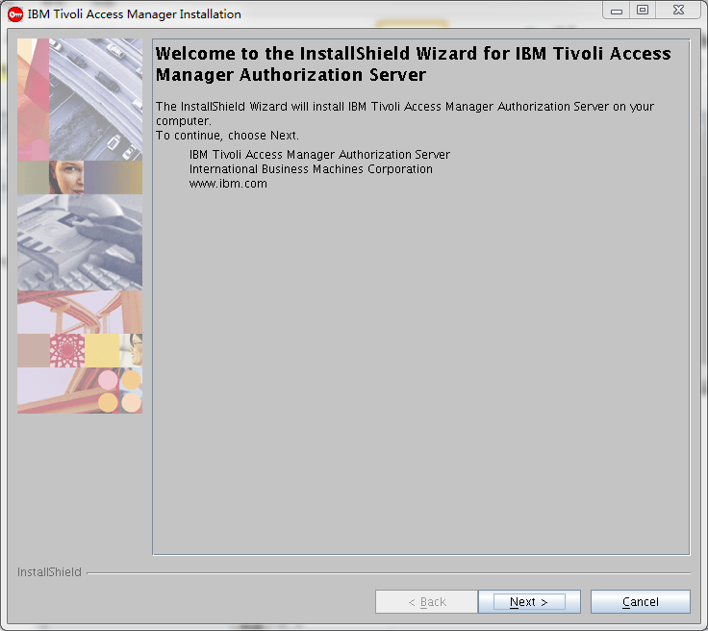 启动安装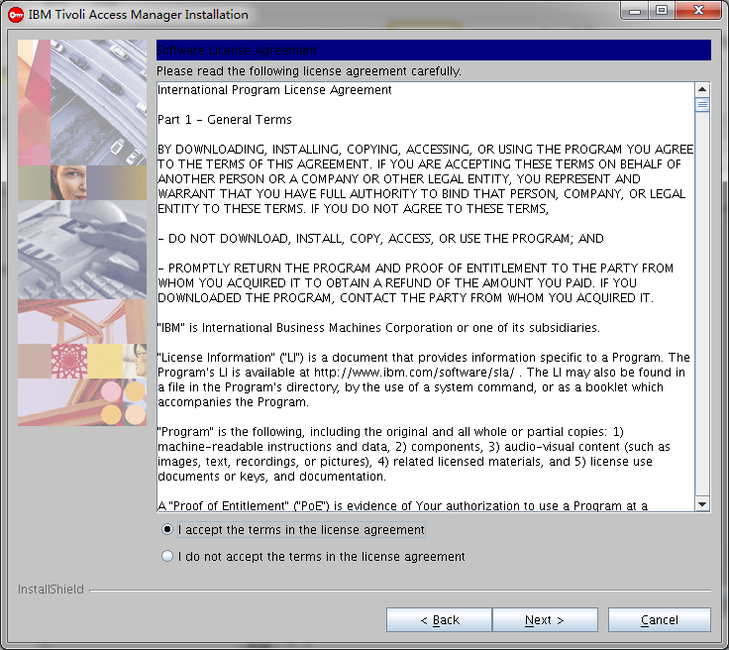

接受协议 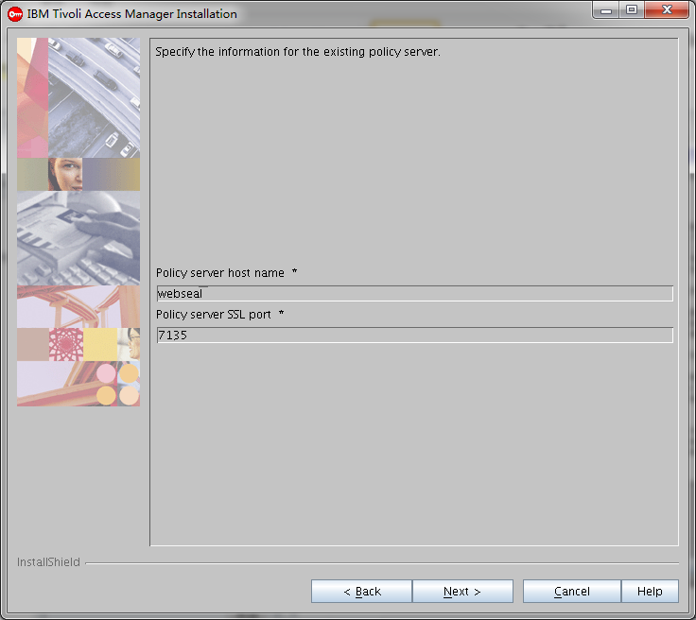

输入安装的主机名和SSL的端口号 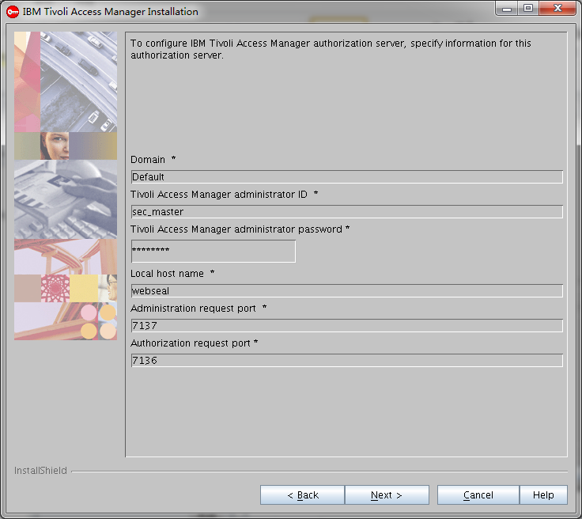

输入管理域、管理账户、密码和端口

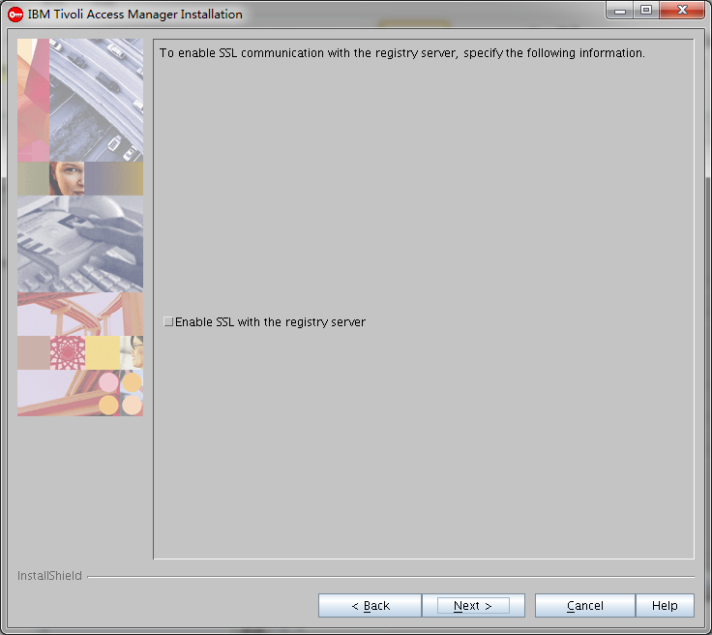

不开启SSL的注册服务 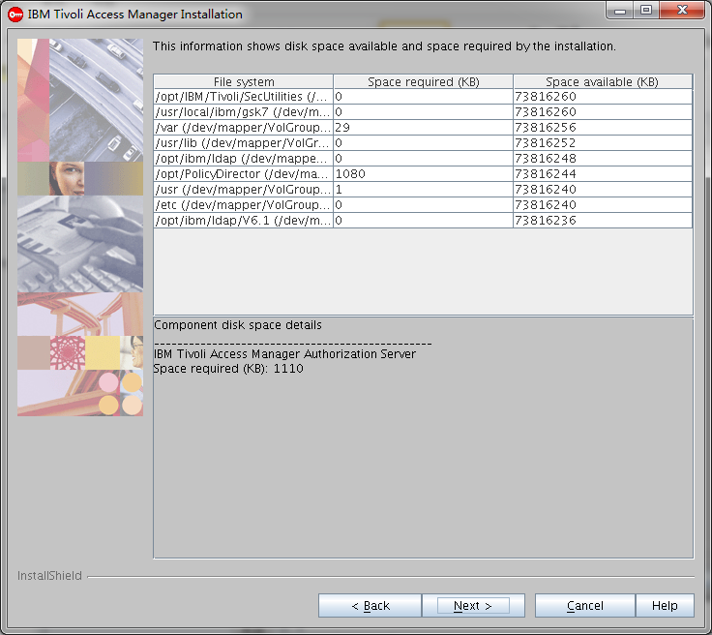

存储需求一览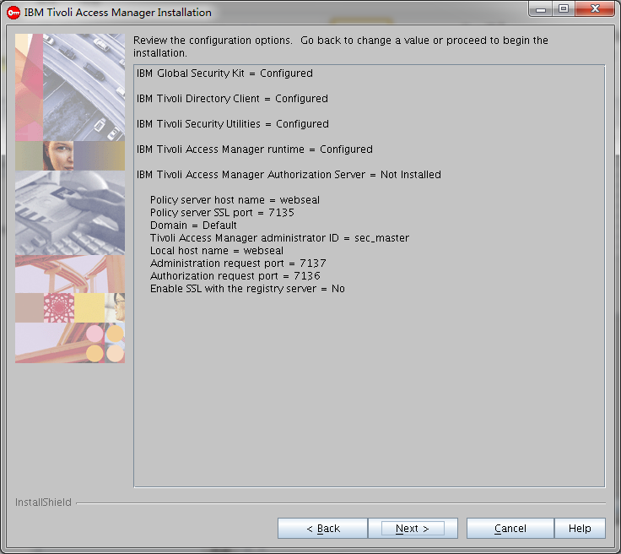 组件安装一览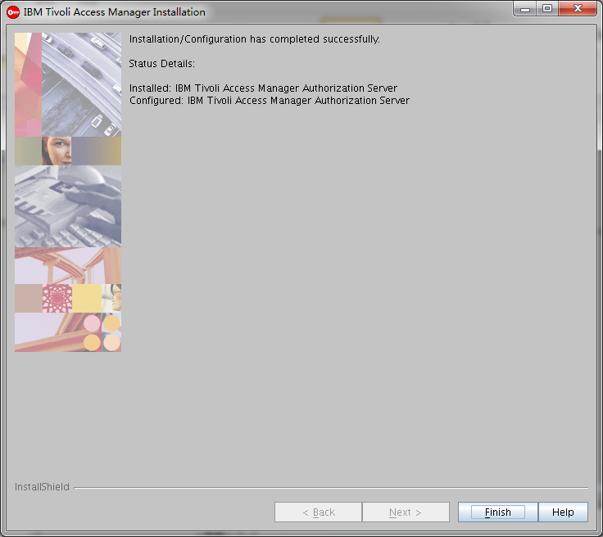

安装完成

## 安装应用程序开发包

./install_amadk -is:javahome /opt/ibm/java2-i386-50/jre

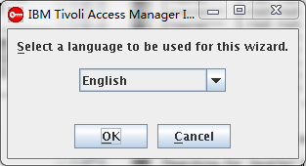 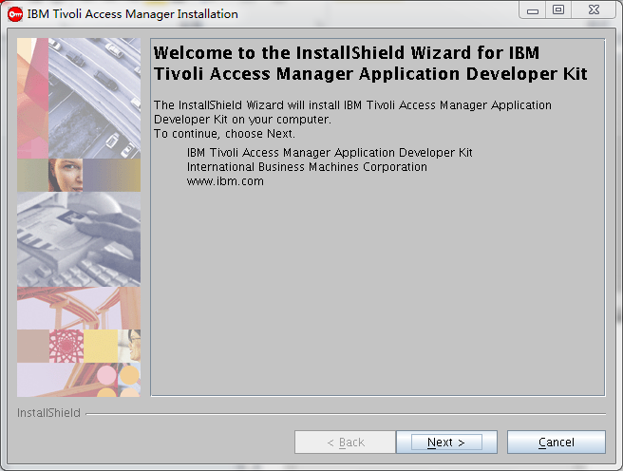

启动安装 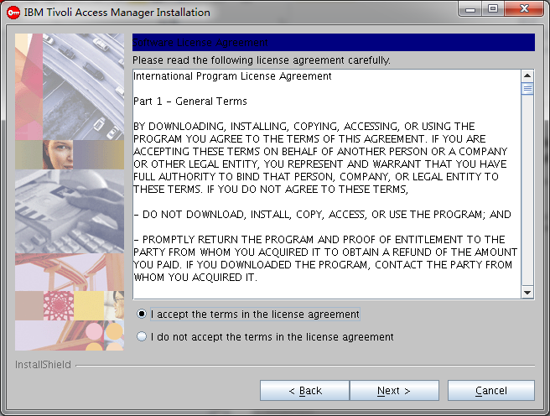

接受协议 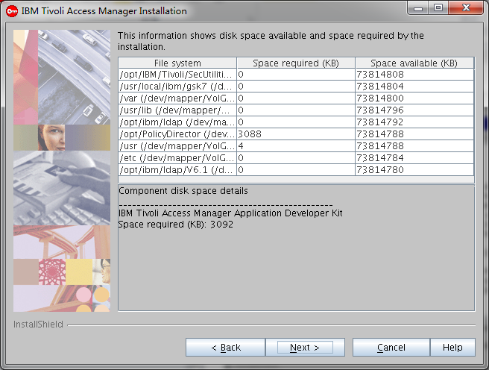

存储空间一览 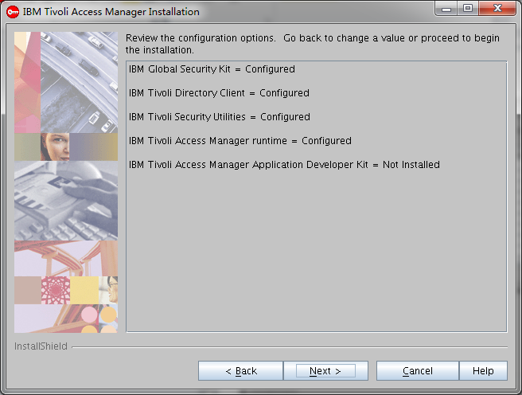

安装组件一览

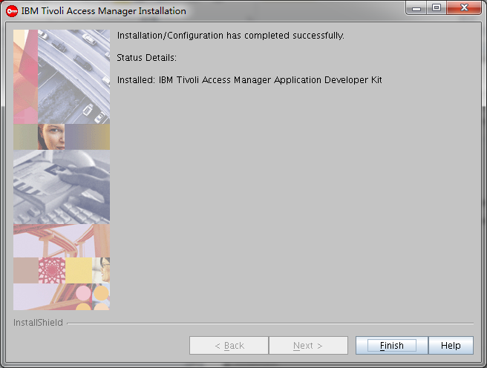

安装完成

## Java运行时包的安装

./install_amjrte -is:javahome /opt/IBM/WebSphere/AppServer/java/jre

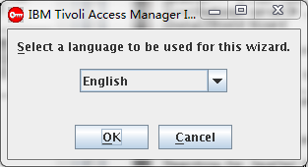 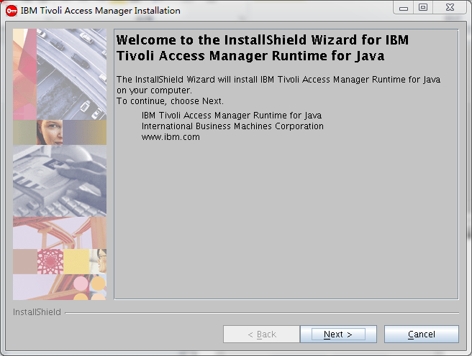

启动安装 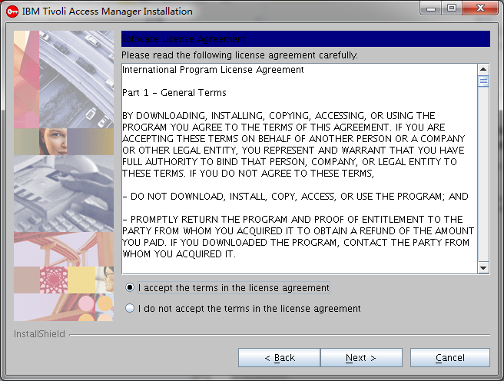

接受协议 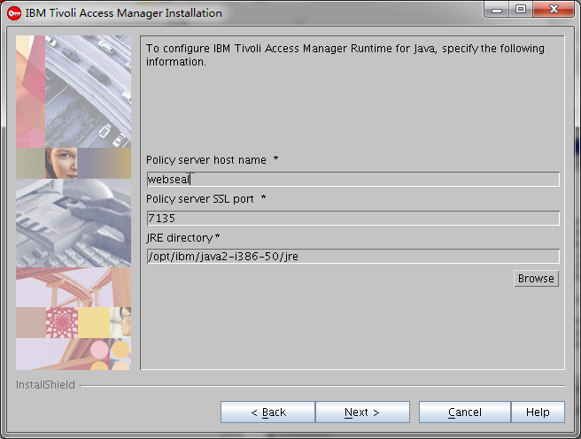

输入主机名、端口和JRE安装目录 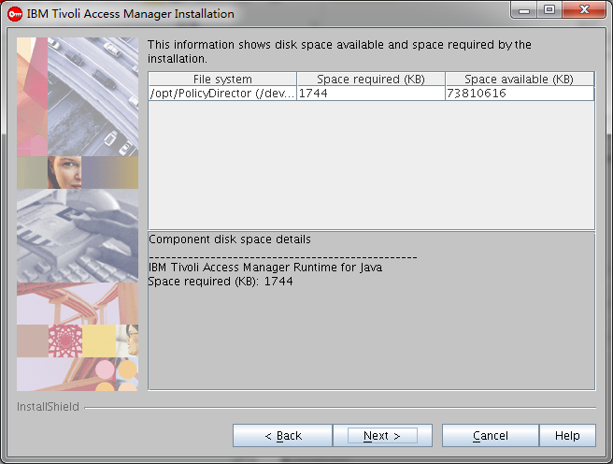

空间一览 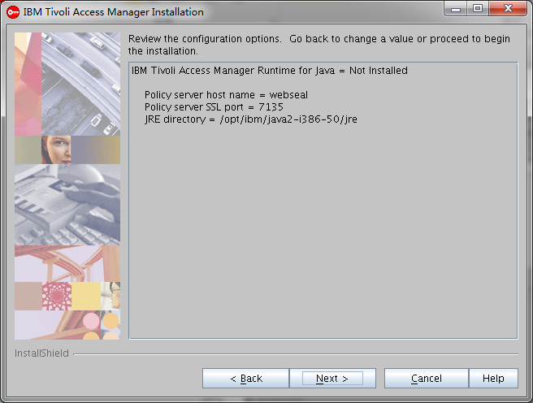

安装组件一览 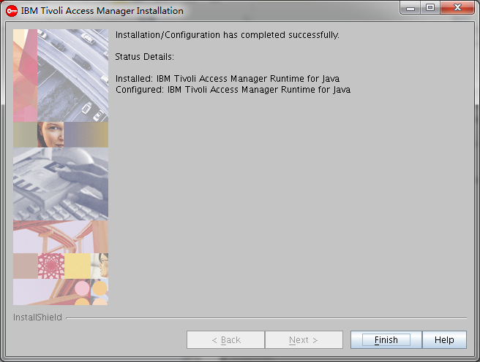

安装完成

## 代理Policy服务器的安装

./install_amproxy -is:javahome /opt/ibm/java2-i386-50/jre

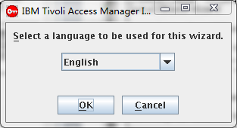 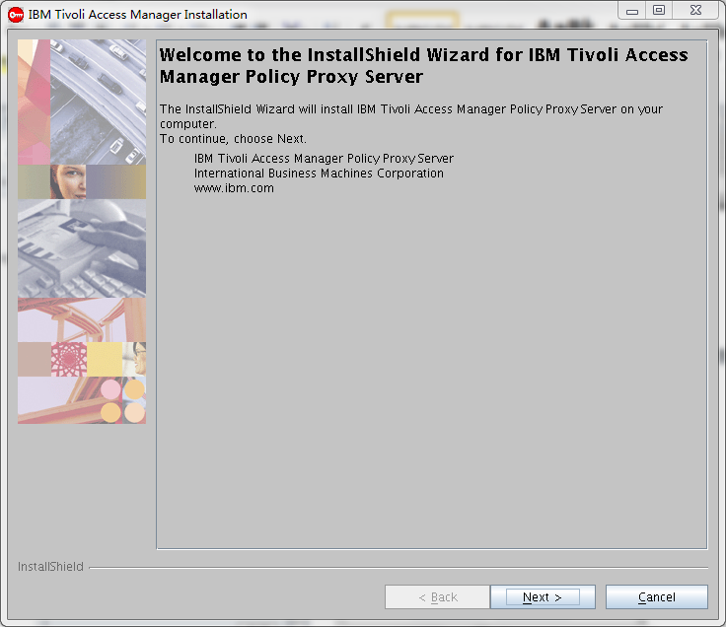

启动安装 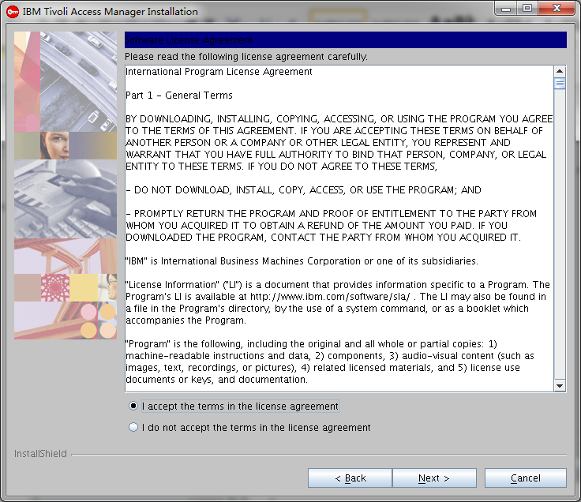

接受协议 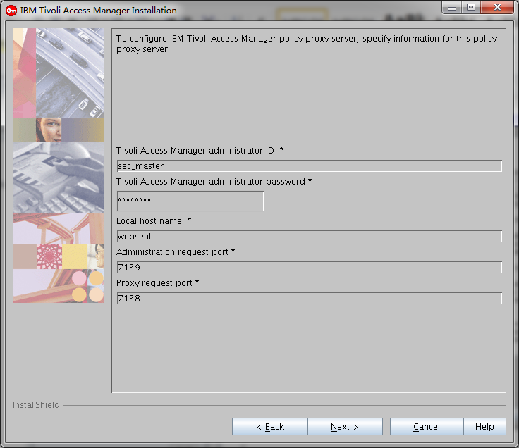

输入管理账户、密码、Webseal的主机名，管理端口和代理端口 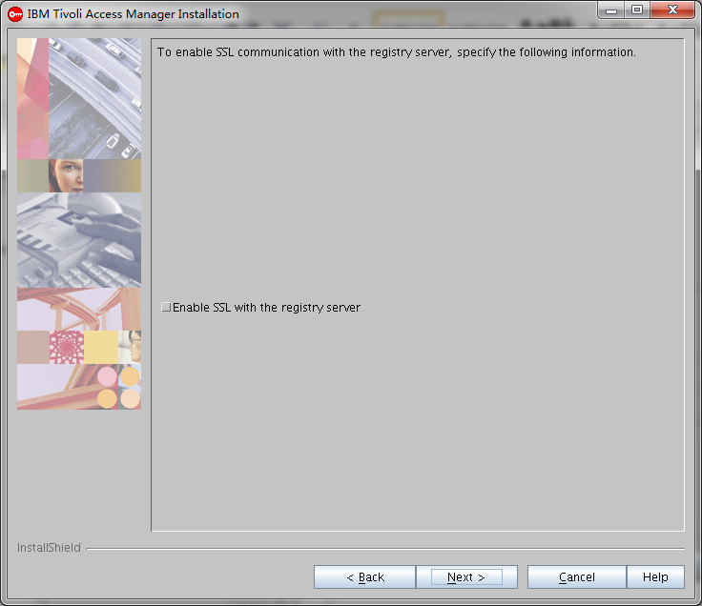

不允许SSL注册服务

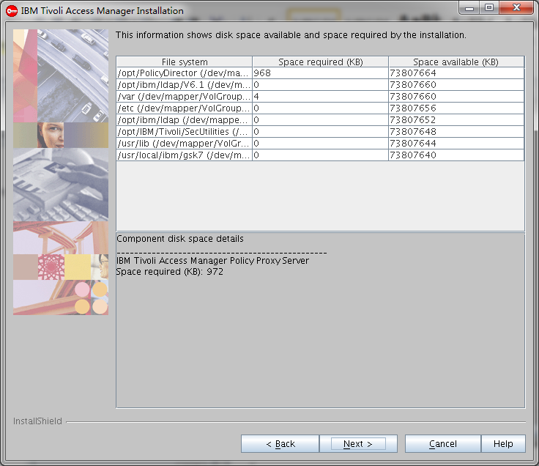

安装空间一览

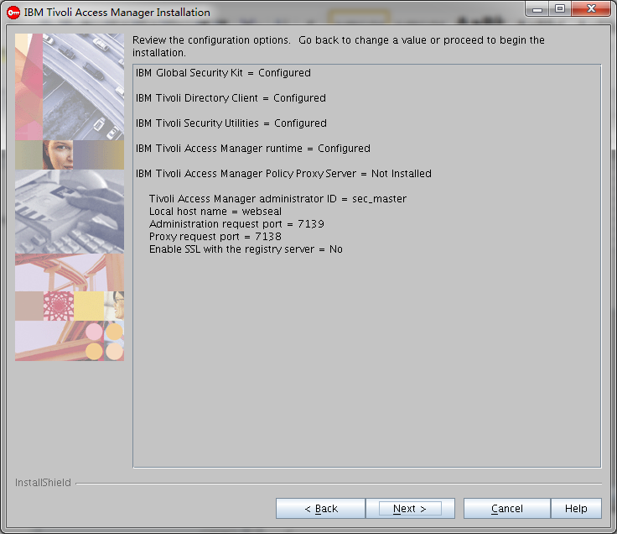

安装组件一览

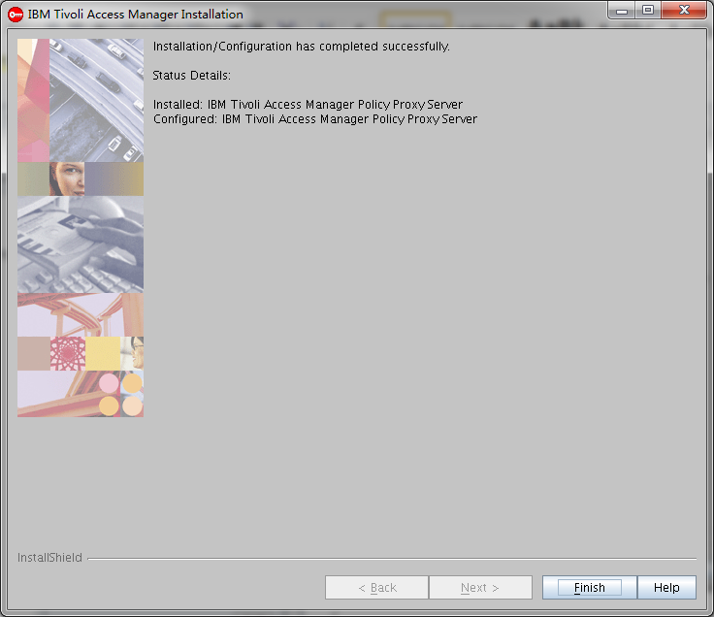

安装完成

## 安装Webseal运行时包

./install_amrte -is:javahome /opt/IBM/WebSphere/AppServer/java/jre

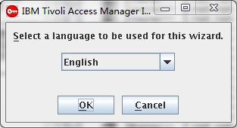 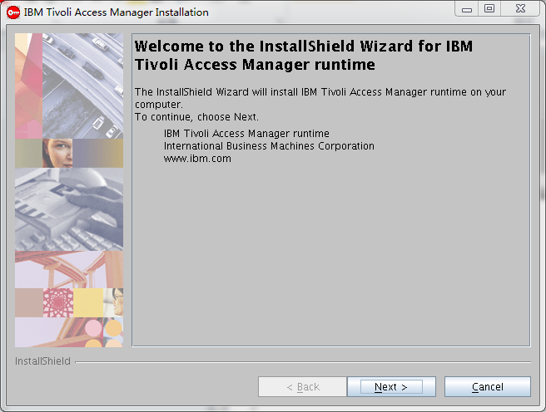

启动安装 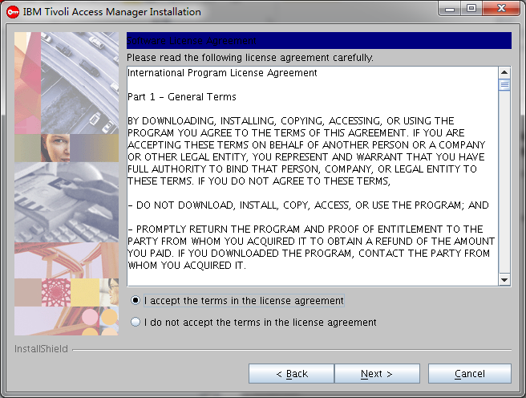

接受协议 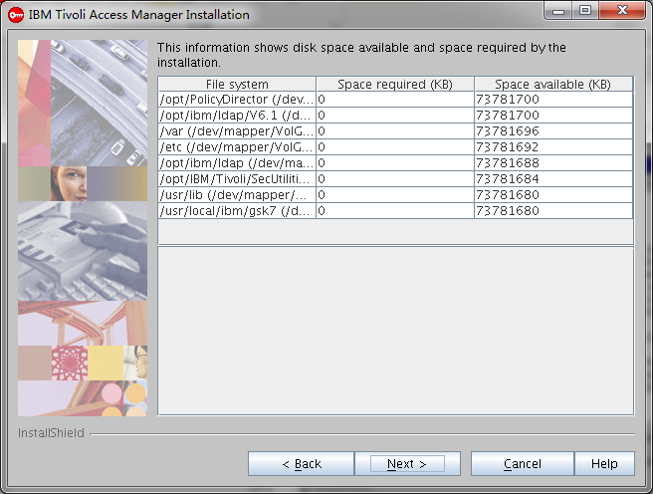

存储空间一览 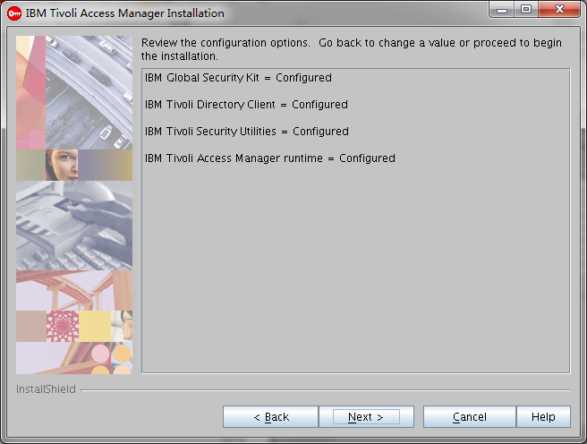

安装足迹一览

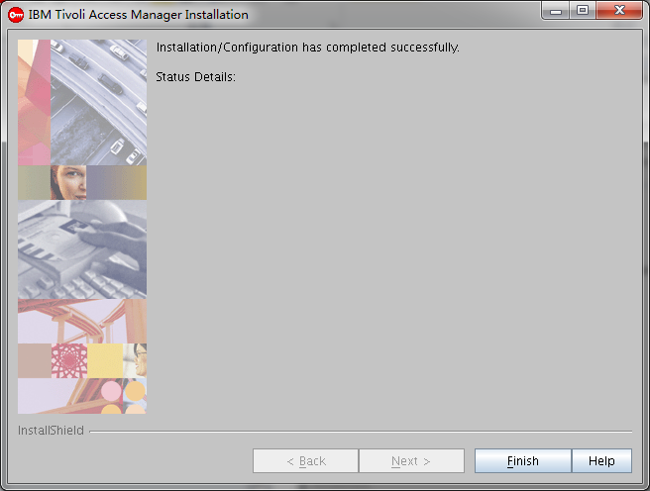

安装完成

## Webseal Portal Manager的安装

./install_amwpm -is:javahome /opt/ibm/java2-i386-50/jre

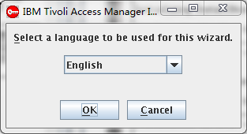 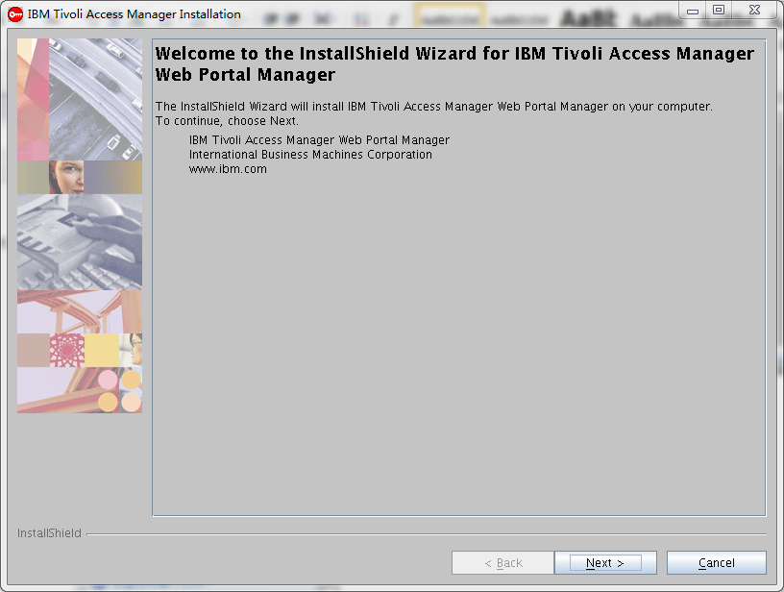

启动安装 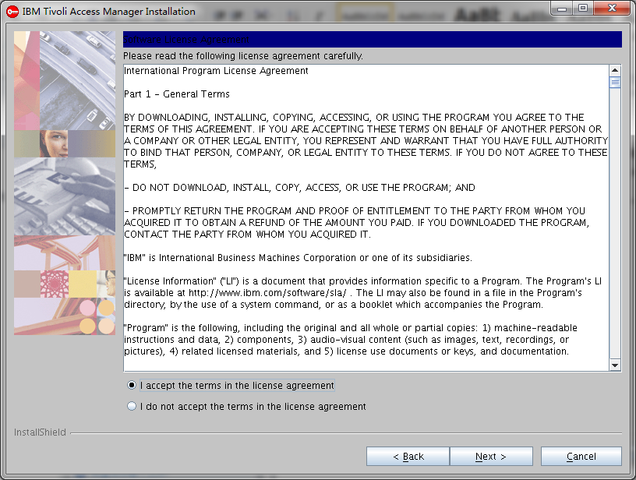

接受协议 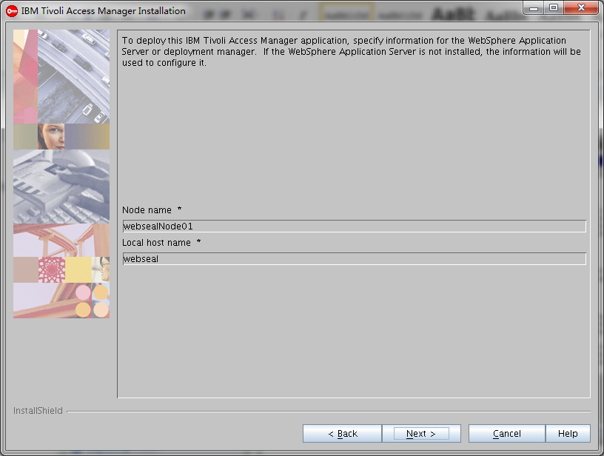

选择node节点 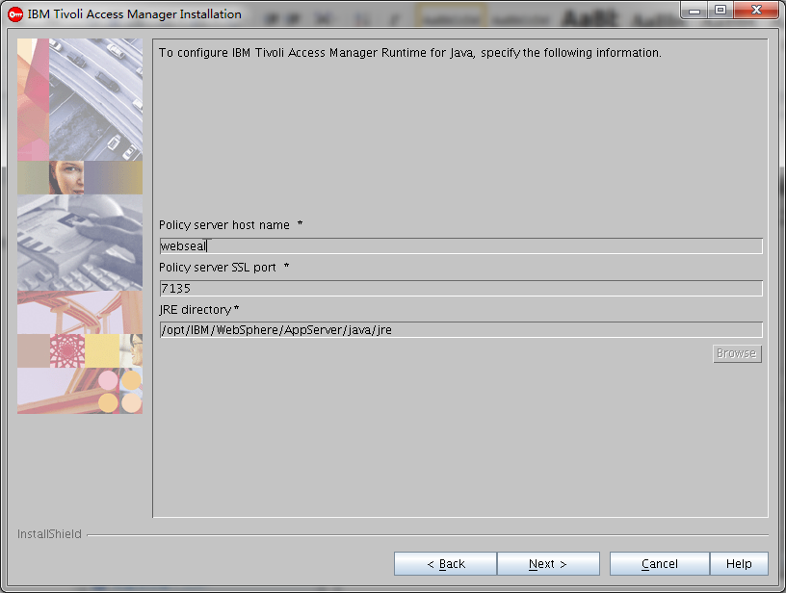

输入主机名、SSL端口和JRE路径

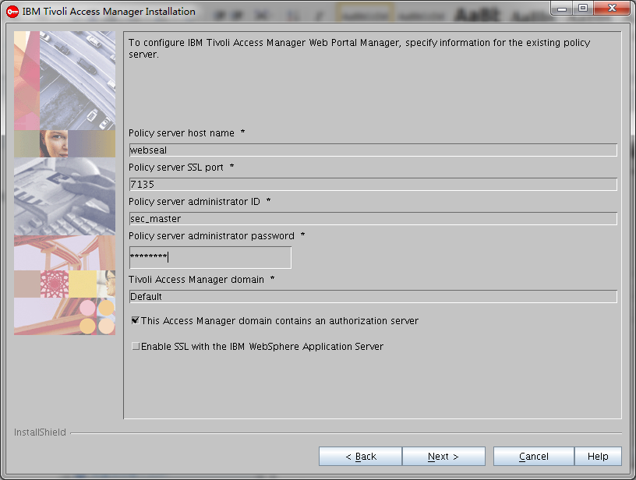

输入Policy服务器的地址、管理用户 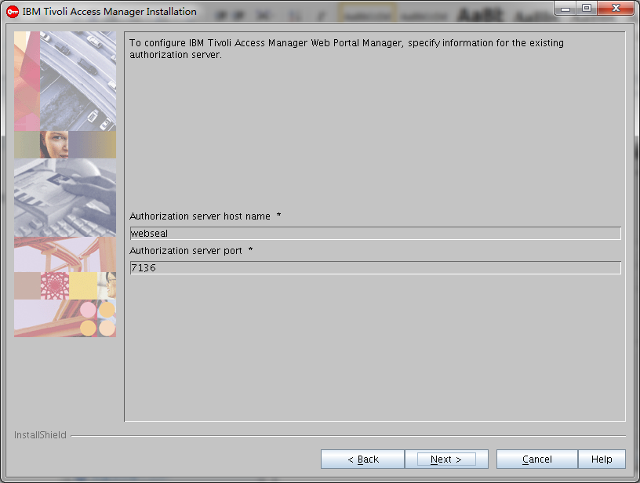

配置认证服务器的主机名和端口 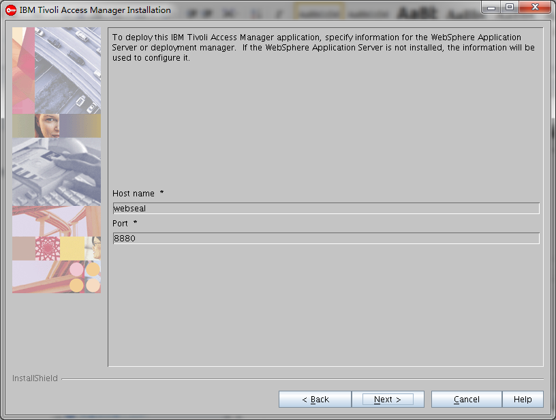

配置应用服务器的主机名和Soap端口

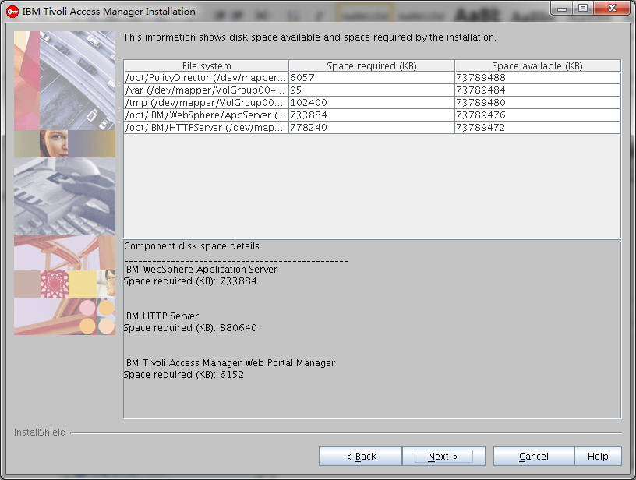

安装空间一览 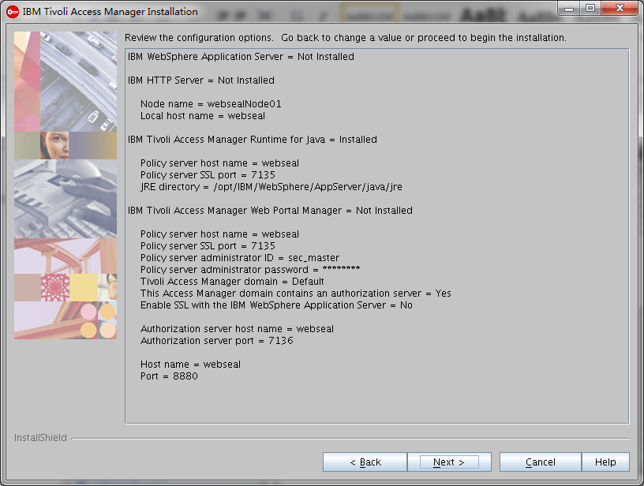

开始安装

cd /software/tam/server/linux_i386

rpm -ivh PDWPM-PD-6.1.0-0.i386.rpm

[root@webseal Tivoli]# export PATH=/opt/IBM/WebSphere/AppServer/java/jre/bin:$PATH

[root@webseal Tivoli]# export JAVA_HOME=/opt/IBM/WebSphere/AppServer/java/jre

[root@webseal Tivoli]# pdconfig

Tivoli Access Manager Setup Menu

1. Configure Package

2. Unconfigure Package

3. Display Configuration Status

x. Exit

Select the menu item [x]: 1

Tivoli Access Manager Configuration Menu

1. Access Manager Web Portal Manager Configuration

2. Access Manager Runtime for Java Configuration

x. Return to the Tivoli Access Manager Setup Menu

Select the menu item [x]: 2

Specify the full path of the Java Runtime Environment (JRE)

to configure for Tivoli Access Manager [/opt/IBM/WebSphere/AppServer/java/jre]:

Enter 'full' or 'standalone' for the configuration type [full]:

Policy server host name [webseal]:

Tivoli Access Manager policy server port number [7135]:

Enter the Access Manager policy server domain [Default]:

Tivoli Common Directory logging is not configured.

If you want to use Tivoli Common Directory logging,

you must enable logging and specify a directory for log files.

The directory will be created if it does not exist.

Do you want to use Tivoli Common Directory logging (y/n) [n]?

Configuration of Access Manager Runtime for Java is in progress.

This might take several minutes.

Configuration of Access Manager Runtime for Java completed successfully.

Press Enter to continue.

Tivoli Access Manager Configuration Menu

1. Access Manager Web Portal Manager Configuration

2. Access Manager Runtime for Java Configuration

x. Return to the Tivoli Access Manager Setup Menu

Select the menu item [x]: 1

Enter the IBM WebSphere Application Server or Deployment Manager

installation full path [/opt/IBM/WebSphere/AppServer]:

Policy server host name [webseal]:

Tivoli Access Manager policy server port number [7135]:

Does the Access Manager domain contain an

Authorization Server (y/n) [y]?

Enter the hostname of the Access Manager

authorization server [webseal]:

Tivoli Access Manager authorization server port number [7136]:

Tivoli Access Manager administrator ID: [sec_master]:

Tivoli Access Manager administrator password:*********

Enter the hostname of the IBM WebSphere Application Server

or Deployment Manager[webseal]:

Enter the SOAP Admin port number of the WebSphere

Application Server or Deployment Manager [8879]: 8880

Is WebSphere security enabled (y/n) [n]? y

Enter the administrator username of the IBM WebSphere

Application Server: wasadmin

Password for IBM WebSphere Application Server administrator:*********

Fully qualified filename for IBM WebSphere Application Server trust store: /opt/IBM/WebSphere/AppServer/profiles/AppSrv01/config/cells/websealNode01Cell/nodes/websealNode01/trust.p12

Password for IBM WebSphere Application Server trust store:****** （WebAS）

Fully qualified filename for IBM WebSphere Application Server key store: /opt/IBM/WebSphere/AppServer/profiles/AppSrv01/config/cells/websealNode01Cell/nodes/websealNode01/key.p12

Password for IBM WebSphere Application Server key store:****** （WebAS）

Configuration of Access Manager Web Portal Manager is in progress.

This might take several minutes.

Press Enter to continue.

Tivoli Access Manager Configuration Menu

1. Access Manager Runtime for Java Configuration

x. Return to the Tivoli Access Manager Setup Menu

Select the menu item [x]: x

Tivoli Access Manager Setup Menu

1. Configure Package

2. Unconfigure Package

3. Display Configuration Status

x. Exit

Select the menu item [x]: x

## Retrieval Service的安装

cd /software/tam/webseal

./install_amwebars -is:javahome /opt/ibm/java2-i386-50/jre

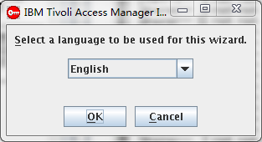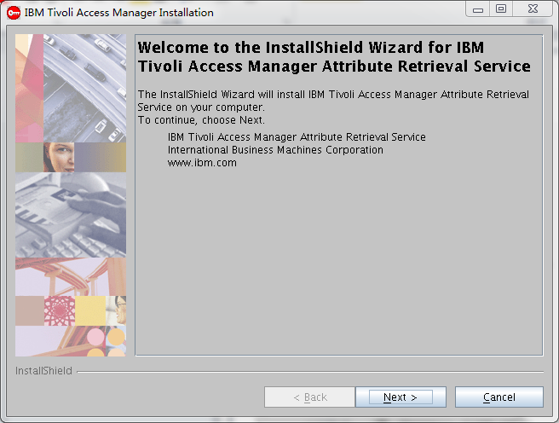

启动安装

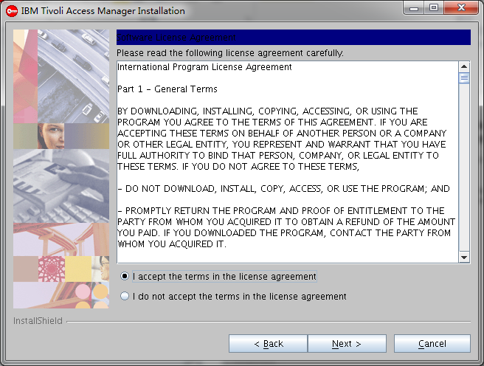

接受协议

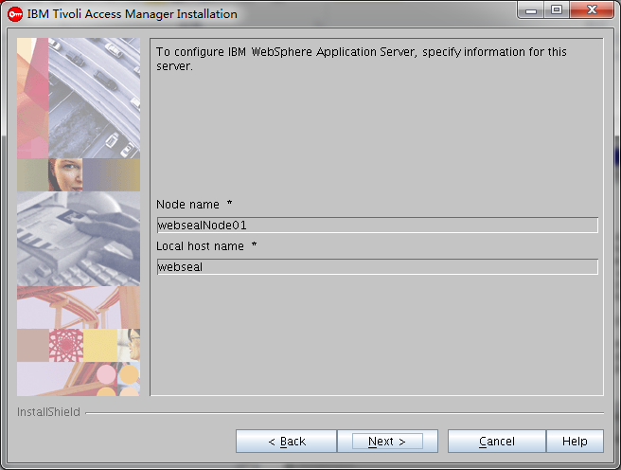

输入应用服务器node节点

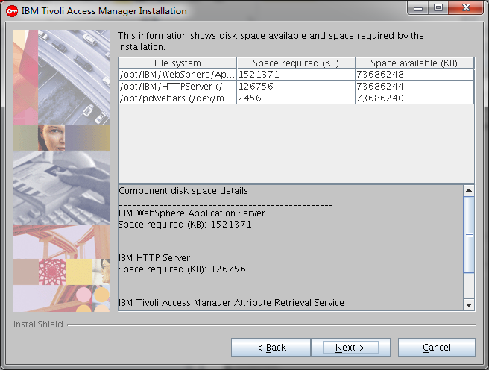

安装空间一览

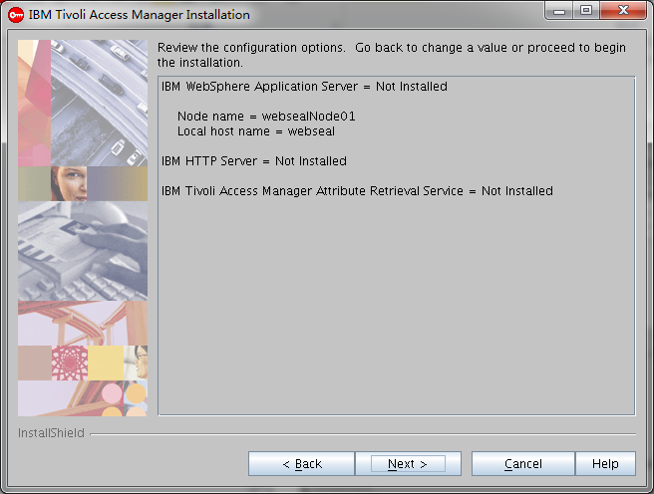

开始安装

## Web Security Development kit的安装

./install_amwebadk -is:javahome /opt/ibm/java2-i386-50/jre

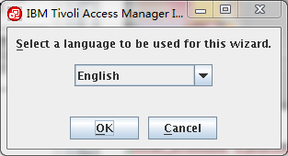

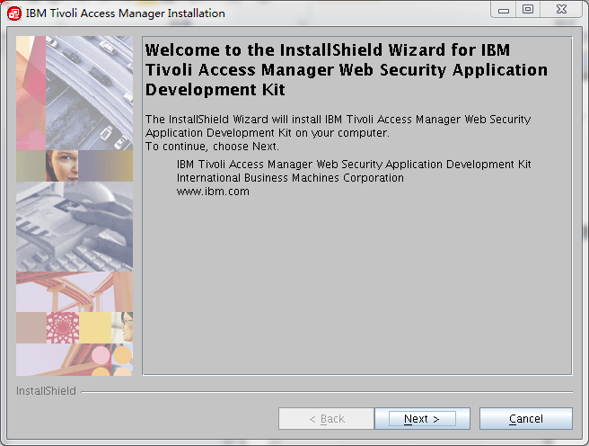

启动安装

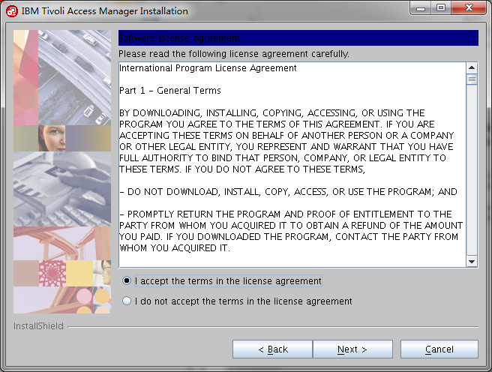

接受协议

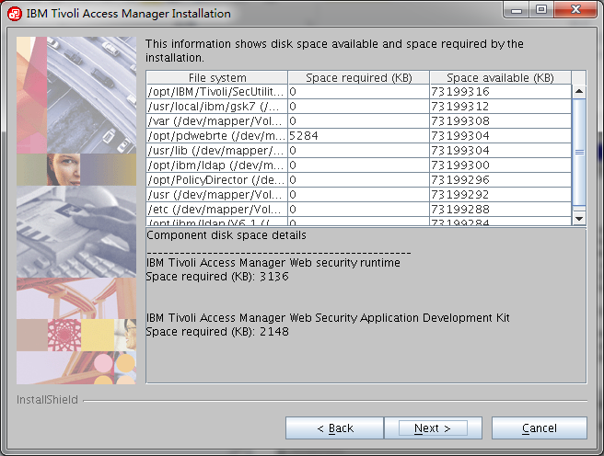

安装空间一览

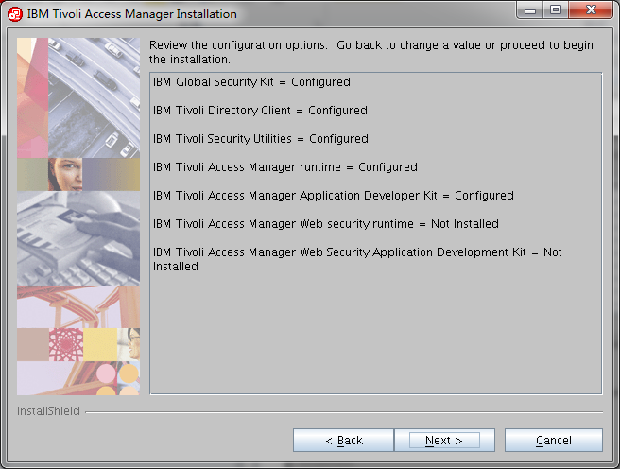

安装组件一览

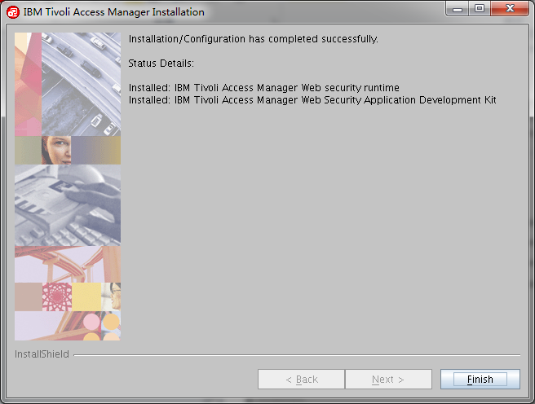

安装完成

## Webseal的安装

./install_amweb -is:javahome /opt/ibm/java2-i386-50/jre

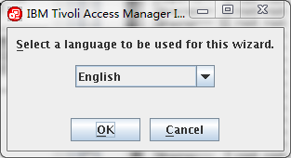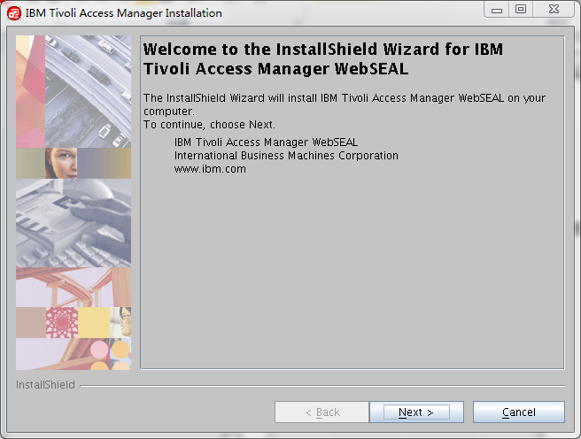

启动安装

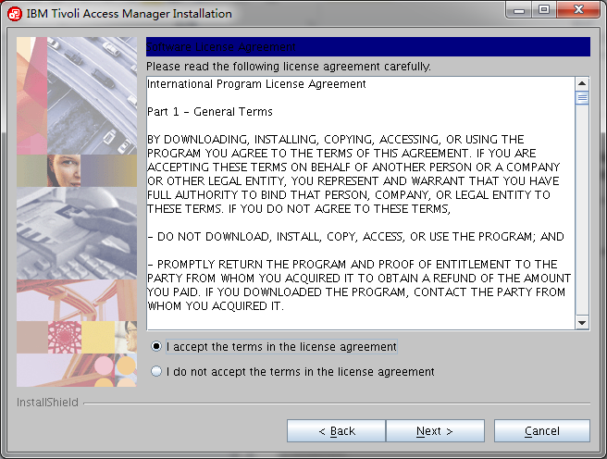

接受协议

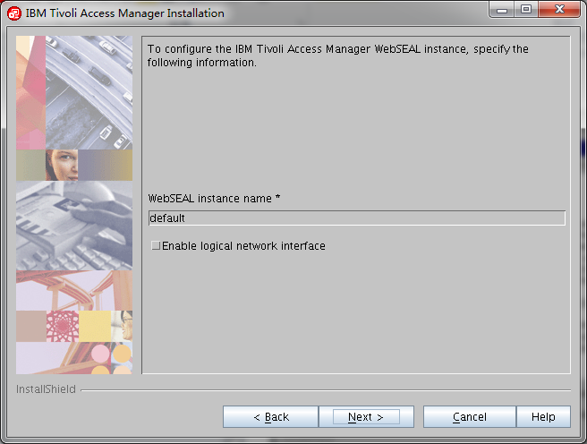

配置实例名

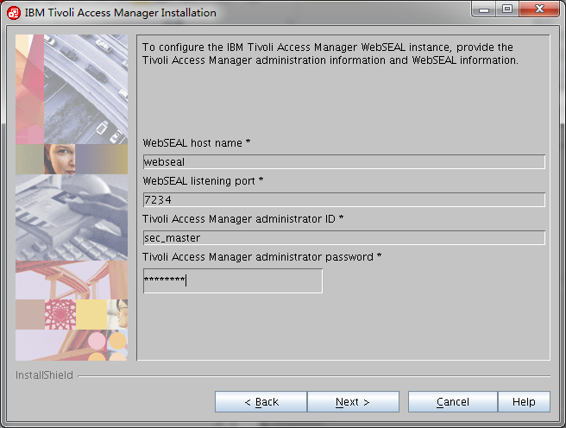

配置实例的管理用户和监听端口

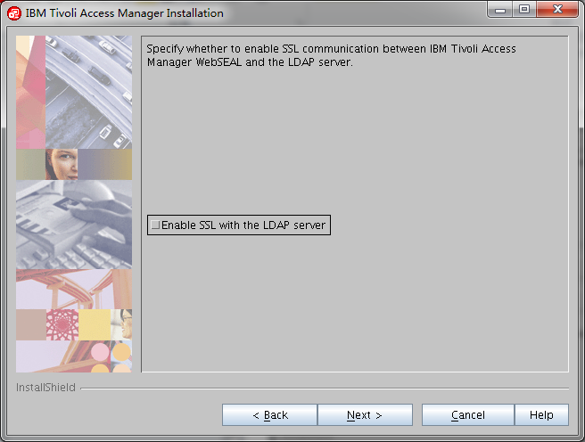

关闭到LDAP的SSL

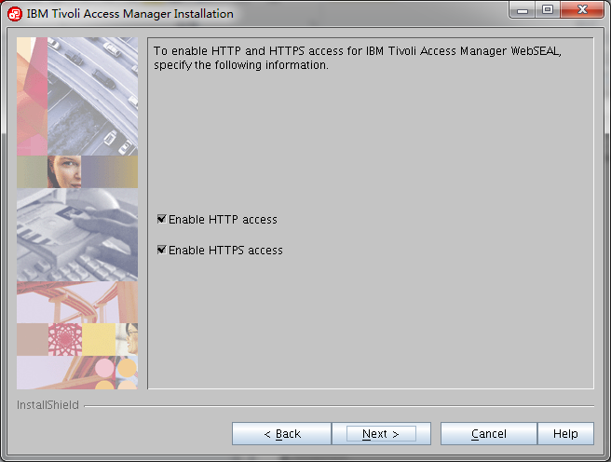

允许HTTP和HTTPS的访问

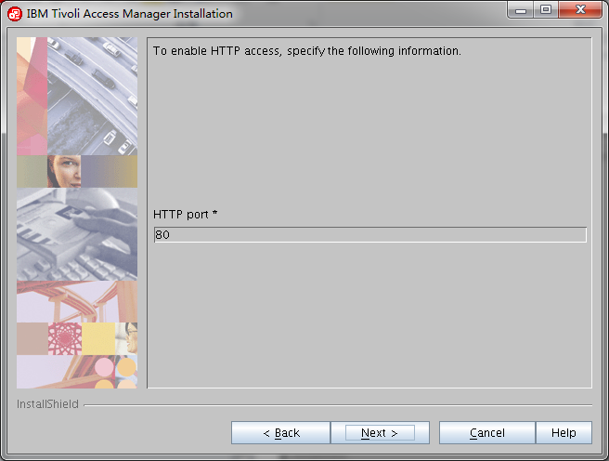

输入HTTP的默认端口

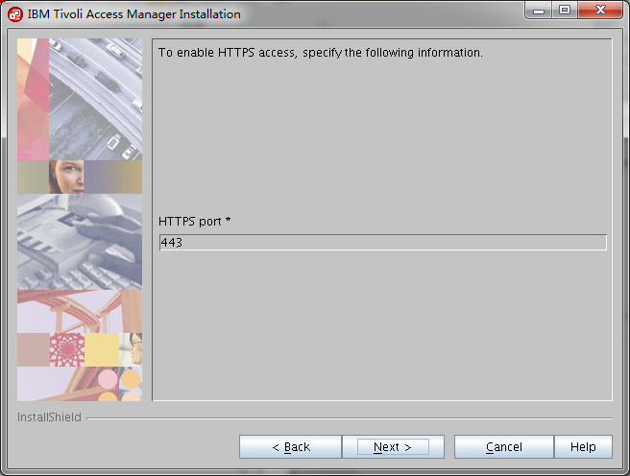

输入HTTPS的默认端口

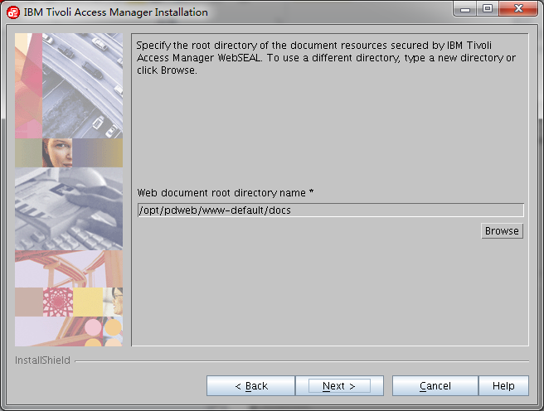

输入主工作页面

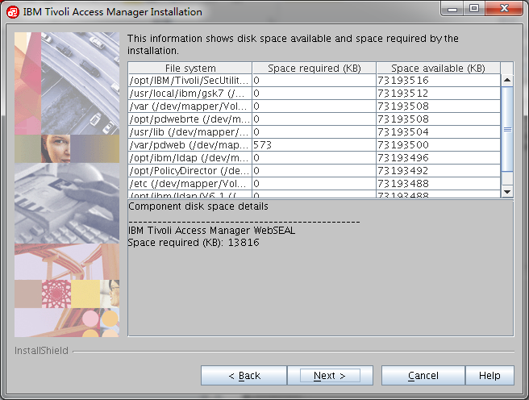

安装空间一览

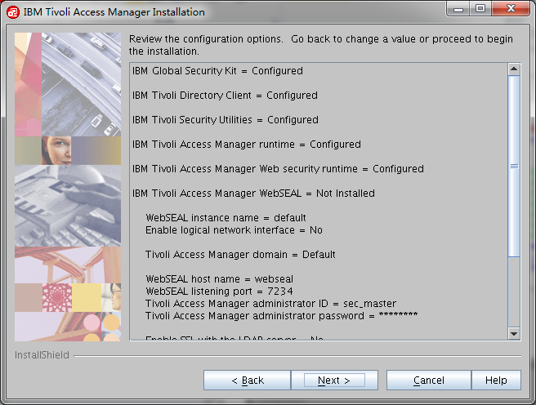

安装组件一览

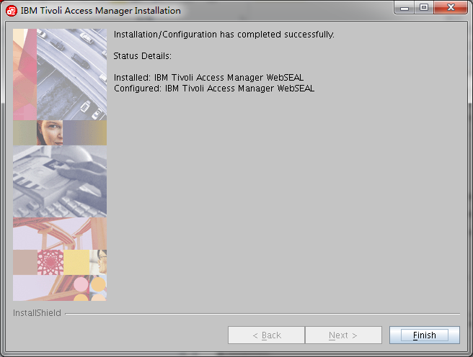

安装完成

## 补丁的安装

cd /software/tamfix

rpm -Uvh *.rpm

## 安装dispatcher

cd /software/adapter/tim

/opt/IBM/TDI/V7.1/jvm/jre/bin/java -jar DispatcherInstall.jar

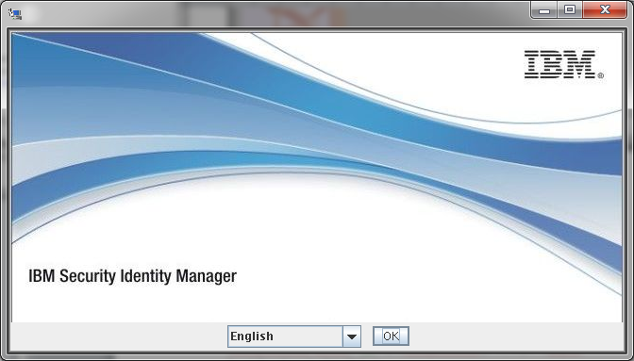

选择安装语言向导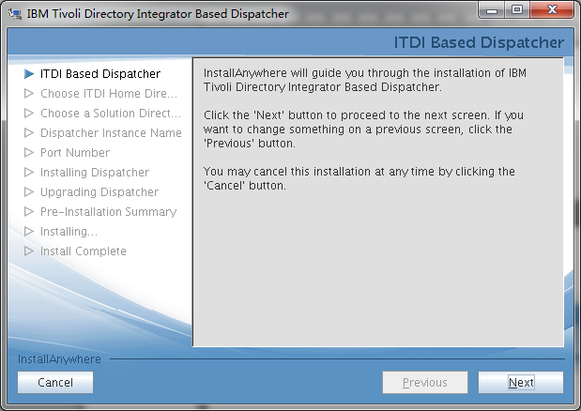

点击下一步

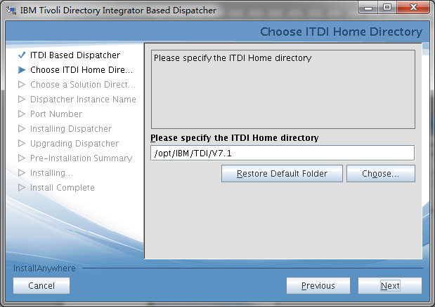

选择TDI的安装目录

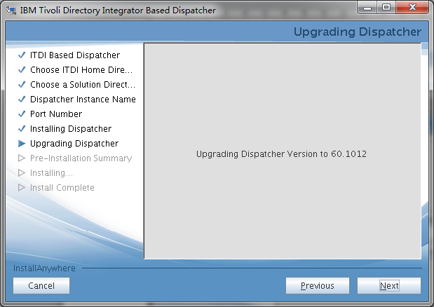

点击下一步

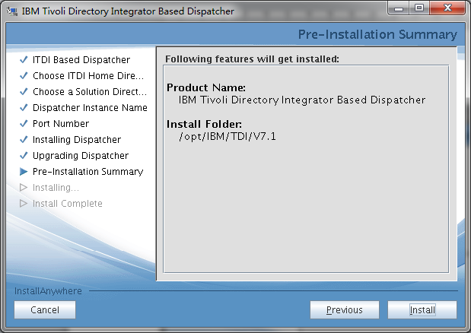

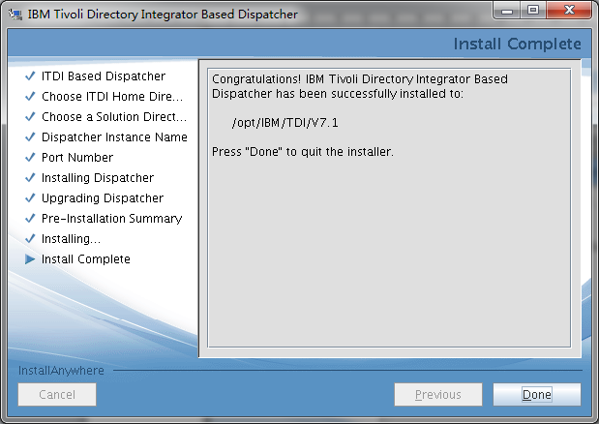

安装完毕

## 配置tim的tam插件

[root@webseal tamfix]# cd /opt/PolicyDirector/java/export/pdjrte

[root@webseal pdjrte]# ls -l

鎬昏 1132

-r--r--r-- 1 ivmgr ivmgr 1151538 2012-07-13 PD.jar

[root@webseal pdjrte]# sftp 10.47.0.108

Connecting to 10.47.0.108...

The authenticity of host '10.47.0.108 (10.47.0.108)' can't be established.

RSA key fingerprint is 3d:95:e1:3c:33:ee:e0:a5:4d:1d:5d:ed:82:da:0c:26.

Are you sure you want to continue connecting (yes/no)? yes

Warning: Permanently added '10.47.0.108' (RSA) to the list of known hosts.

root@10.47.0.108's password:

sftp> cd /opt/IBM/TDI/V7.1/jvm/jre/lib/ext

sftp> put PD.jar

Uploading PD.jar to /opt/IBM/TDI/V7.1/jvm/jre/lib/ext/PD.jar

PD.jar 100% 1125KB 1.1MB/s 00:00

sftp> by

Invalid command.

sftp>

tdsldap

cd /software/adapter/sam

cp TAMComboUtils.jar /opt/IBM/TDI/V7.1/jars/connectors

cd /software/tam/server/linux_i386

[root@tdsldap linux_i386]# rpm -ivh ibm-java2-i386-sdk-5.0-5.0.i386.rpm

Preparing... ########################################### [100%]

1:ibm-java2-i386-sdk ########################################### [100%]

cd ..

[root@tdsldap server]# ./install_amjrte -is:javahome /opt/ibm/java2-i386-50/jre -console

InstallShield Wizard

Initializing InstallShield Wizard...

Searching for Java(tm) Virtual Machine...

..........................

-------------------------------------------------------------------------------

Select a language to be used for this wizard.

[ ] 1 - Czech

[X] 2 - English

[ ] 3 - French

[ ] 4 - German

[ ] 5 - Hungarian

[ ] 6 - Italian

[ ] 7 - Japanese

[ ] 8 - Korean

[ ] 9 - Polish

[ ] 10 - Portuguese (Brazil)

[ ] 11 - Russian

[ ] 12 - Simplified Chinese

[ ] 13 - Spanish

[ ] 14 - Traditional Chinese

To select an item enter its number, or 0 when you are finished: [0]

-------------------------------------------------------------------------------

Welcome to the InstallShield Wizard for IBM Tivoli Access Manager Runtime for

Java

The InstallShield Wizard will install IBM Tivoli Access Manager Runtime for

Java on your computer.

To continue, choose Next.

IBM Tivoli Access Manager Runtime for Java

International Business Machines Corporation

www.ibm.com

Press 1 for Next, 3 to Cancel or 4 to Redisplay [1]

-------------------------------------------------------------------------------

Software Licensing Agreement

Press Enter to display the license agreement on your screen. Please

read the agreement carefully before installing the Program. After

reading the agreement, you will be given the opportunity to accept it

or decline it. If you choose to decline the agreement, installation

will not be completed and you will not be able to use the Program.

International Program License Agreement

Part 1 - General Terms

BY DOWNLOADING, INSTALLING, COPYING, ACCESSING, OR USING

THE PROGRAM YOU AGREE TO THE TERMS OF THIS AGREEMENT. IF YOU

ARE ACCEPTING THESE TERMS ON BEHALF OF ANOTHER PERSON OR A

COMPANY OR OTHER LEGAL ENTITY, YOU REPRESENT AND WARRANT

THAT YOU HAVE FULL AUTHORITY TO BIND THAT PERSON, COMPANY,

OR LEGAL ENTITY TO THESE TERMS. IF YOU DO NOT AGREE TO

THESE TERMS,

- DO NOT DOWNLOAD, INSTALL, COPY, ACCESS, OR USE THE

PROGRAM; AND

- PROMPTLY RETURN THE PROGRAM AND PROOF OF ENTITLEMENT TO

THE PARTY FROM WHOM YOU ACQUIRED IT TO OBTAIN A REFUND OF

THE AMOUNT YOU PAID. IF YOU DOWNLOADED THE PROGRAM, CONTACT

THE PARTY FROM WHOM YOU ACQUIRED IT.

"IBM" is International Business Machines Corporation or one

of its subsidiaries.

"License Information" ("LI") is a document that provides

information specific to a Program. The Program's LI is

available at http://www.ibm.com/software/sla/ . The LI may

also be found in a file in the Program's directory, by the

use of a system command, or as a booklet which accompanies

the Program.

Press Enter to continue viewing the license agreement, or, Enter 1 to

accept the agreement, 2 to decline it or 99 to go back to the previous

screen.

1

Press 1 for Next, 2 for Previous, 3 to Cancel or 4 to Redisplay [1]

-------------------------------------------------------------------------------

Tivoli Common Directory logging is already configured. You may choose

to use the configured location for log files, or use an

application-specific log directory.

The current configured Tivoli Common Logging directory is:

/var/ibm/tivoli/common

-------------------------------------------------------------------------------

Enable Tivoli Common Directory for logging

[ ] 1 - Enable Tivoli Common Directory for logging

To select an item enter its number, or 0 when you are finished [0]:

Press 1 for Next, 2 for Previous, 3 to Cancel or 4 to Redisplay [1]

-------------------------------------------------------------------------------

To configure IBM Tivoli Access Manager Runtime for Java, specify the following

information.

Policy server host name * [] webseal

Policy server SSL port * [7135]

Please specify a directory name or press Enter

[/opt/ibm/java2-i386-50/jre] /opt/IBM/TDI/V7.1/jvm/jre

Press 1 for Next, 2 for Previous, 3 to Cancel or 4 to Redisplay [1]

-------------------------------------------------------------------------------

This information shows disk space available and space required by the

installation.

Component disk space details

________________________________________________

File system: /opt/PolicyDirector (/dev/mapper/VolGroup00-LogVol00)

Space required (KB): 1744

Space available (KB): 62717816

Press 1 for Next, 2 for Previous, 3 to Cancel or 4 to Redisplay [1]

-------------------------------------------------------------------------------

Review the configuration options. Go back to change a value or proceed to begin

the installation.

IBM Tivoli Access Manager Runtime for Java = Not Installed

Enable Tivoli Common Directory for logging = No

Policy server host name = webseal

Policy server SSL port = 7135

JRE directory = /opt/IBM/TDI/V7.1/jvm/jre

Press 1 for Next, 2 for Previous, 3 to Cancel or 4 to Redisplay [1]

IBM Tivoli Access Manager Runtime for Java

|-----------|-----------|-----------|------------|

0% 25% 50% 75% 100%

||||||||||||||

|-----------|-----------|-----------|------------|

0% 25% 50% 75% 100%

||||||||||||||||||||||||||||||||||

IBM Tivoli Access Manager Runtime for Java

|-----------|-----------|-----------|------------|

0% 25% 50% 75% 100%

|||||||||||||||||||||||||||||||||||||||||||||||||

-------------------------------------------------------------------------------

Installation/Configuration has completed successfully. Status Details:

Installed: IBM Tivoli Access Manager license Installed: IBM Tivoli Access

Manager Runtime for Java Configured: IBM Tivoli Access Manager Runtime for

Java

Press 3 to Finish or 4 to Redisplay [3]

[root@tdsldap server]# pdconfig

-bash: pdconfig: command not found

[root@tdsldap server]# pdconfig

-bash: pdconfig: command not found

[root@tdsldap server]# ls -l

total 292892

drwxrwx--- 2 root root 4096 Mar 25 2008 bin

-rw-r--r-- 1 root root 240744978 Jan 8 10:58 C1AY5ML.zip

drwxrwx--- 2 root root 4096 Mar 25 2008 common

drwxrwx--- 8 root root 4096 Mar 25 2008 EIC

drwxrwx--- 18 root root 4096 Mar 25 2008 help

-rwxrwx--- 1 root root 659970 Mar 25 2008 install_amacld

-rwxrwx--- 1 root root 9139583 Mar 25 2008 install_amacld_setup.jar

-rwxrwx--- 1 root root 659482 Mar 25 2008 install_amadk

-rwxrwx--- 1 root root 9128807 Mar 25 2008 install_amadk_setup.jar

-rwxrwx--- 1 root root 659483 Mar 25 2008 install_amjrte

-rwxrwx--- 1 root root 9083392 Mar 25 2008 install_amjrte_setup.jar

-rwxrwx--- 1 root root 659482 Mar 25 2008 install_ammgr

-rwxrwx--- 1 root root 9145644 Mar 25 2008 install_ammgr_setup.jar

-rwxrwx--- 1 root root 659484 Mar 25 2008 install_amproxy

-rwxrwx--- 1 root root 9139507 Mar 25 2008 install_amproxy_setup.jar

-rwxrwx--- 1 root root 659482 Mar 25 2008 install_amrte

-rwxrwx--- 1 root root 9126977 Mar 25 2008 install_amrte_setup.jar

-rwxrwxrwx 1 root root 16818 Mar 25 2008 install_amwpm

drwxrwx--- 2 root root 4096 Mar 25 2008 license

drwxrwx--- 4 root root 4096 Mar 25 2008 linux_i386

drwxrwx--- 2 root root 4096 Mar 25 2008 rspfile

drwxrwx--- 2 root root 4096 Mar 25 2008 spd

cp /software/adapter/com.tivoli.pd.rgy.jar /opt/IBM/TDI/V7.1/jvm/jre/lib/ext

# TIM上添加TAM的配置

## 在TIM上添加TAM的配置信息

[root@tdsldap server]# export PATH=/opt/IBM/WebSphere/AppServer/java/jre/bin:$PATH

[root@tdsldap server]# export JAVA_HOME=/opt/IBM/WebSphere/AppServer/java/jre

[root@tdsldap server]# /opt/IBM/TDI/V7.1/jvm/jre/bin/java com.tivoli.pd.jcfg.SvrSslCfg -action config -admin_id sec_master -admin_pwd p@55w0rd -appsvr_id itdi_tam -port 1234 -mode remote -policysvr webseal:7135:1 -authzsvr webseal:7136:1 -cfg_file /opt/IBM/TDI/V7.1/timsol/tam.conf -key_file /opt/IBM/TDI/V7.1/timsol/tam.ks

The configuration completed successfully.

cd /opt/IBM/isim/lib

cp itdiAgents-common.jar /opt/IBM/TDI/V7.1/jars/3rdparty/IBM

cp rmi-dispatcher-client.jar /opt/IBM/TDI/V7.1/jars/3rdparty/IBM

cd /opt/IBM/TDI/V7.1/timsol

./ITIMAd stop

./ITIMAd start

Itim manager/secret

## 在TIM上配置TAM Service

<http://10.47.0.108:9080/itim/console>

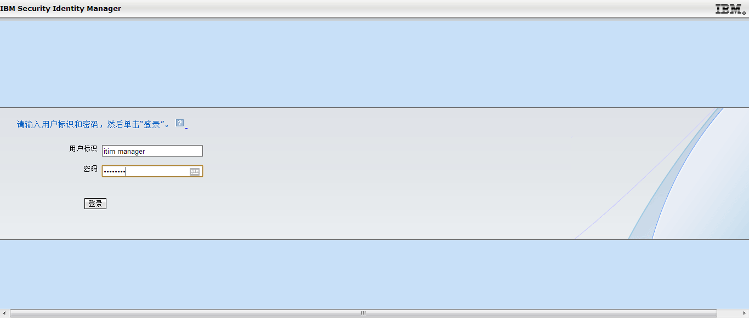 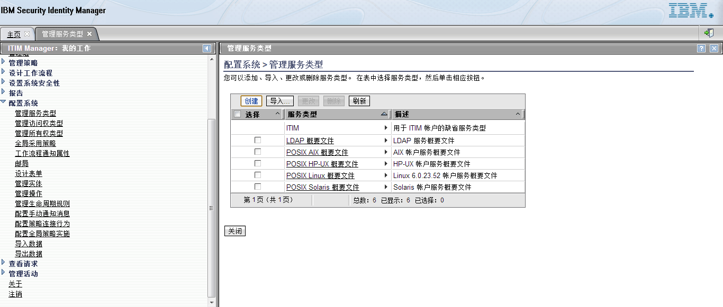 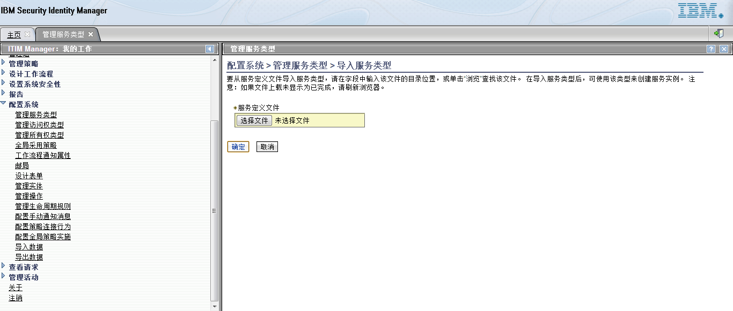 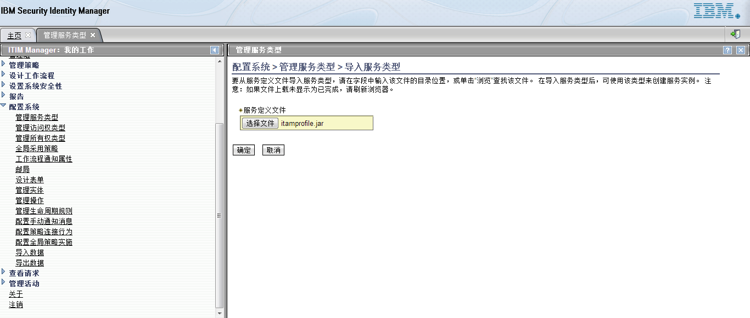

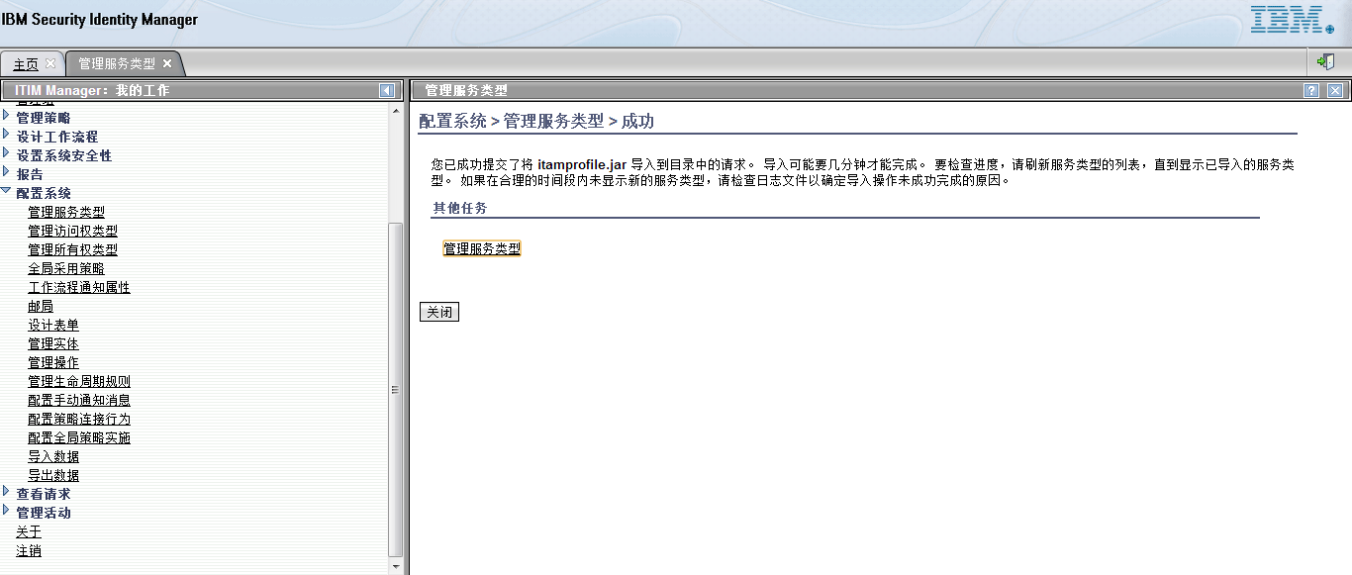 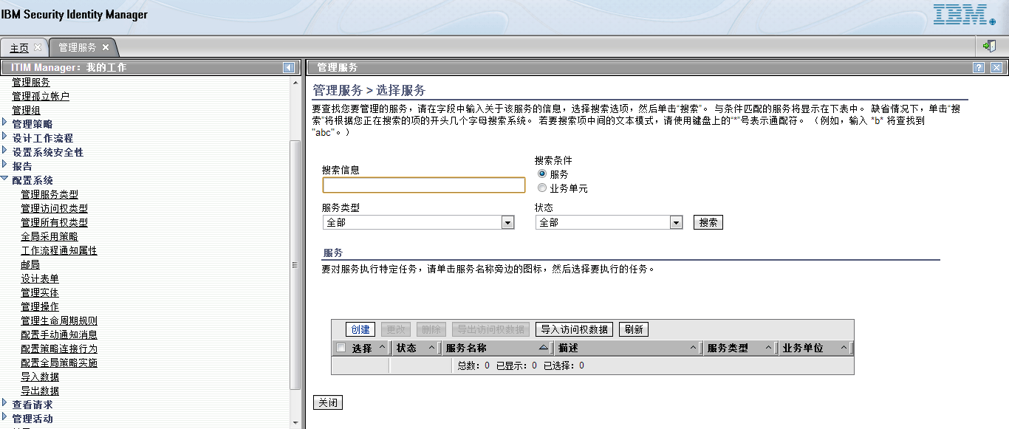 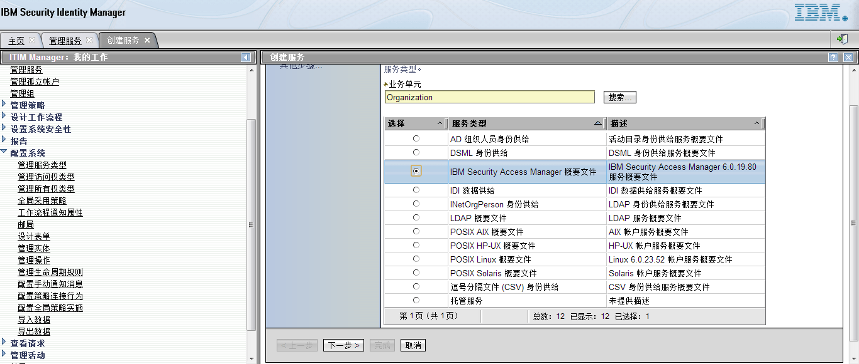 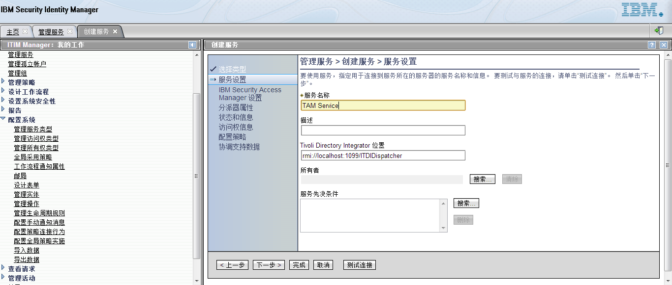

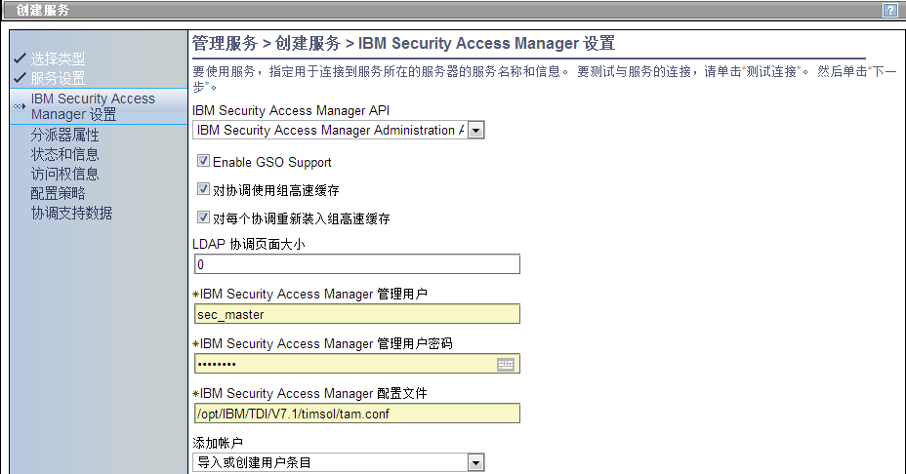

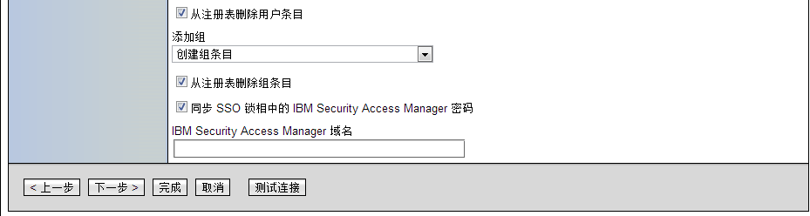 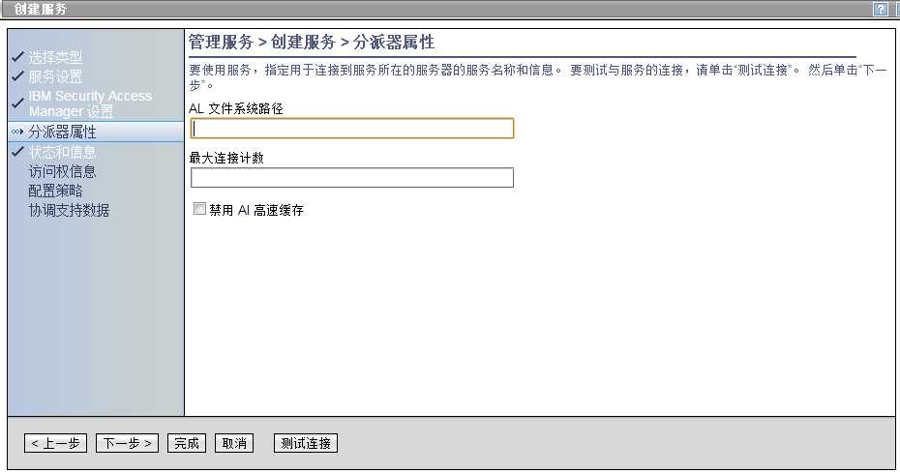 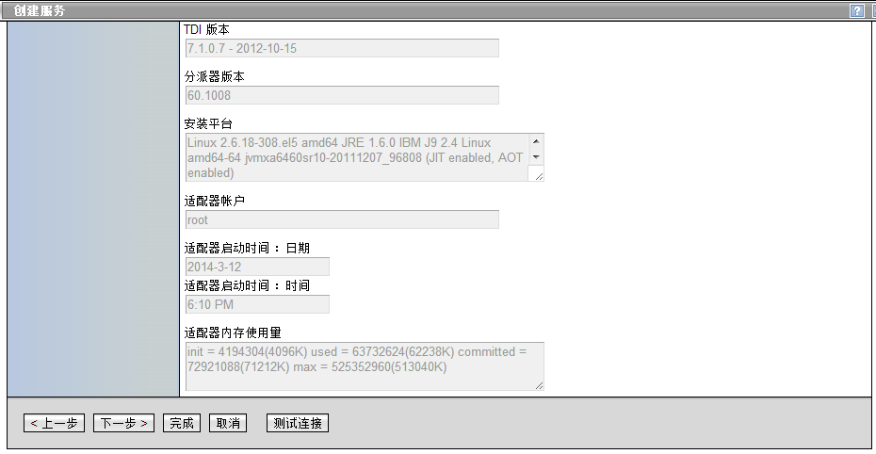 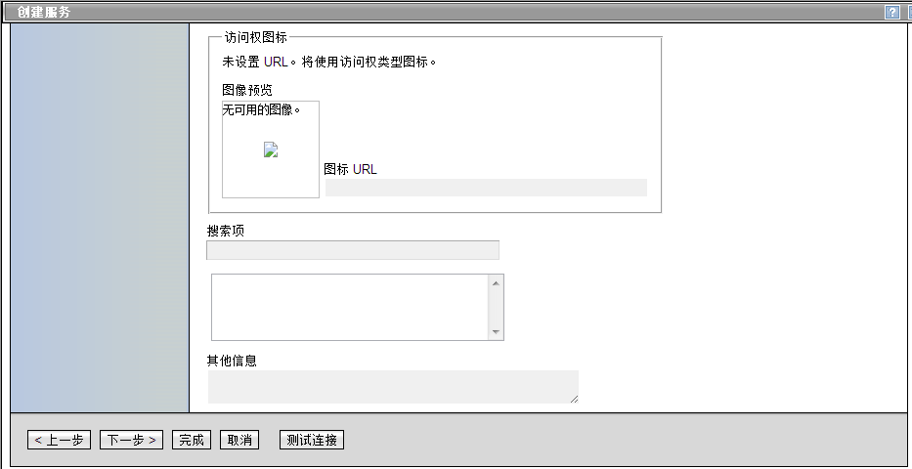 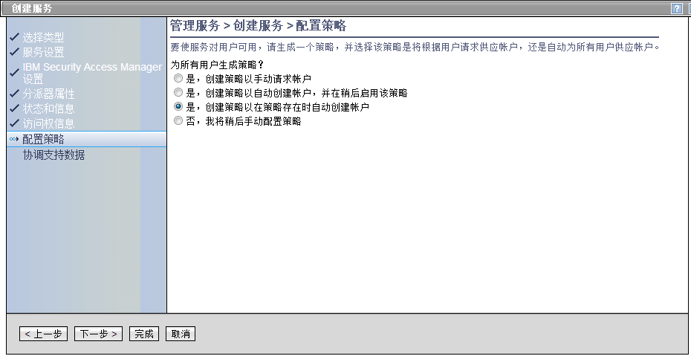 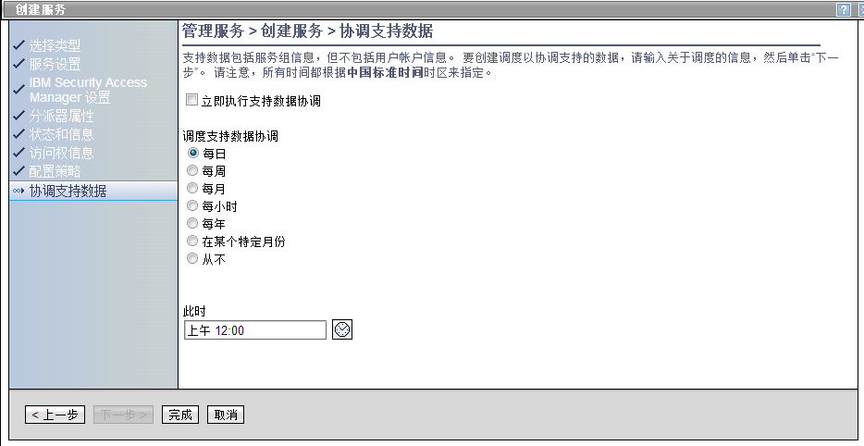 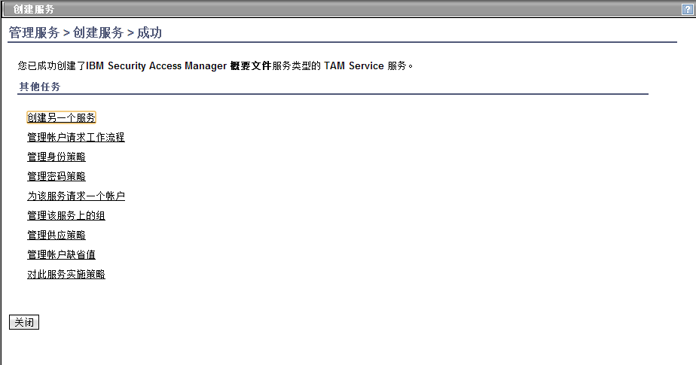 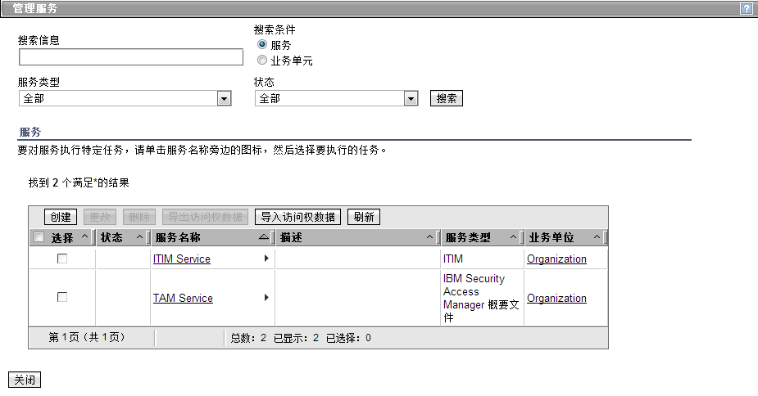 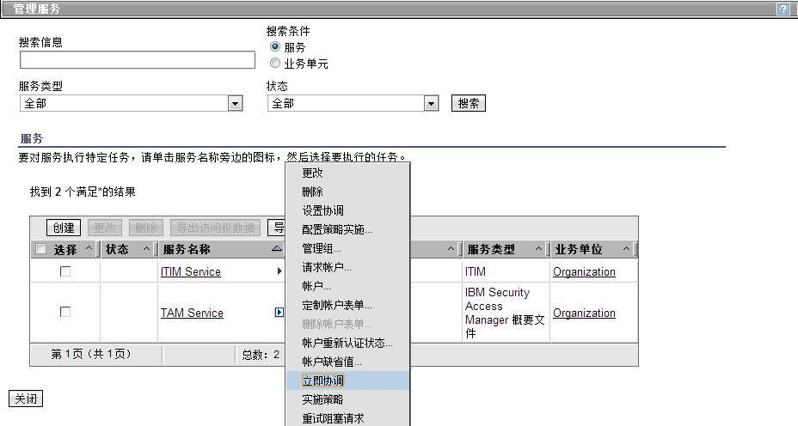 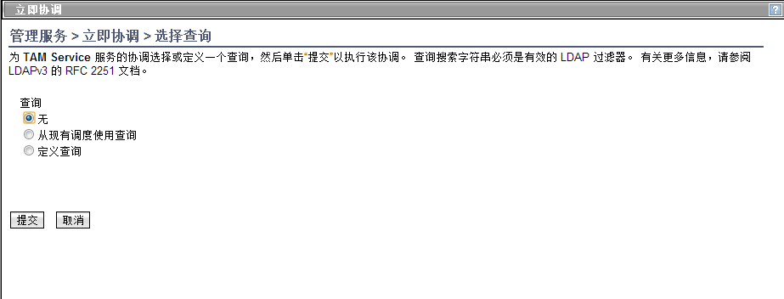 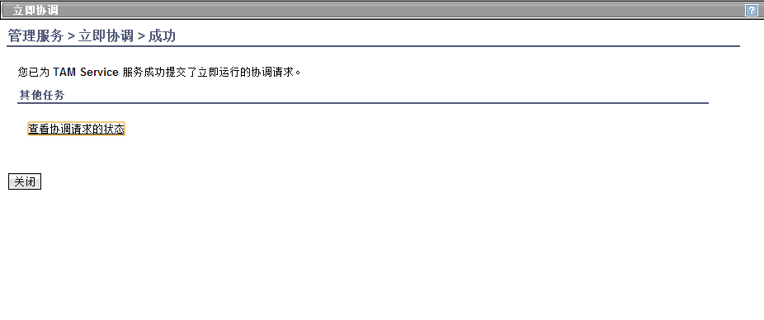

登陆TIM管理Console，选择TAM供应策略

http://10.47.0.108:9080/itim/console

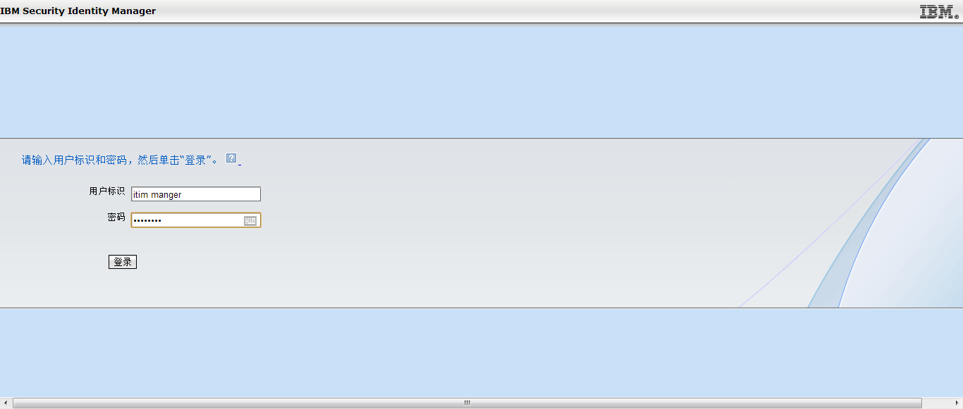

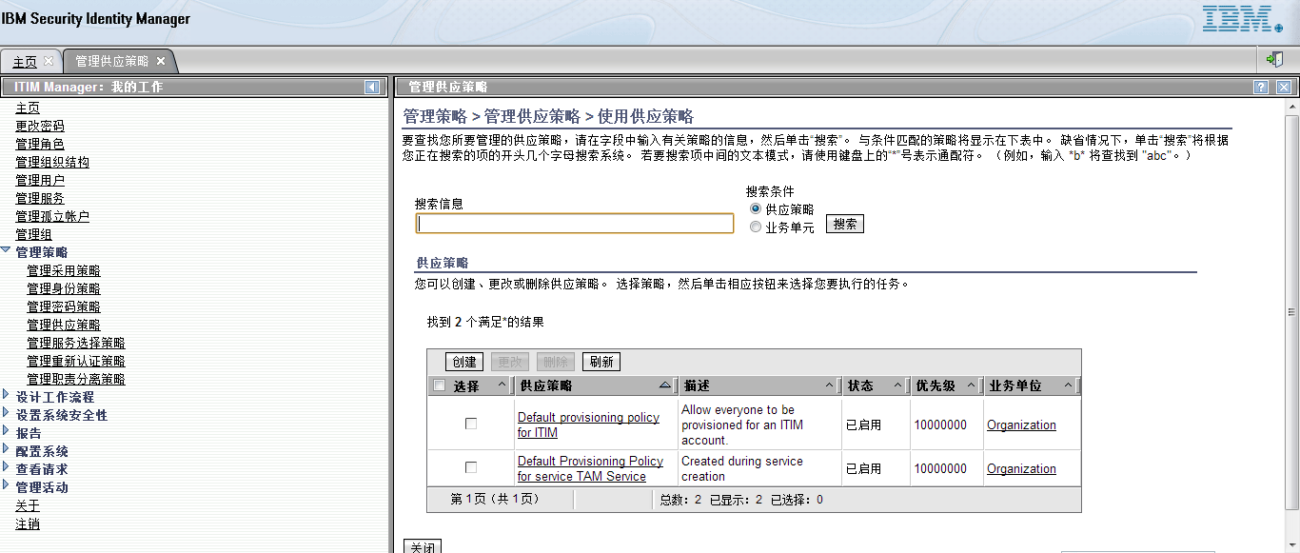 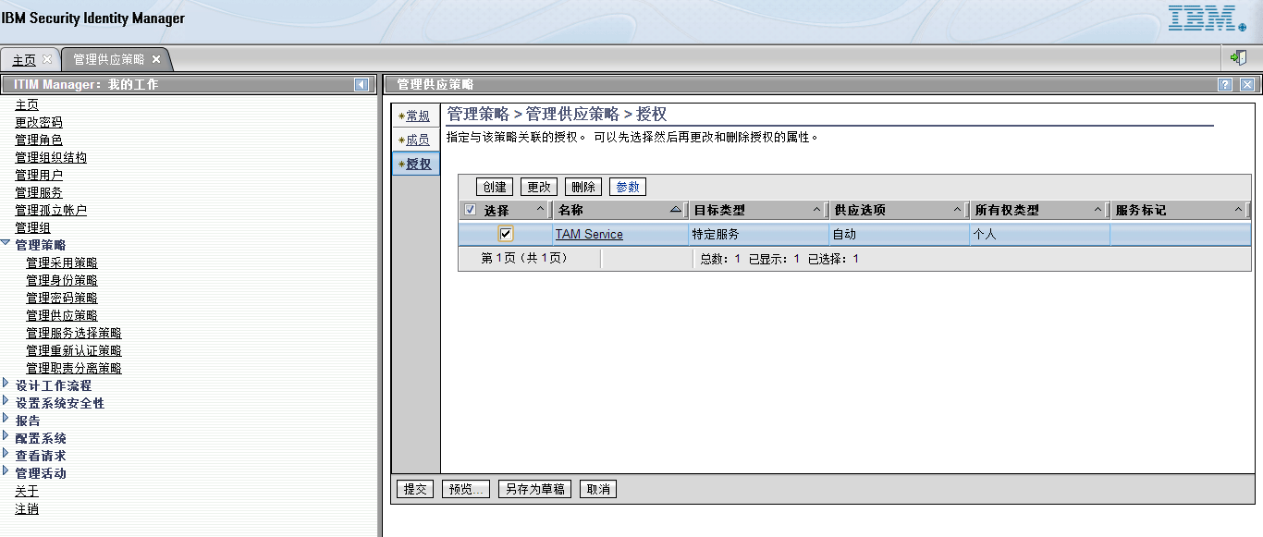

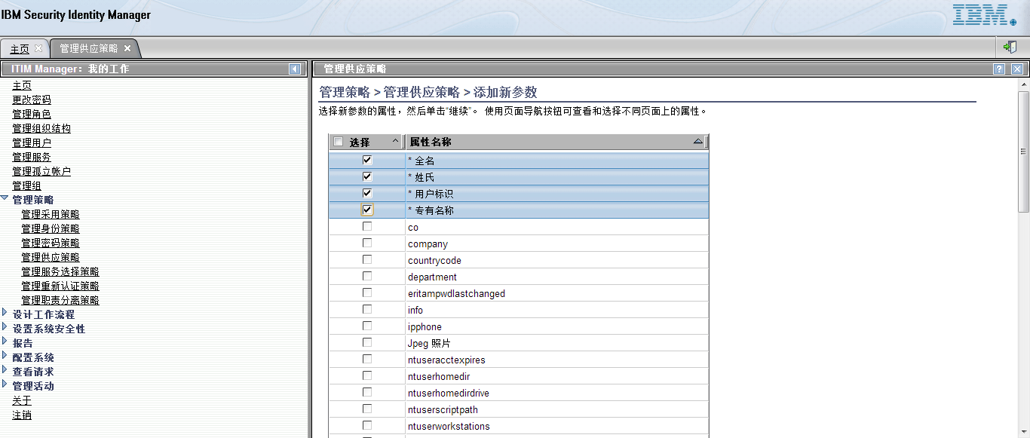

在对应“全名”的属性中，输入以下内容，点击“继续”，如图：

var value= subject.getProperty("cn");if (value.length > 0) {return value[0];}else {return " ";}

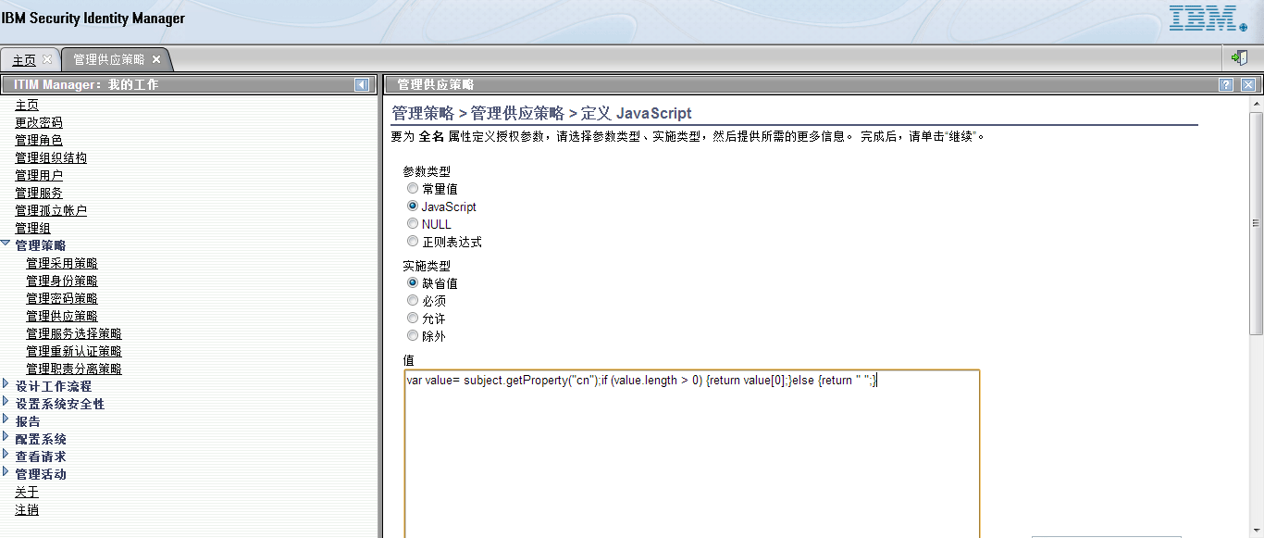

在对应“**Distinguished Name”**属性中，输入以下内容，点击“继续”，如图：

var value= subject.getProperty("uid");if (value.length > 0) {return "uid=" + value[0] + ",cn=users,dc=shccig,dc=com";}else {return " ";}

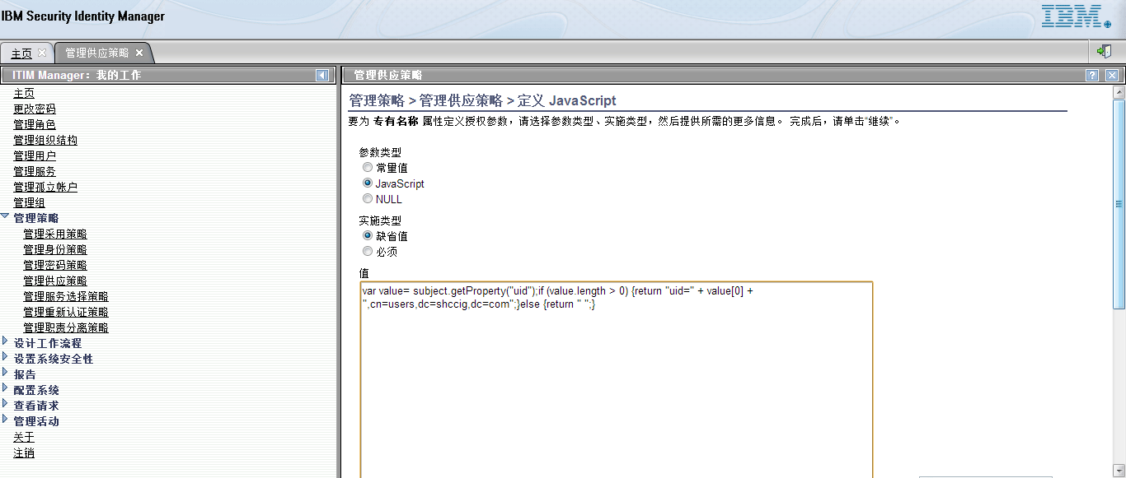

在对应“用户标识”的属性中，输入以下内容，点击“继续”，如图：

var value= subject.getProperty("uid");if (value.length > 0) {return value[0];}else {return " ";}

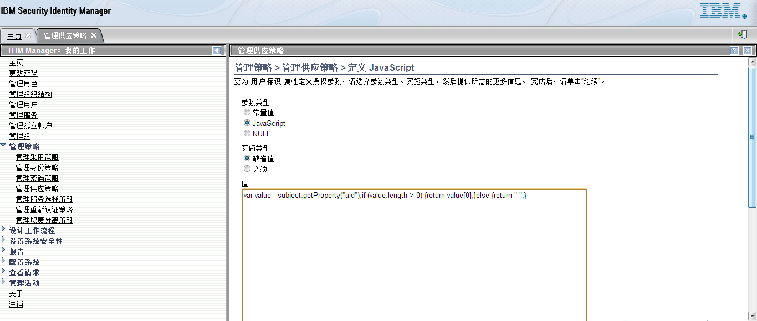

在对应“姓氏”的属性中，输入以下内容，点击“继续”，如图：

var value= subject.getProperty("sn");if (value.length > 0) {return value[0];}else {return " ";}

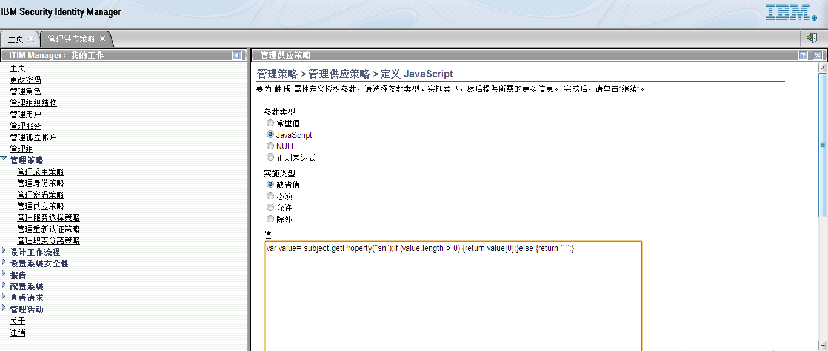 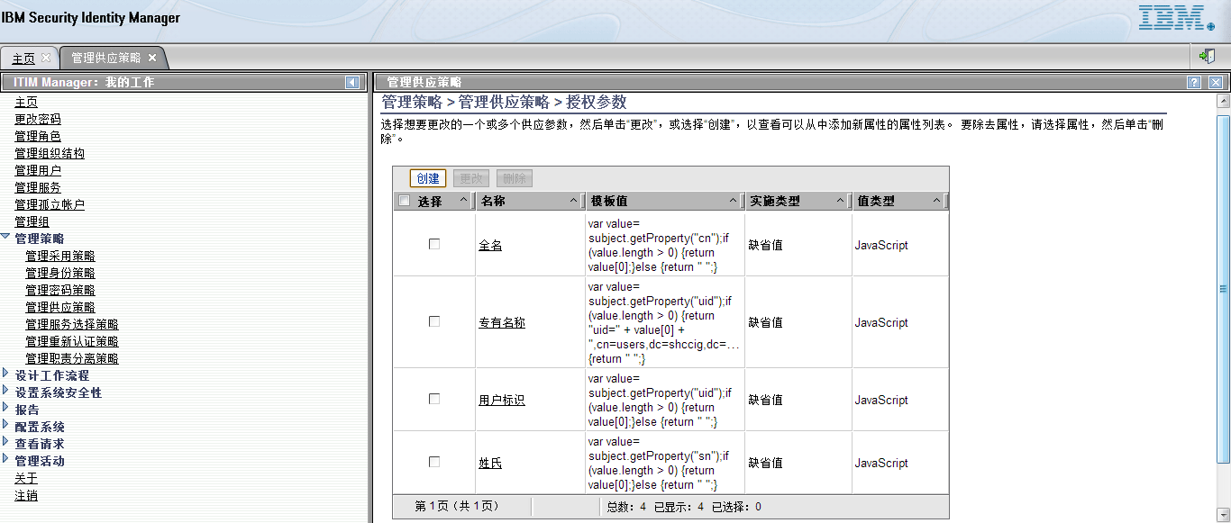 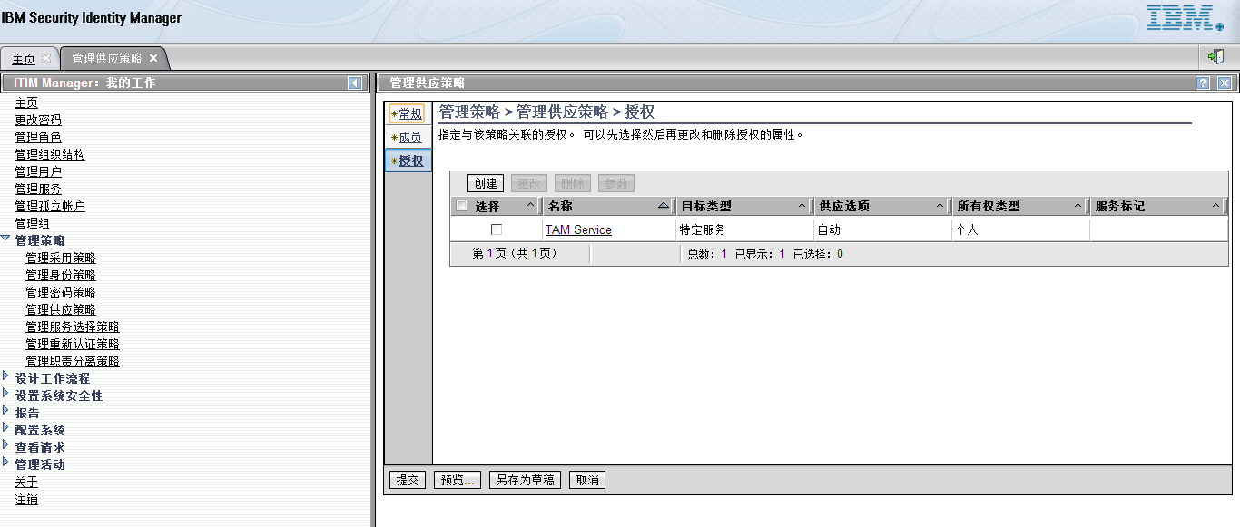 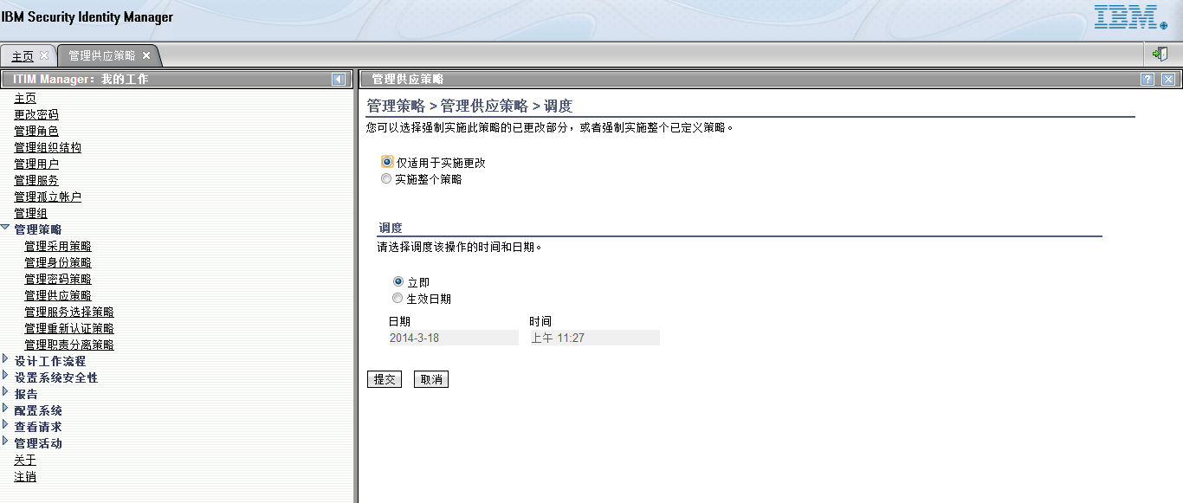 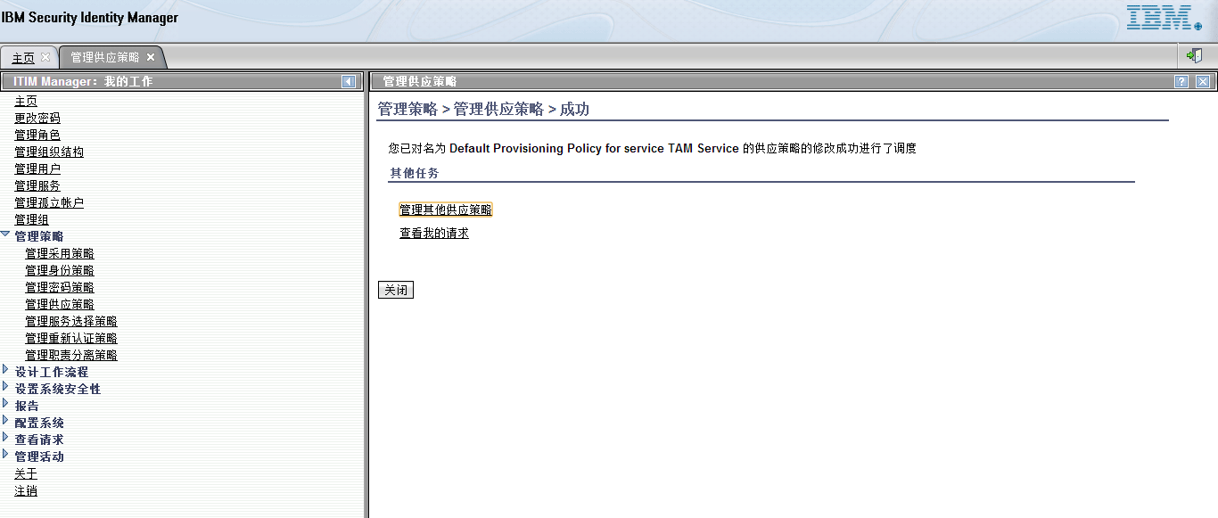

# portal安装

## Install Manager的安装

cd /software/was8.5

mount -o loop IM_152_IMAGES.iso /media

cd /media/IM_152_linux.gtk.x86

./install

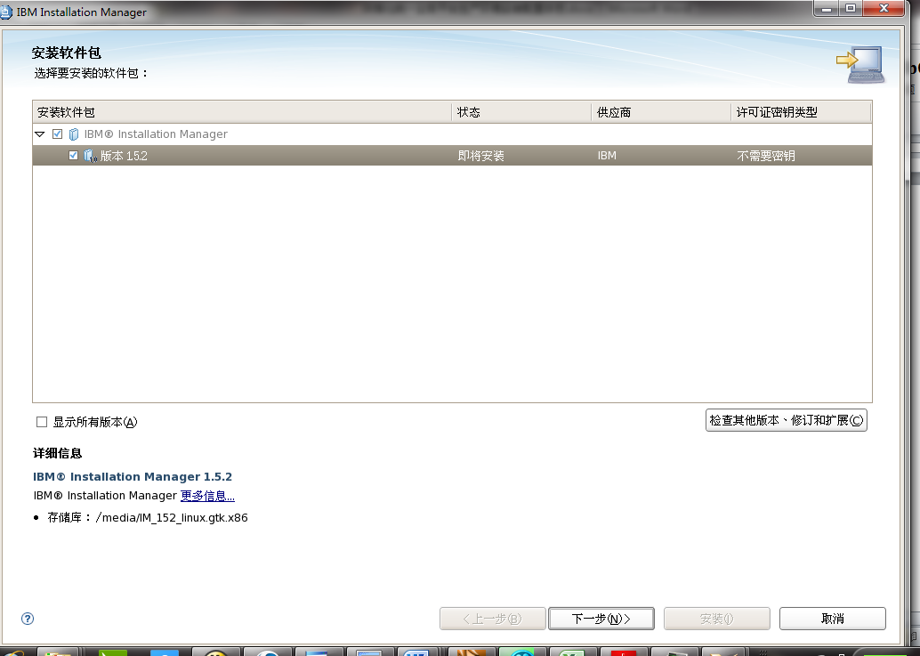

开始安装

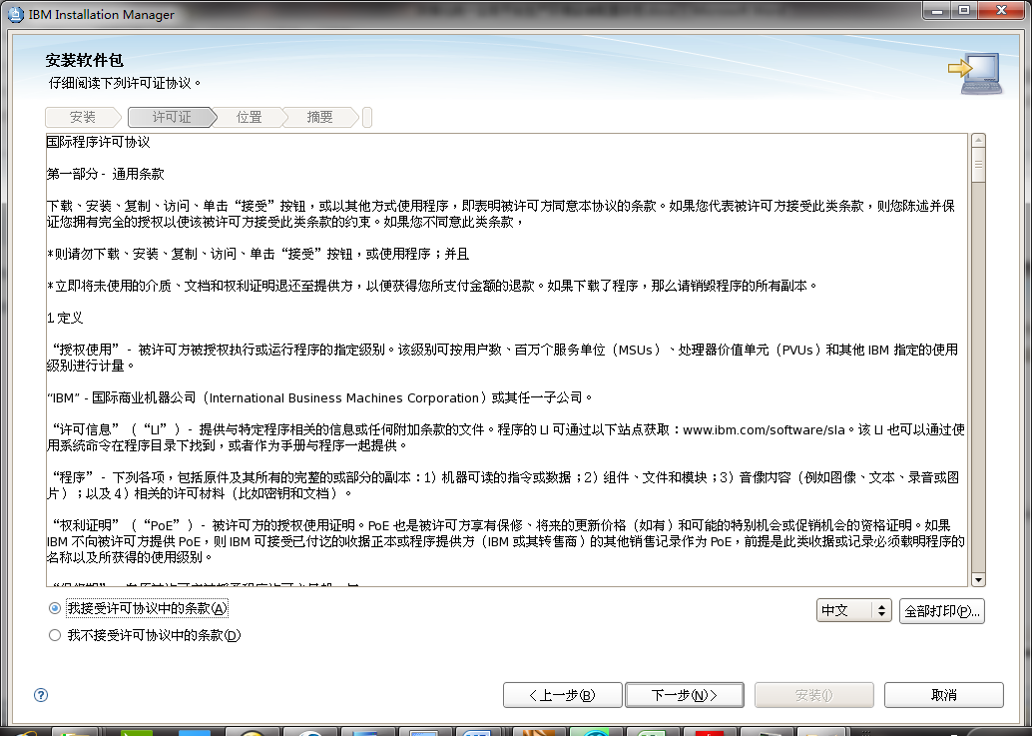

接受协议

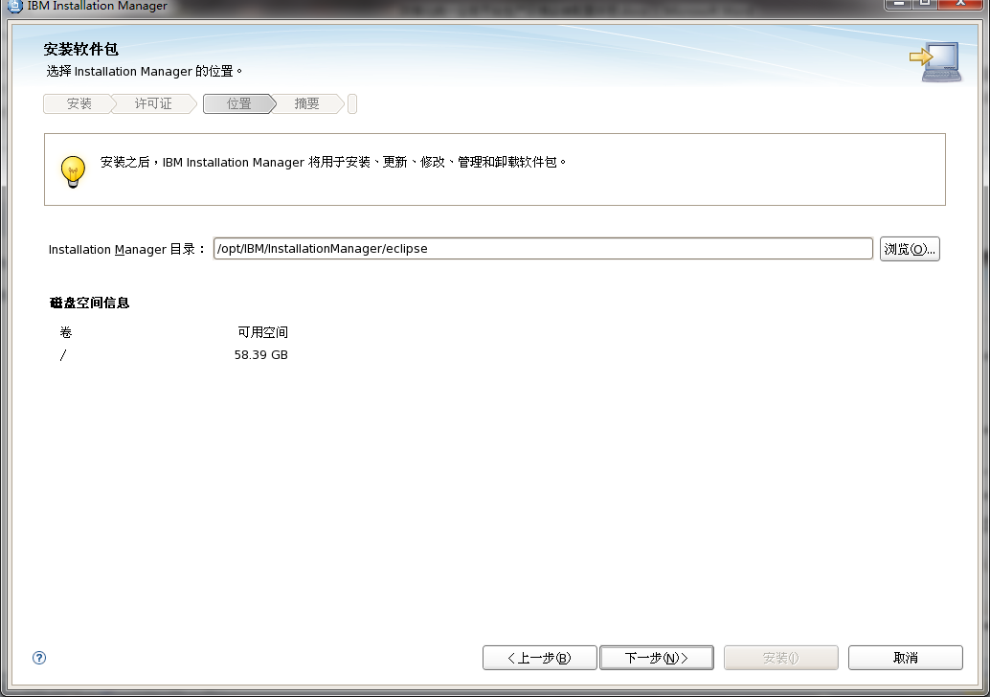

选择Install Manager的位置

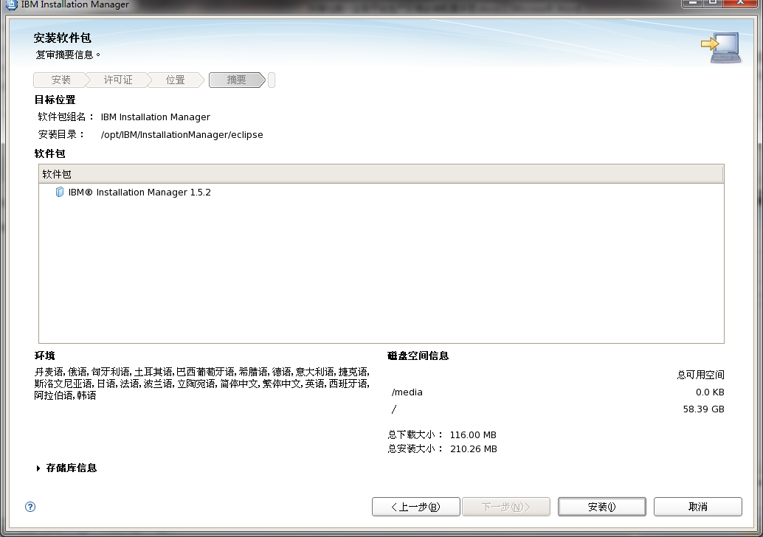

确认需要安装的软件包

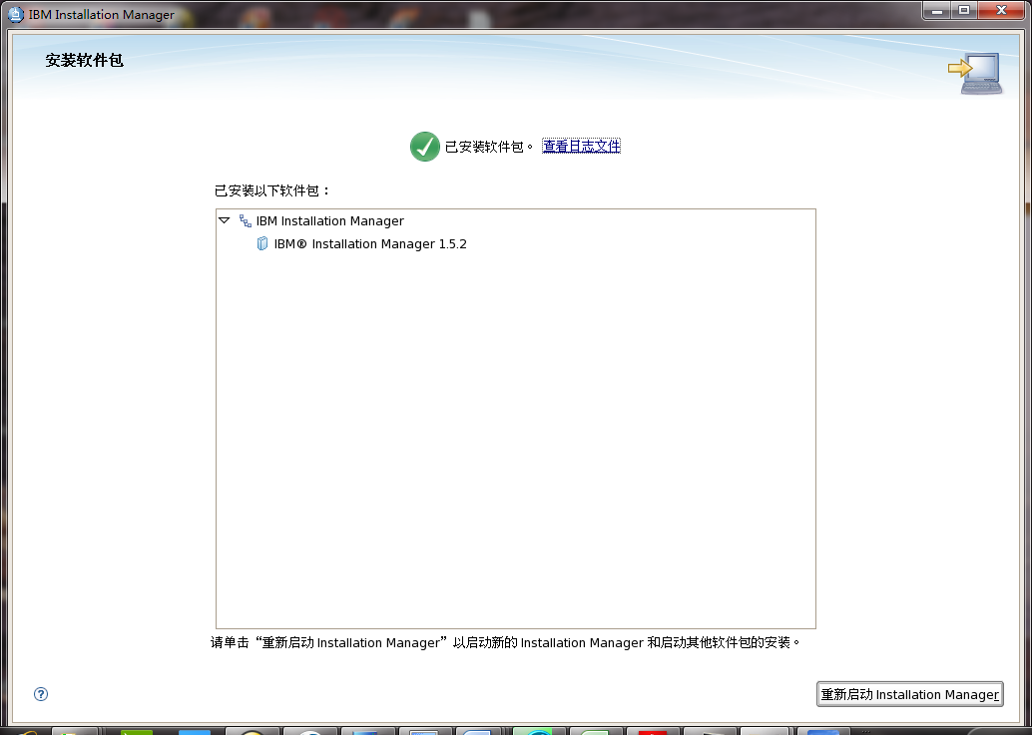

Install Manager 安装完毕

## 安装Was8.5软件

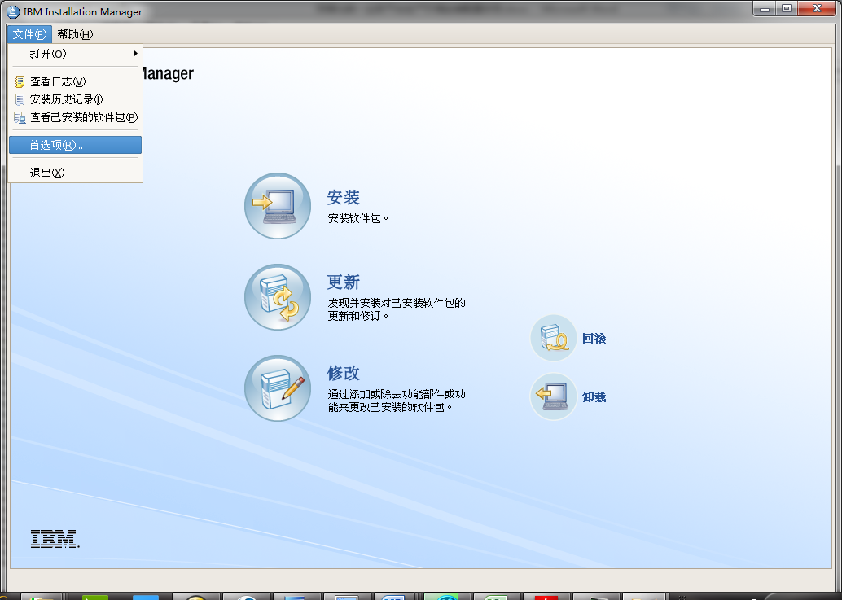

打开IBM Install Manager界面

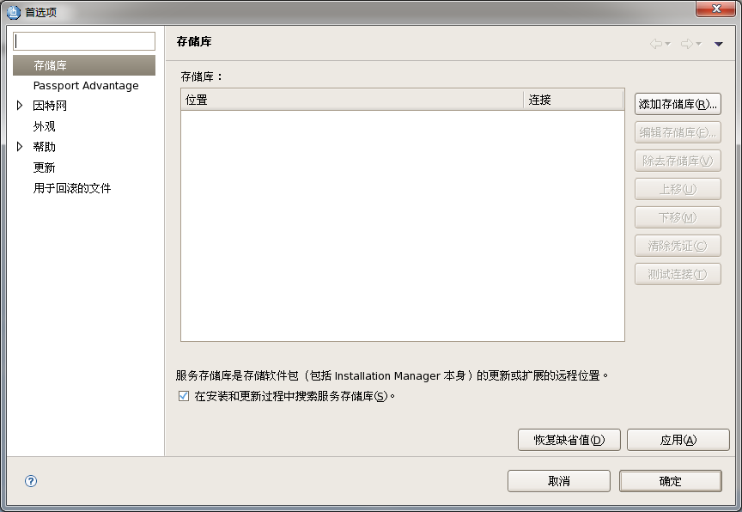

添加WAS的存储库

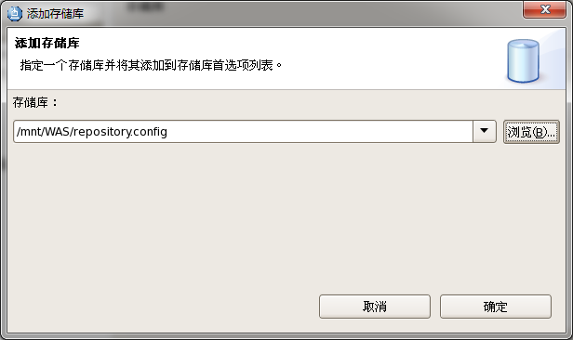

选择config的路径

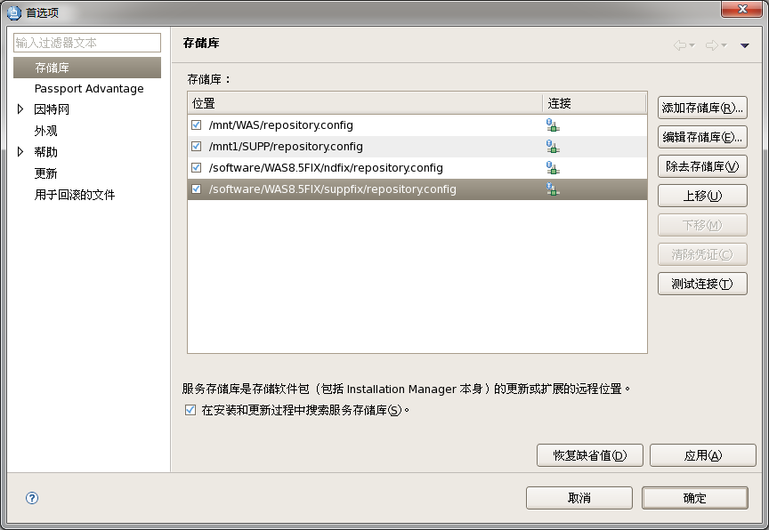

添加所有的config

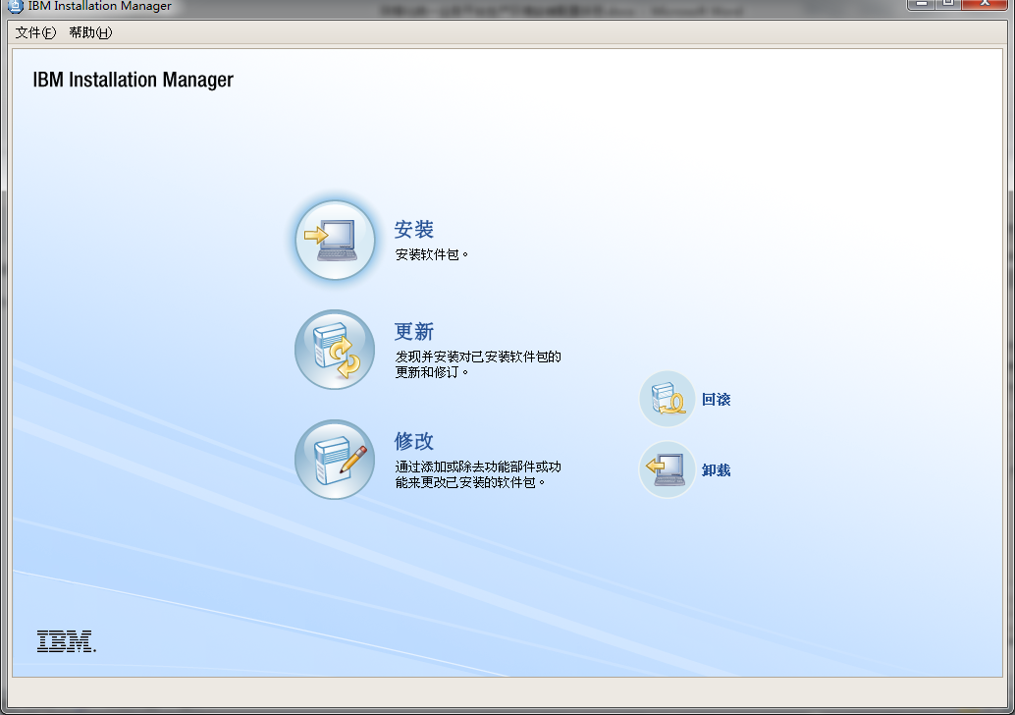

点击安装

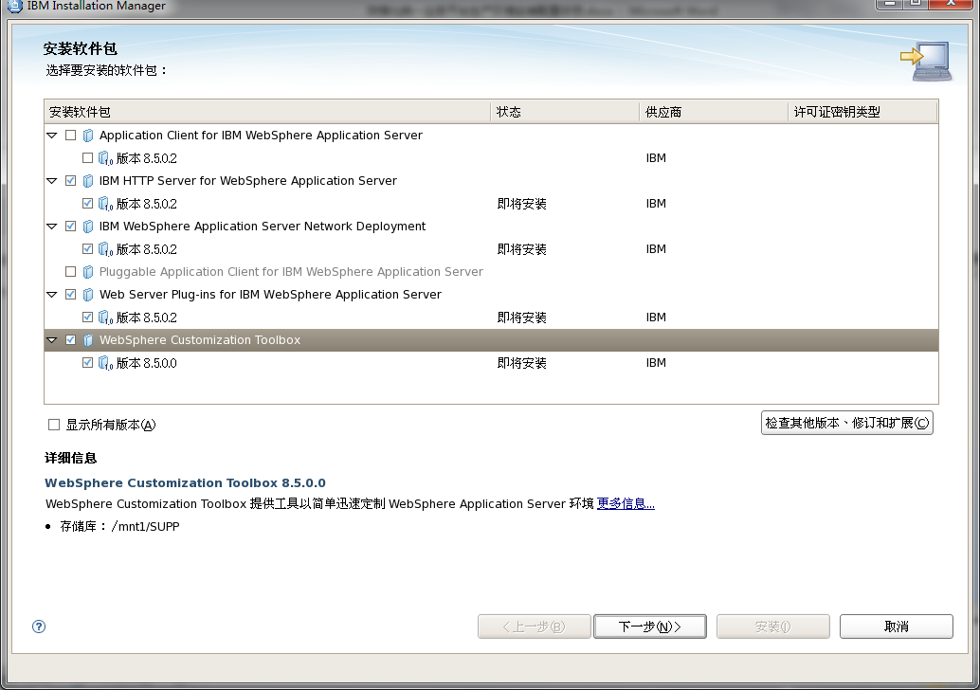

选择需要安装的组件

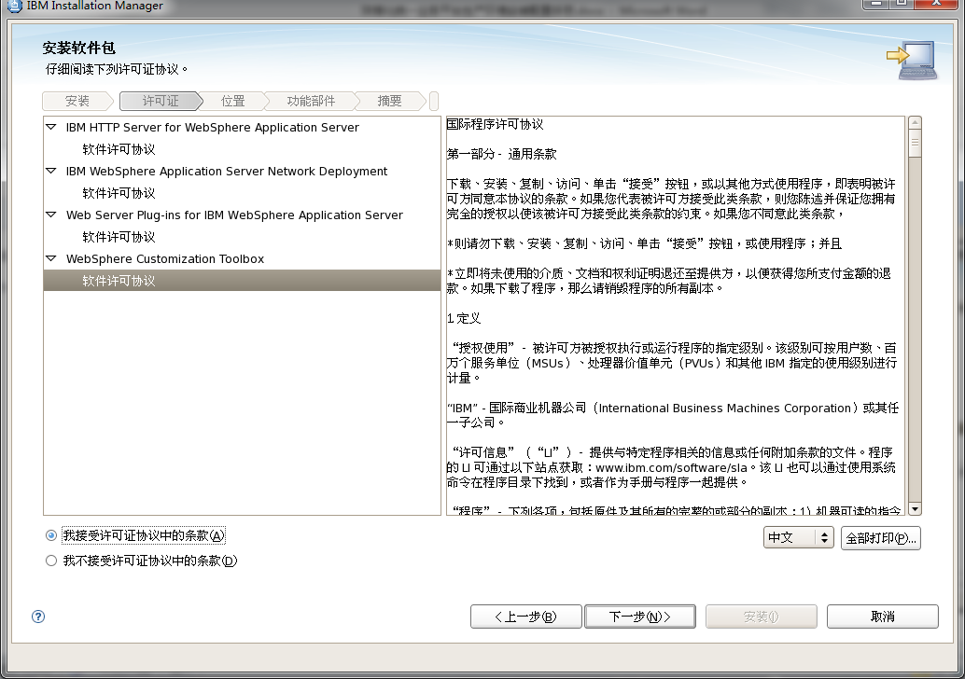

接受许可证

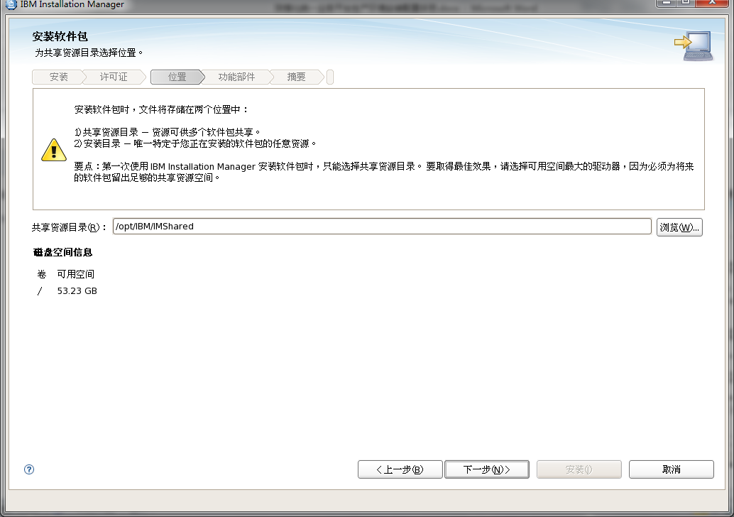

选择文件共享资源的路径

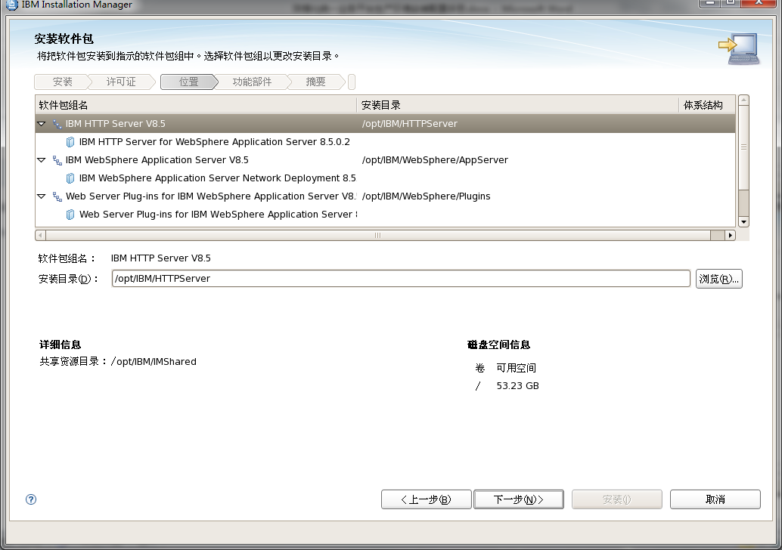

编辑各个组件的安装目录

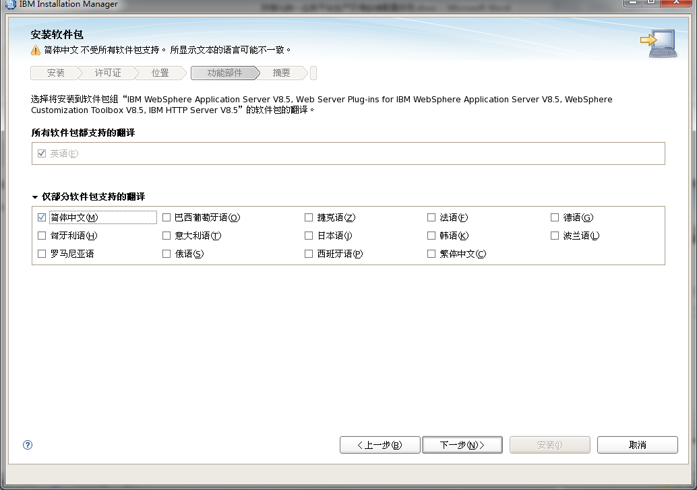

选择简体中文的语言包

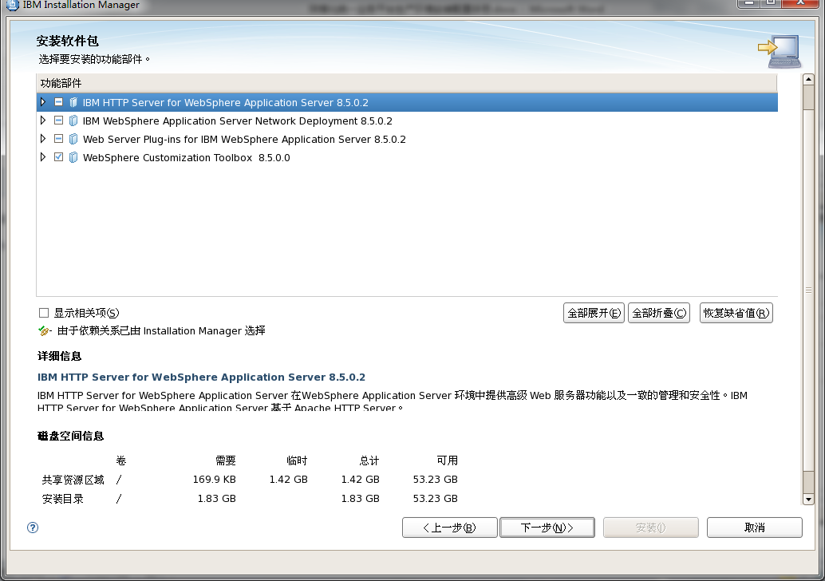

点击下一步，开始安装

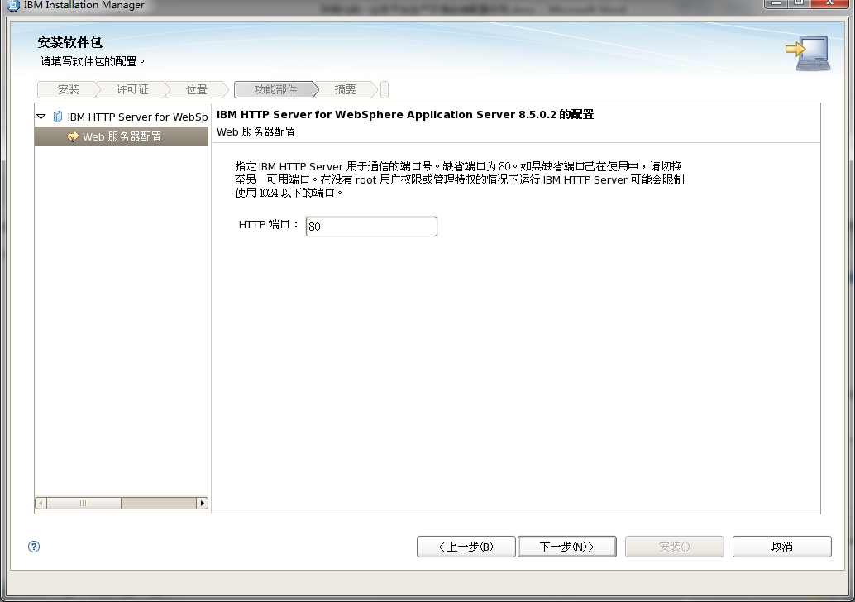

配置IHS for WAS的 http的默认端口

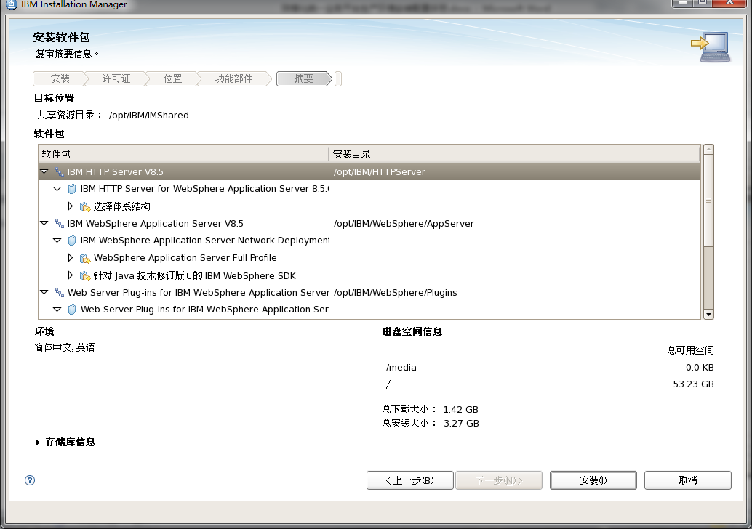

开始安装

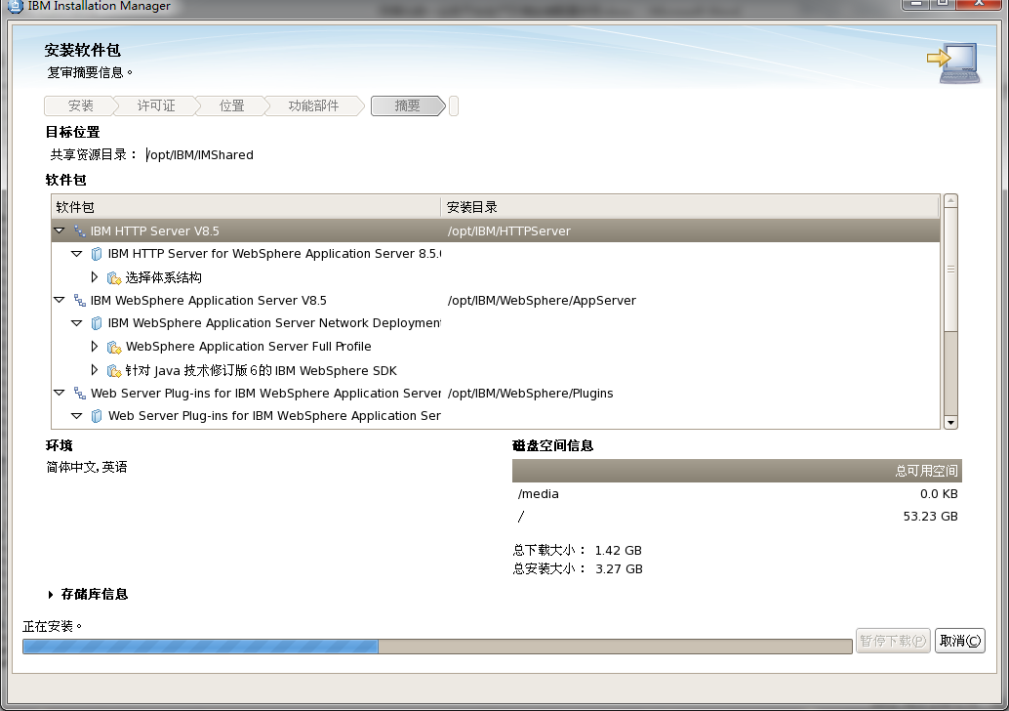

开始安装

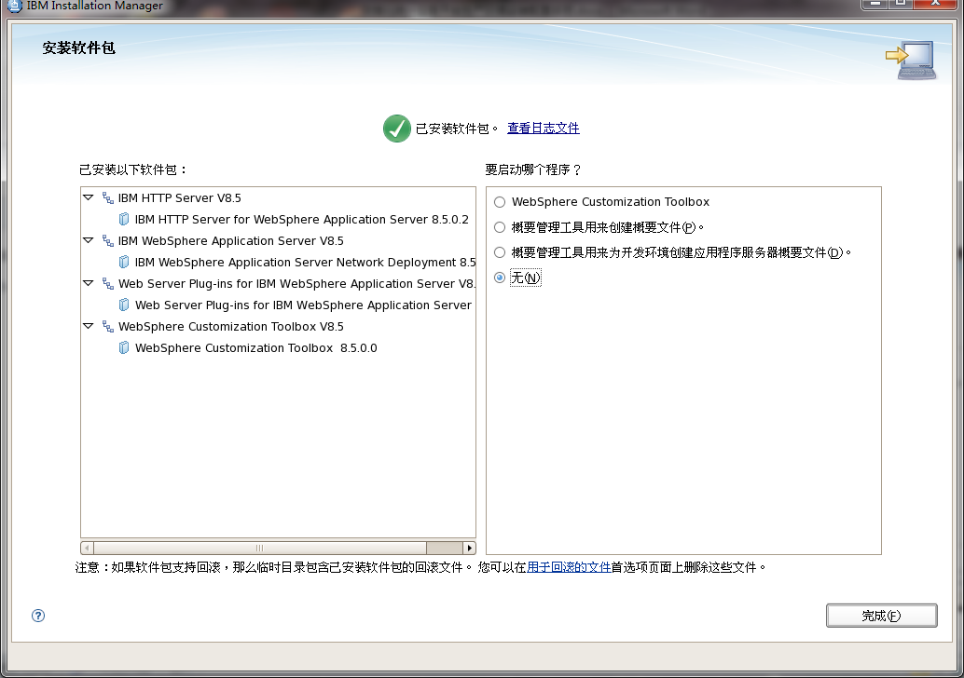

安装完成

## 安装Portal软件

cd /opt/IBM/InstallationManager/eclipse

./launcher

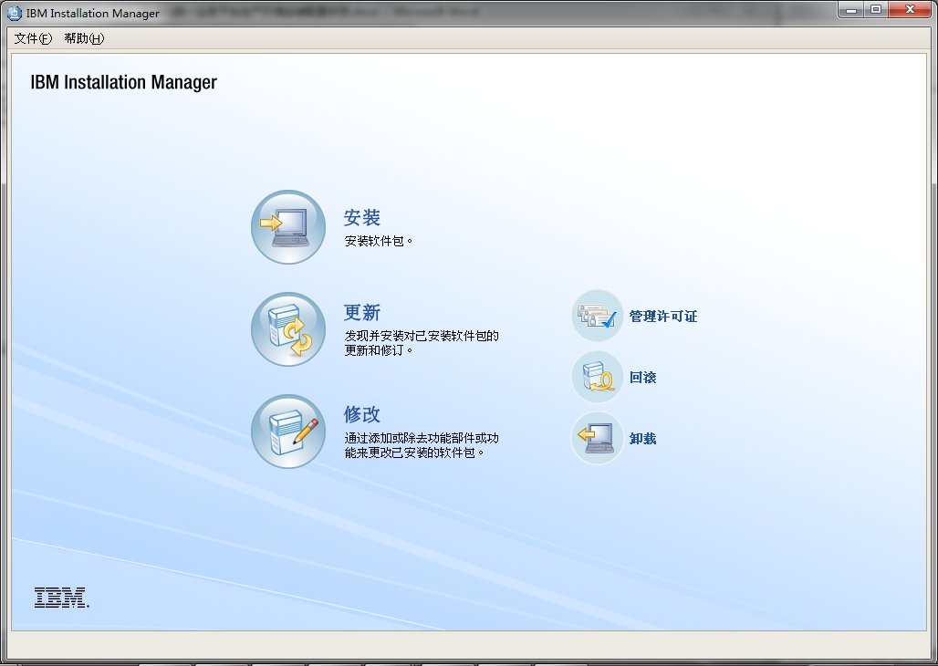

打开Install Manager

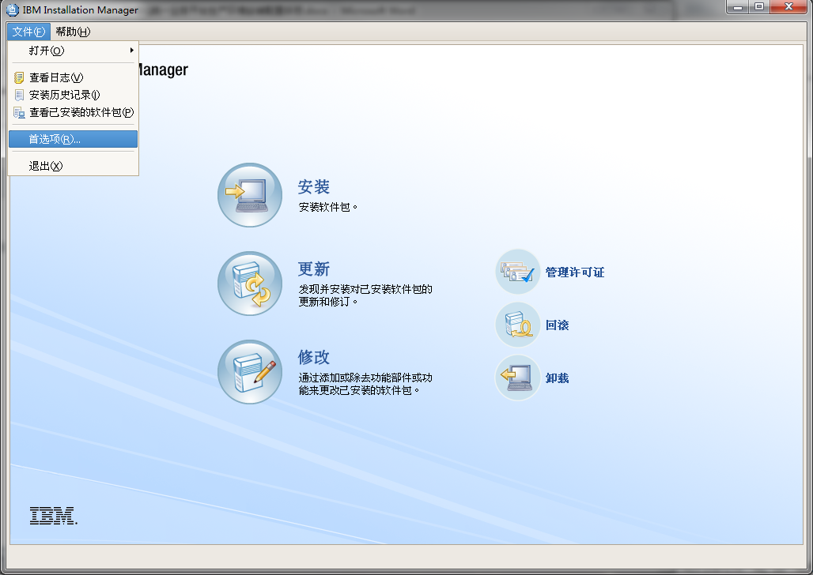

配置repository的路径

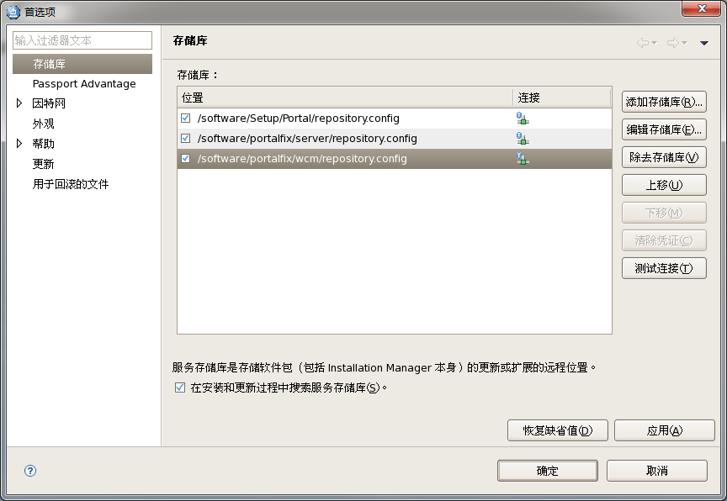

选择合适的repository的config文件

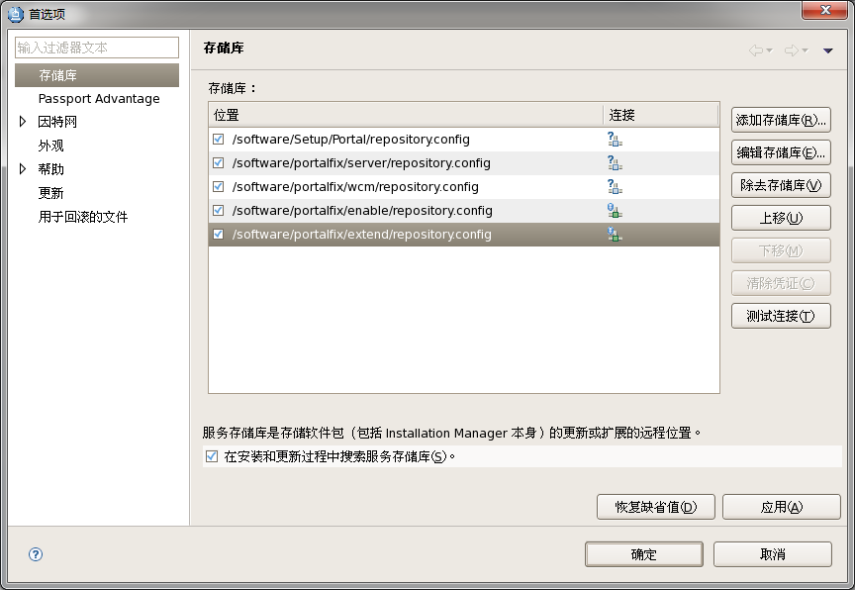

添加portal的补丁repository

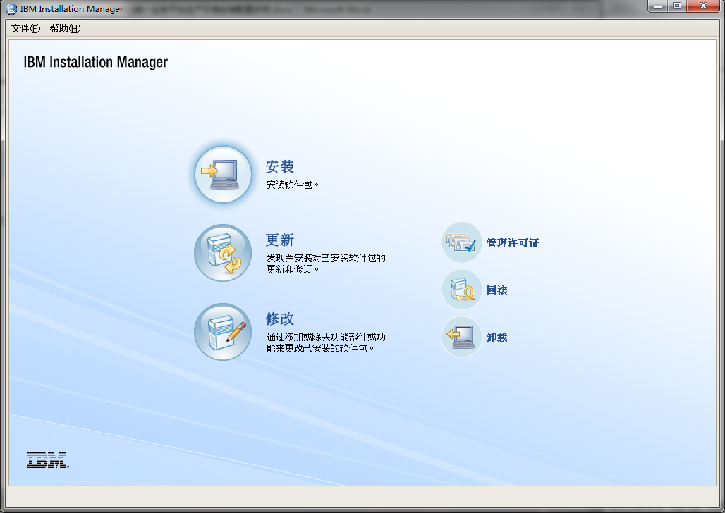

开始安装

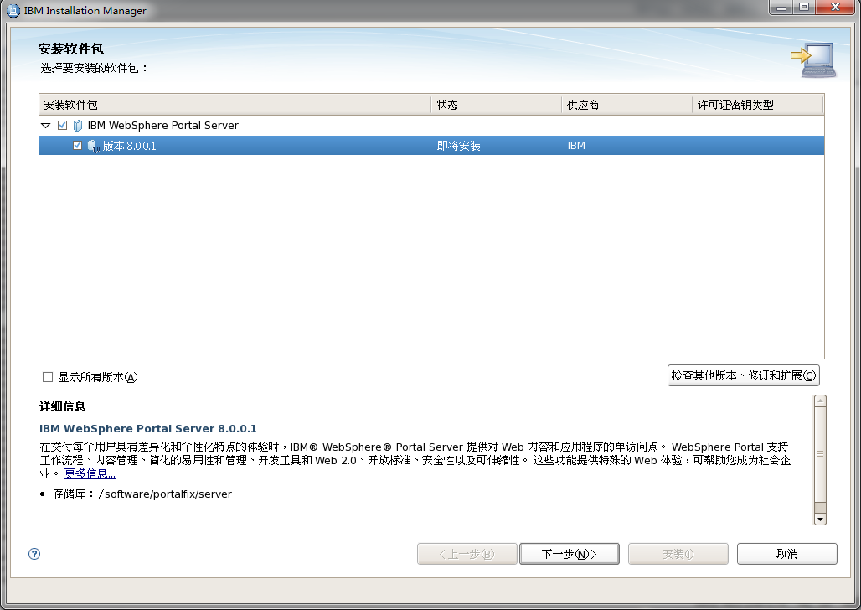

选择需要安装的产品

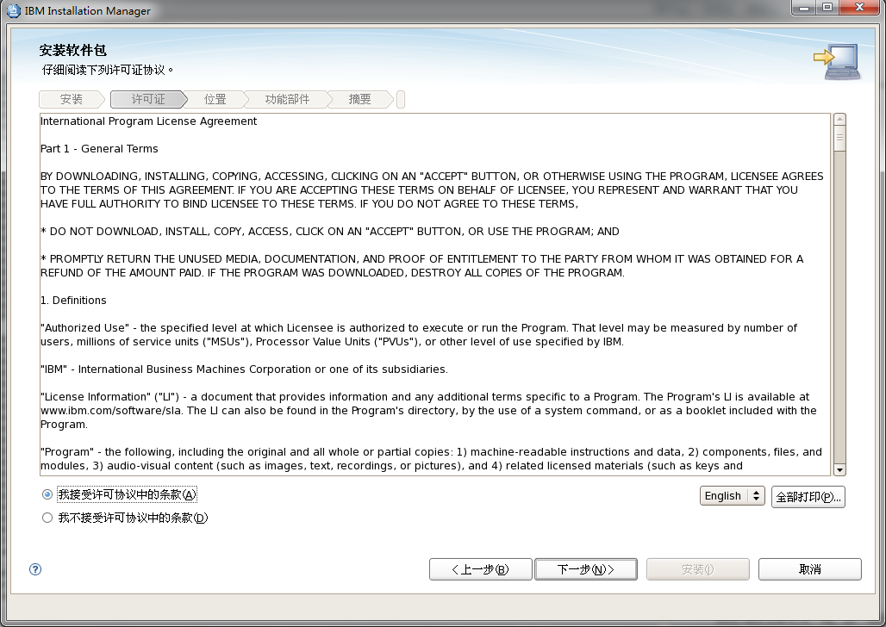

接受许可协议

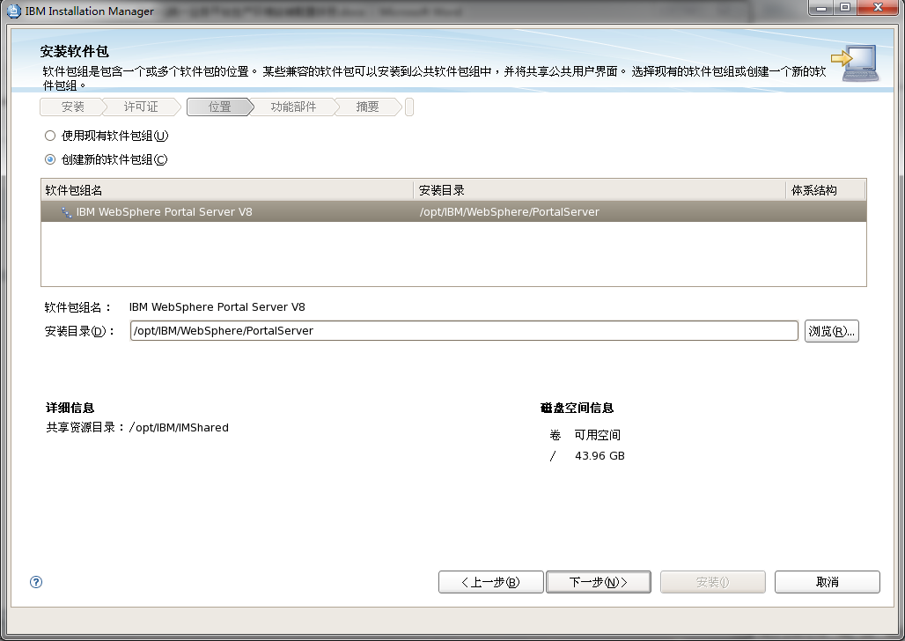

指定安装的路径

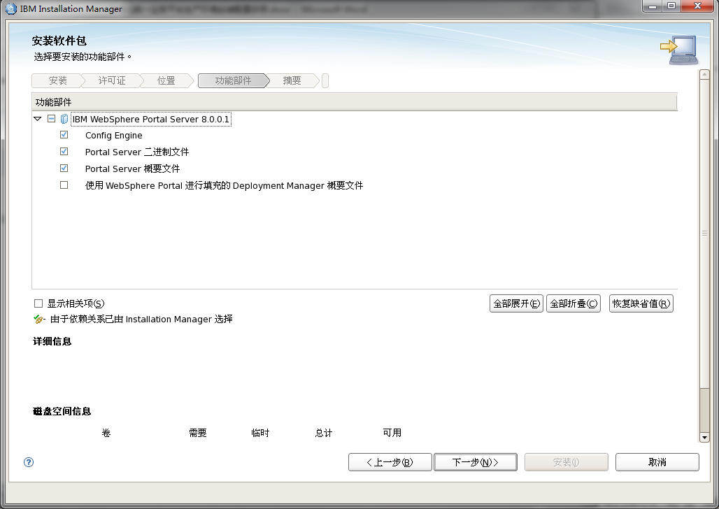

选择安装的组件

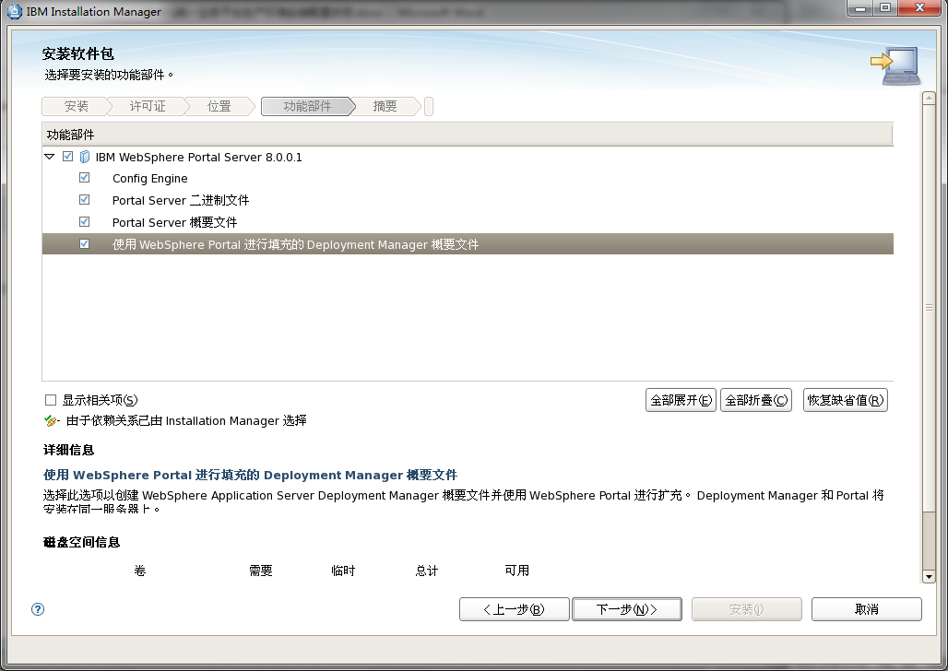

选择管理控制台的概要文件

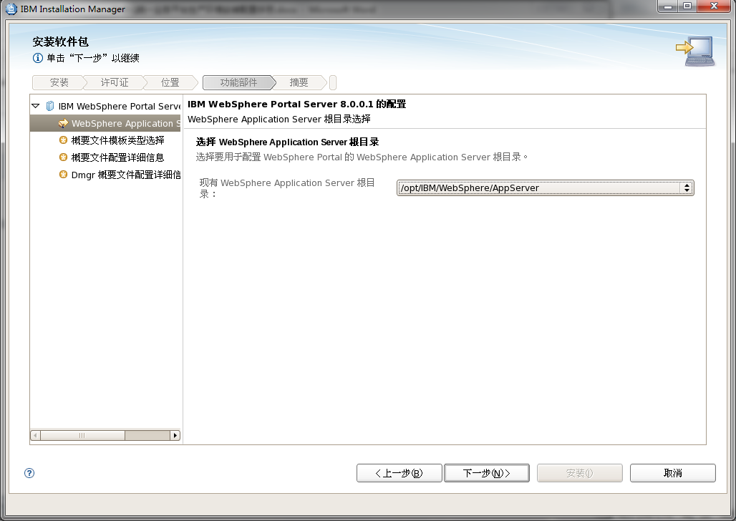

选择已经安装好的应用服务器

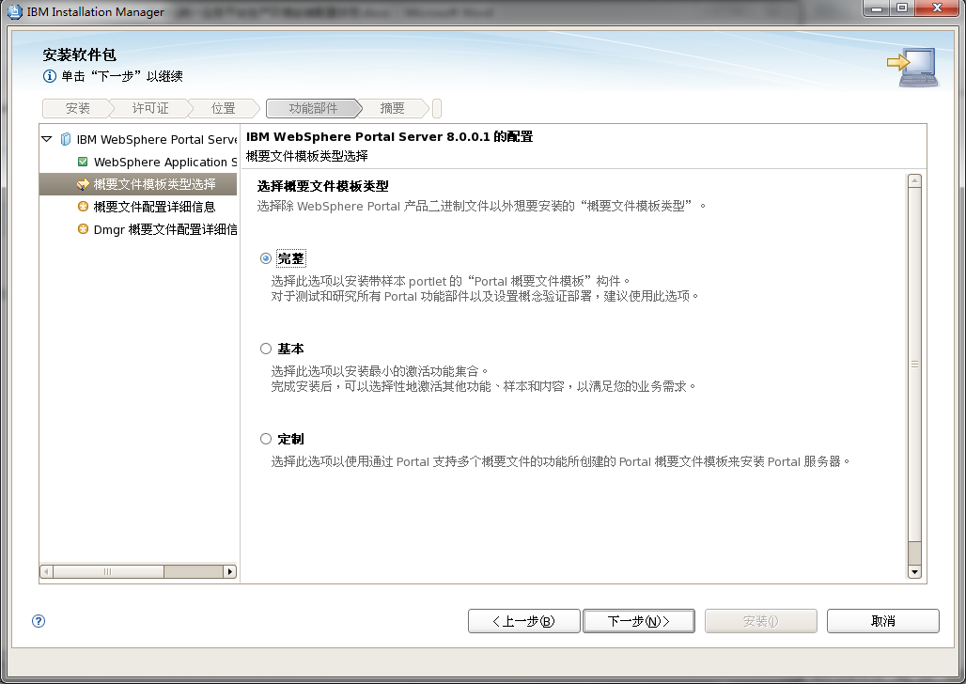

选择完整安装

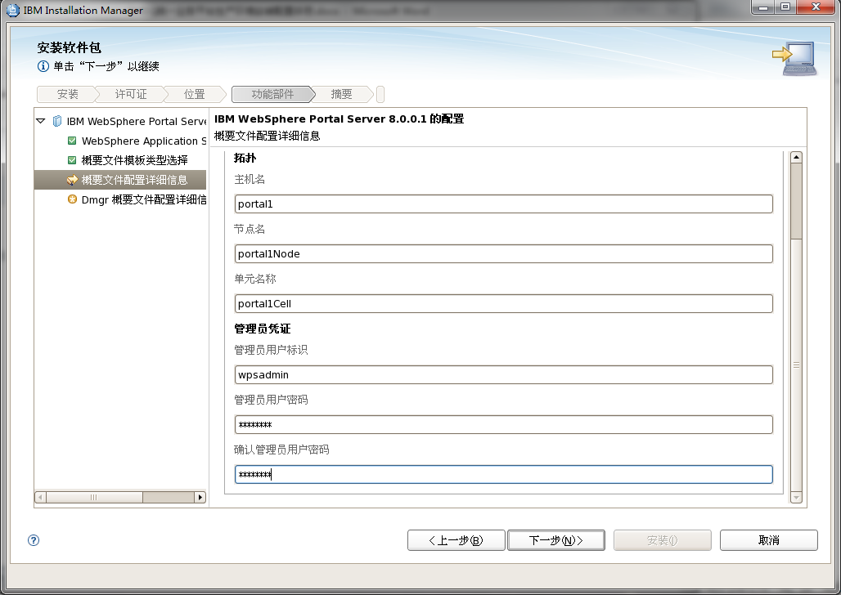

输入管理用户和密码

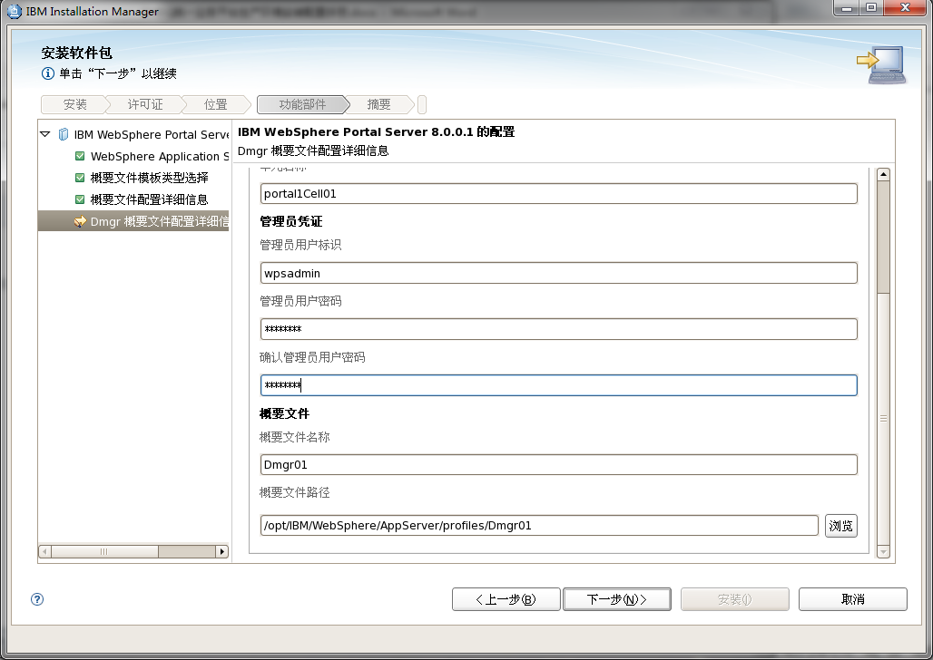

输入Dmgr的管理用户和密码

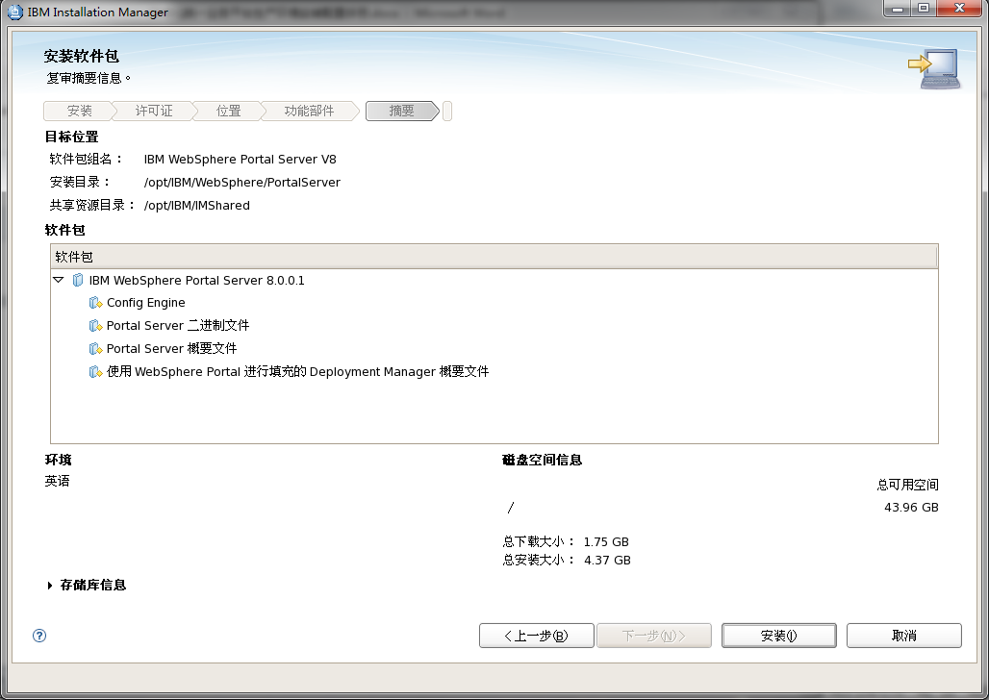

开始安装

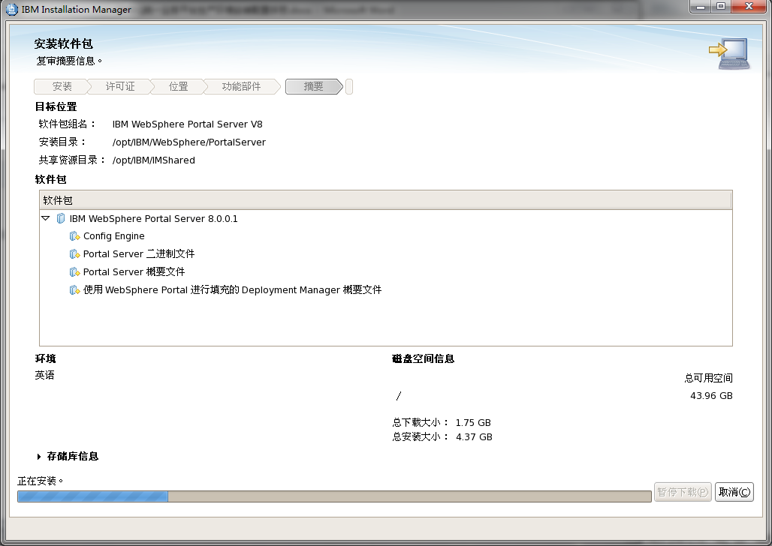

正在安装

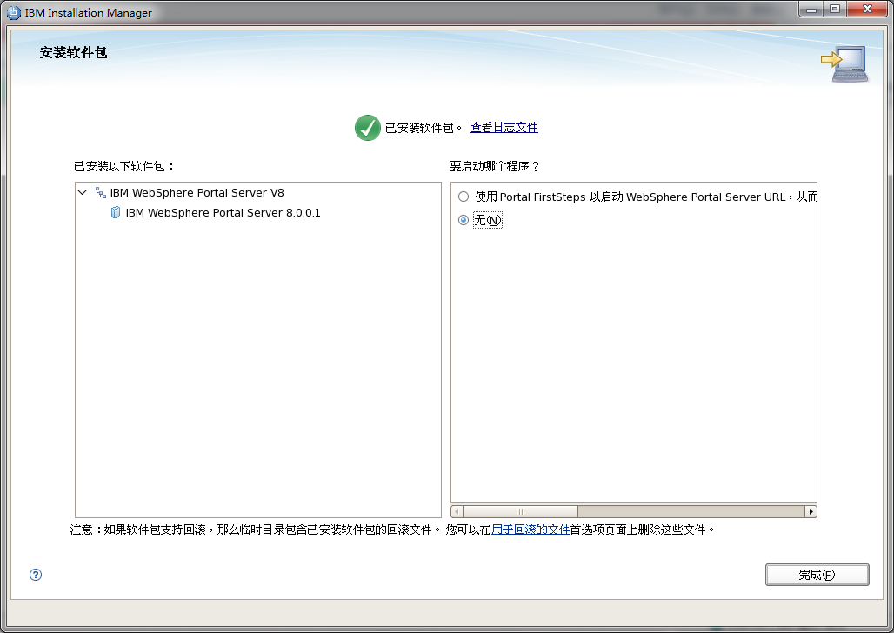

安装完成

## 将数据库从deby迁移到oralce上

cd /opt/IBM/WebSphere/AppServer/profiles/cw_profile/bin

./startServer.sh server1

<https://10.47.0.104:9043/ibm/console/logon.jsp>

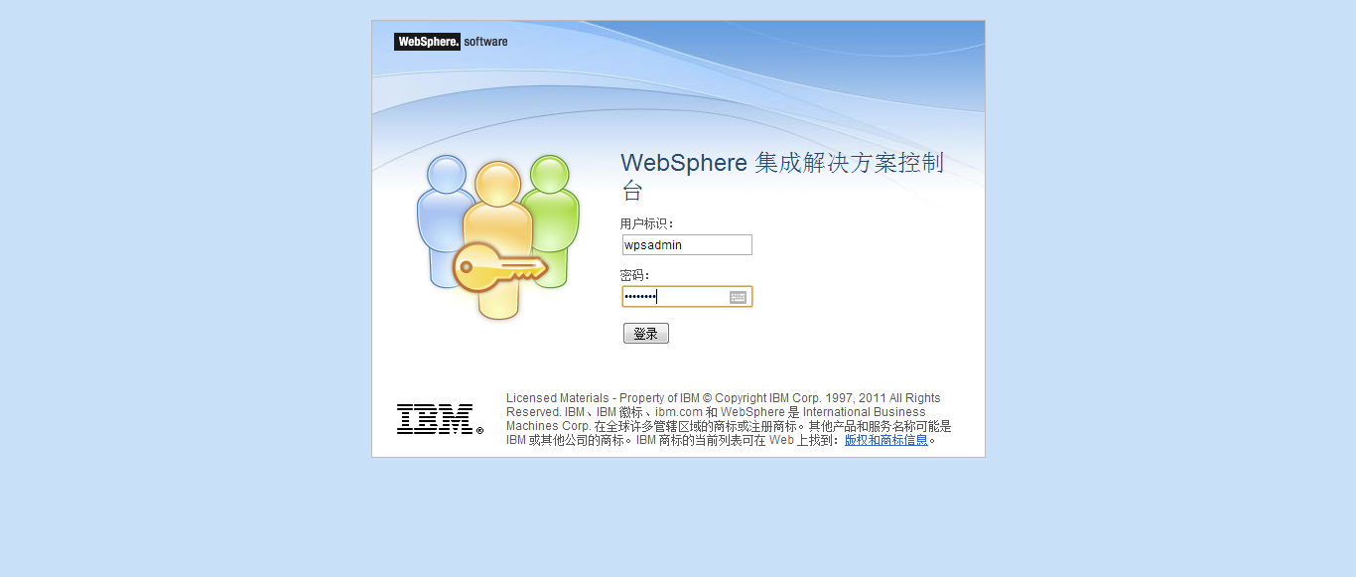 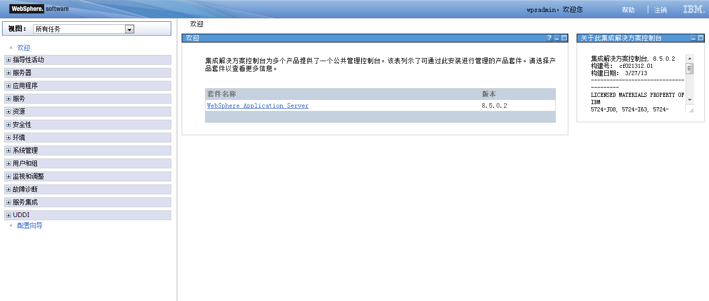 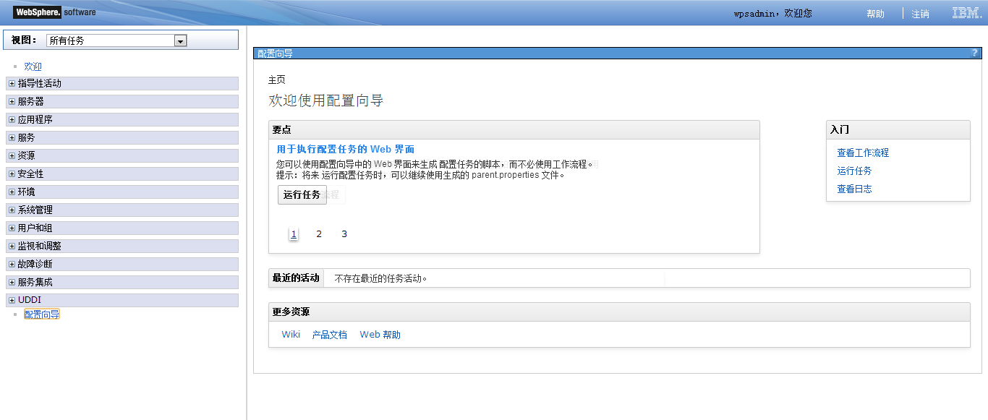 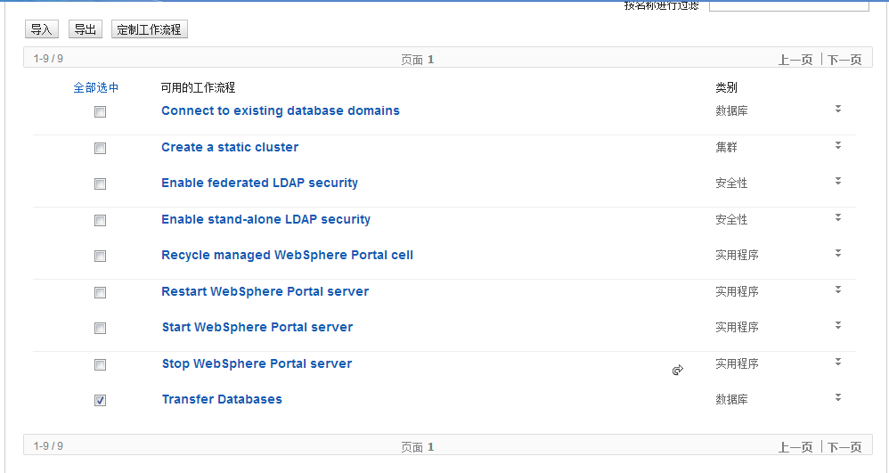 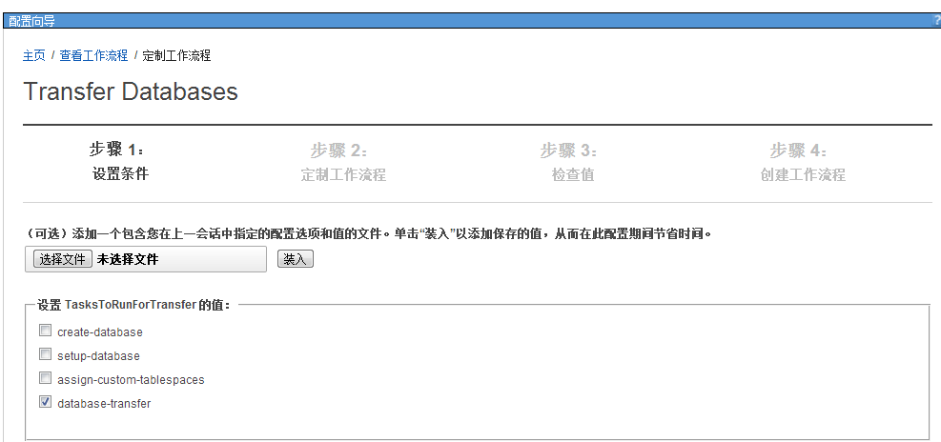 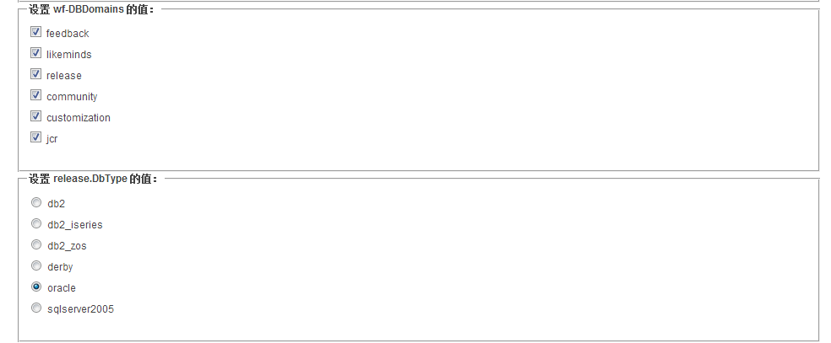 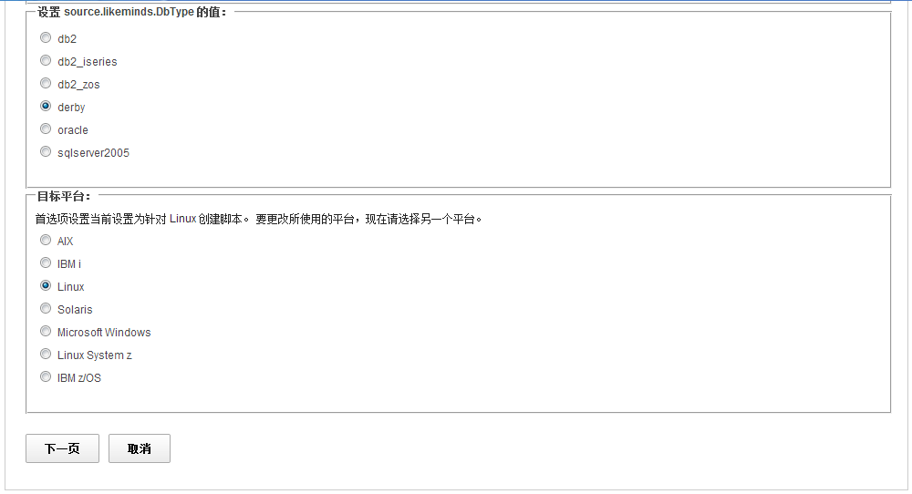 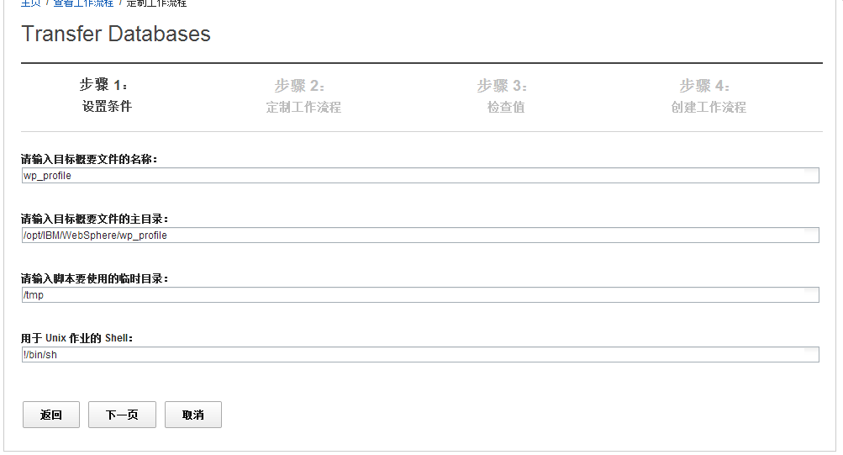 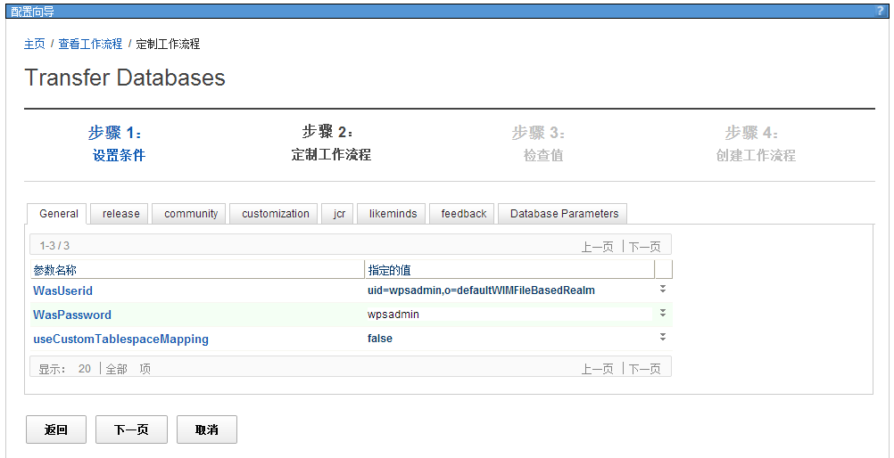 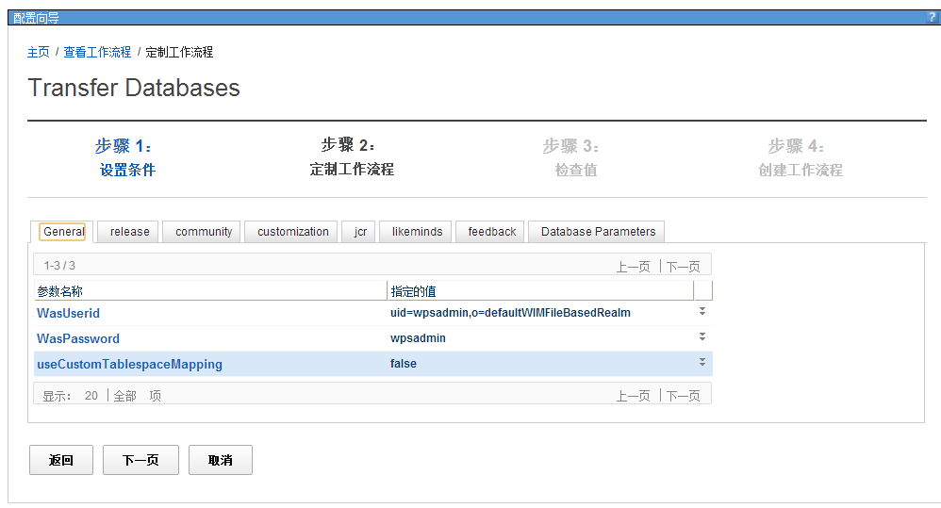 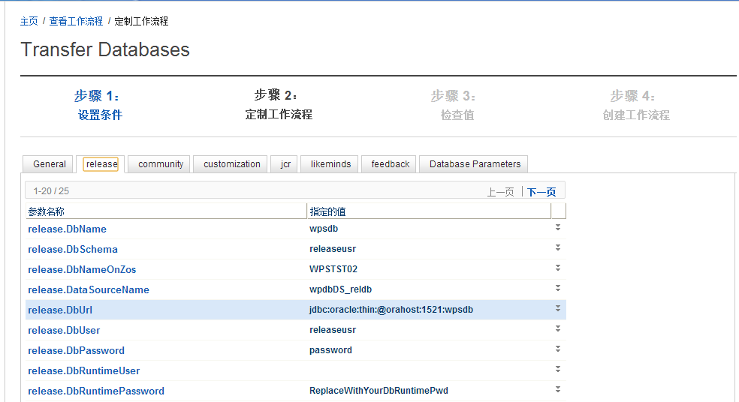 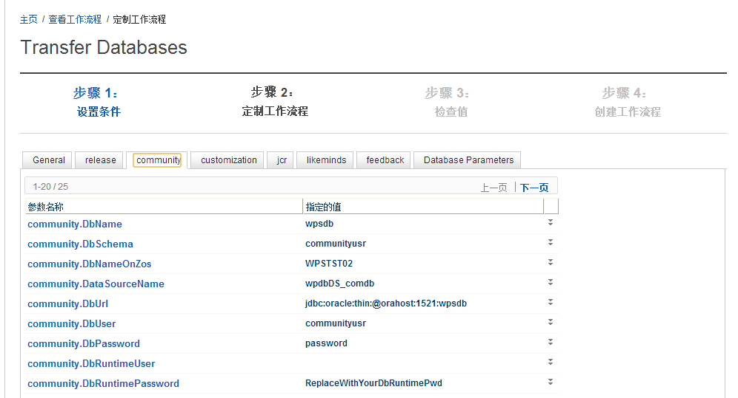 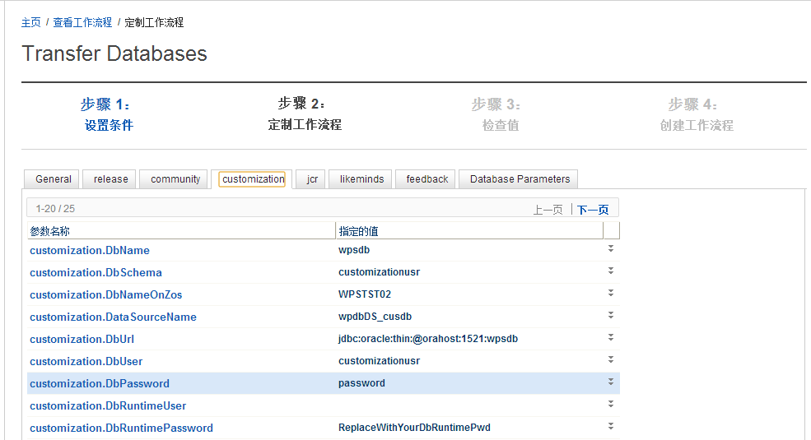 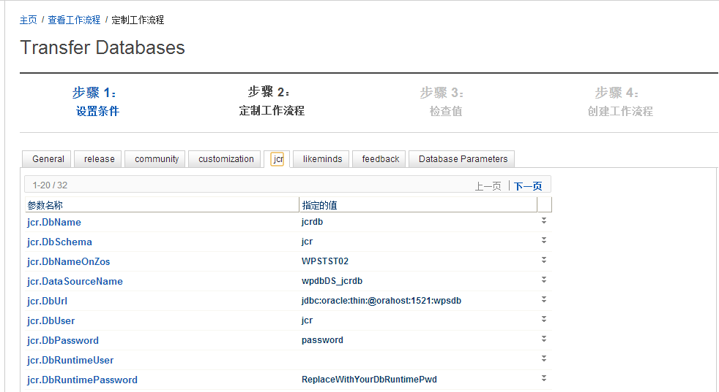 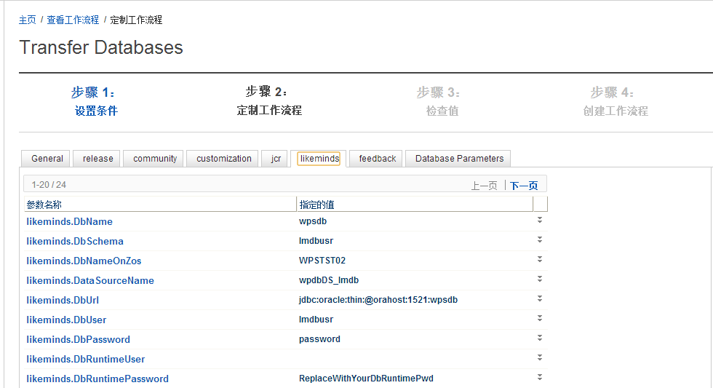 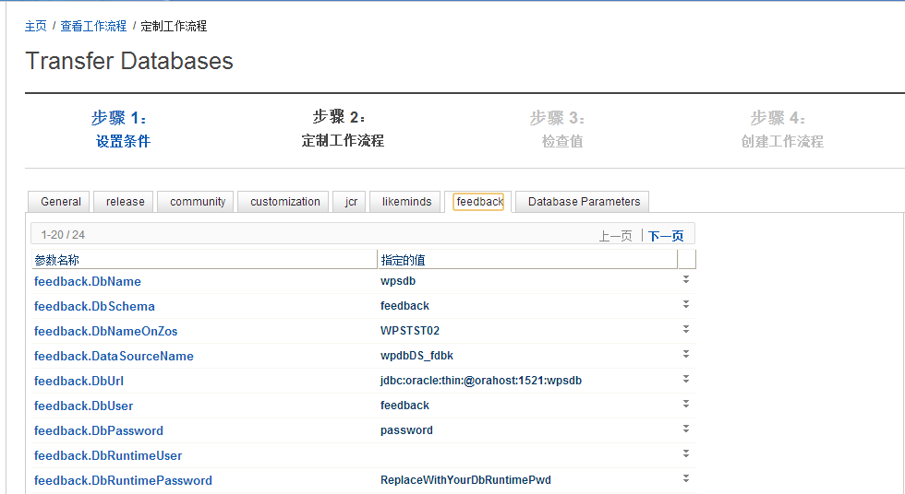 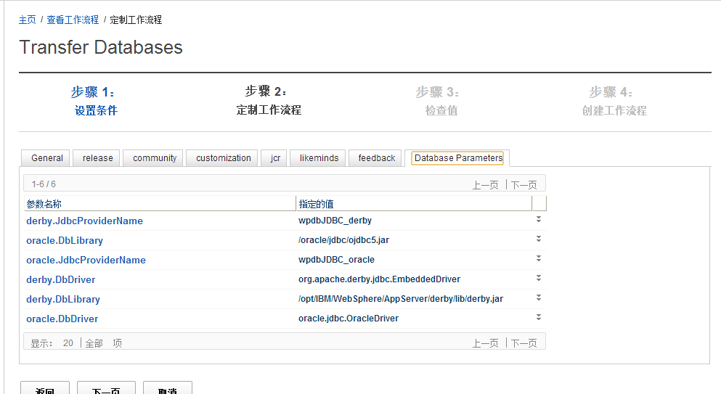

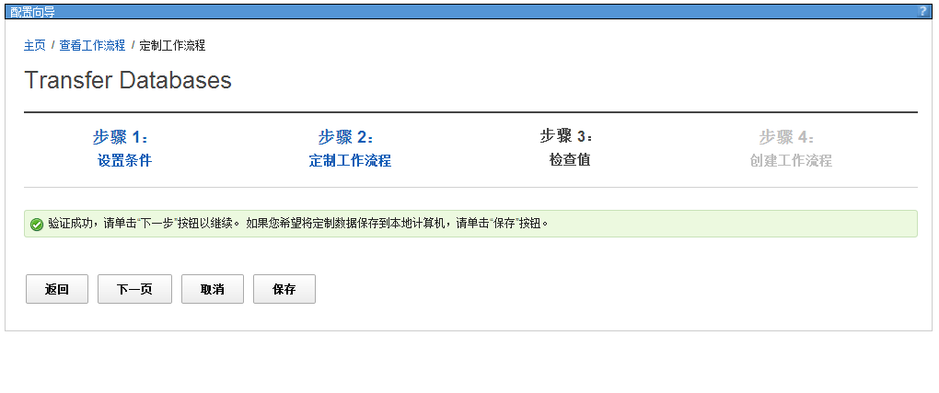 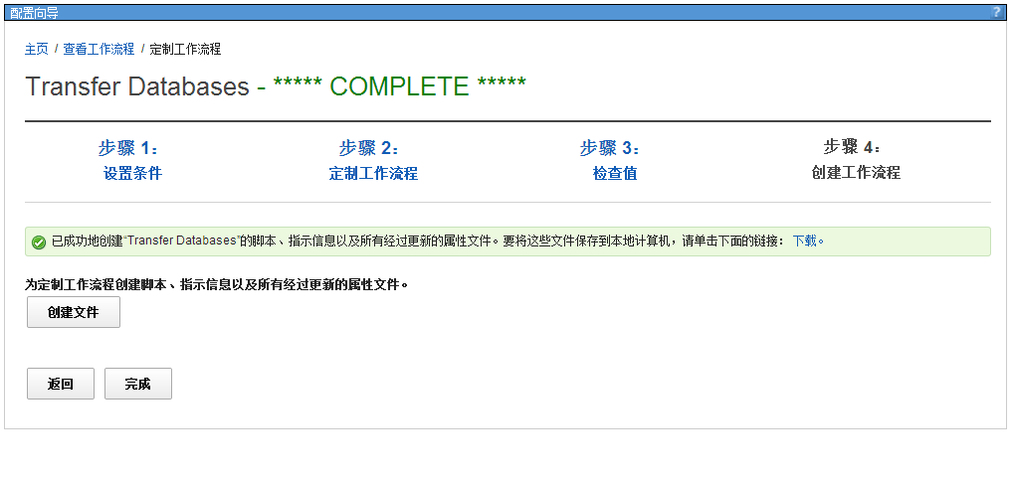

cd /software/db/scripts

## 将用户验证迁移到TDS的服务器上

停止portal

/opt/IBM/WebSphere/wp_profile/bin/stopServer.sh WebSphere_Portal

编辑如下文件，修改数据库配置信息

/opt/IBM/WebSphere/wp_profile/ConfigEngine/properties/wkplc.properties   
/opt/IBM/WebSphere/wp_profile/ConfigEngine/properties/wkplc_dbdomain.properties   
/opt/IBM/WebSphere/wp_profile/ConfigEngine/properties/wkplc_dbtype.properties

/opt/IBM/WebSphere/wp_profile/ConfigEngine

./ConfigEngine.sh validate-standalone-ldap-attribute-config -DPortalAdminPwd=wpsadmin -DWasPassword=wpsadmin

./ConfigEngine.sh wp-modify-ldap-security -DWasUserid=wpsadmin -DWasPassword=wpsadmin

./ConfigEngine.sh validate-database-connection -DWasPassword=wpsadmin

./ConfigEngine.sh database-transfer -DPortalAdminPwd=wpsadmin -DWasPassword=wpsadmin

/opt/IBM/WebSphere/wp_profile/bin/startServer.sh WebSphere_Portal

TAM adapter 6.0上要求：TDI v7.1 fix5 或v7.1.1  
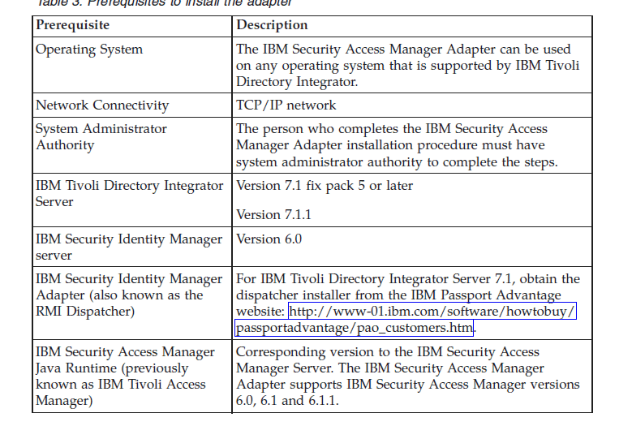

## portal与webseal的单点

[root@portal bin]# pdadmin -a sec_master -p p@55w0rd

pdadmin sec_master> server task default-webseald-portal create -t tcp -h portal -p 10039 -A -F /opt/pdweb/portal.ltpa -Z p@55w0rd -k -f -c all /portal

Created junction at /portal

添加ACL

acl create WP_authenticated_access

acl create WP_admin_access

acl create WP_no_access

acl create WP_all_access

acl modify WP_admin_access set user sec_master TcmdbsvaBrxl

acl modify WP_admin_access set group iv-admin Tcmdbsvarxl

acl modify WP_admin_access set group webseal-servers Tgmdbsrxl

acl modify WP_admin_access set group wpsadmins Tr

acl modify WP_admin_access set any-other T

acl modify WP_admin_access set unauthenticated T

acl modify WP_no_access set user sec_master TcmdbsvaBrxl

acl modify WP_no_access set group iv-admin Tcmdbsvarxl

acl modify WP_no_access set group webseal-servers Tgmdbsrxl

acl modify WP_no_access set group wpsadmins T

acl modify WP_no_access set any-other T

acl modify WP_no_access set unauthenticated T

acl modify WP_authenticated_access set user sec_master TcmdbsvaBrxl

acl modify WP_authenticated_access set group iv-admin Tcmdbsvarxl

acl modify WP_authenticated_access set group webseal-servers Tgmdbsrxl

acl modify WP_authenticated_access set group wpsadmins Tr

acl modify WP_authenticated_access set any-other Tr

acl modify WP_authenticated_access set unauthenticated T

acl modify WP_all_access set user sec_master TcmdbsvaBrxl

acl modify WP_all_access set group iv-admin Tcmdbsvarxl

acl modify WP_all_access set group webseal-servers Tgmdbsrxl

acl modify WP_all_access set group wpsadmins Tr

acl modify WP_all_access set any-other Tr

acl modify WP_all_access set unauthenticated Tr

acl attach /WebSEAL/portal-default/portal/wps/config WP_admin_access

acl attach /WebSEAL/portal-default/portal/wps/myportal WP_authenticated_access

acl attach /WebSEAL/portal-default/portal/wps/portal WP_all_access

acl attach /WebSEAL/portal-default/portal/wps/doc WP_all_access

acl attach /WebSEAL/portal-default/portal/wps/wps WP_all_access

group import wpsadmins "cn=wpsadmins,cn=groups,dc=shccig,dc=com"

user import wpsadmin "uid=wpsadmin,cn=users,dc=shccig,dc=com"

user modify wpsadmin account-valid yes

user import wpsbind "uid=wpsbind,cn=users,dc=shccig,dc=com"

user modify wpsbind account-valid yes

在/opt/pdweb/www-default/lib下面添加如下两个文件

jmt.conf：

/portal /wps/portal*

/portal /wps/config*

/portal /wps/doc*

/portal /wps/myportal*

dynurl.conf：

/portal/wps/portal /portal/wps/portal*

/portal/wps/myportal /portal/wps/myportal*

/portal/wps/config /portal/wps/config*

/portal/wps/doc /portal/wps/doc*

/portal /wps*